# **Mehanti Admin Panel User Guide**

## **Table of Contents**

1. Introduction
2. Getting Started
   * Accessing the Admin Panel
   * Admin Login and Authentication
   * Dashboard Overview
3. Newsletter Management
   * View All Newsletters
   * Create Newsletter
   * Edit Newsletter
   * Delete Newsletter
   * Update Newsletter
4. Deletion Requests
   * View All Deletion Requests
   * Update Deletion Request
   * Manage Deletion Policies
5. Support Management
   * View All Support Requests
   * Update Support Request
   * Manage Support Tickets
   * Track Response Times
6. Payments
   * View All Payments
   * Process Payments
   * Generate Payment Reports
7. Service Provider on Dashboard
   * View Service Providers
   * Update Service Provider Information
8. Service Category on QuickBooks
   * Manage Service Categories
   * Sync with QuickBooks
9. Certificate Issuers
   * View Certificate Issuers
   * Add New Issuer
   * Update Issuer Information
10. Spotlights
    * Manage Spotlights
    * Add New Spotlight
11. Reports
    * View Reports
    * Generate Report
12. Bookings
    * View All Bookings
    * Update Booking Status
13. Roles
    * View Roles
    * Add New Role
    * Edit Role Permissions
14. Countries
    * View and Manage Countries
15. States
    * View and Manage States
16. Cities
    * View and Manage Cities
17. Timeslots
    * View Timeslots
    * Add or Edit Timeslot
18. Service Categories
    * Manage Service Categories
19. Service Sub Categories
    * Manage Service Sub Categories
20. Support Contact
    * Update Support Contact Information
21. Users
    * View Users
    * Edit User Profile
22. Service Providers
    * View Service Providers
    * Edit Service Provider Profile

## **1. Introduction**

Welcome to the Mehanti Admin Panel User Guide. This document is crafted to assist administrators in managing all facets of the Mehanti platform efficiently. As an administrator, you are essential to maintaining the platform's smooth operation, including user management, service provider oversight, and system integrity.

The Mehanti platform integrates various functionalities, including connecting service providers with clients, managing bookings, overseeing payments, and much more. This guide provides detailed instructions to help you navigate and utilize the admin panel effectively.

## **2. Getting Started**

### **Accessing the Admin Panel**

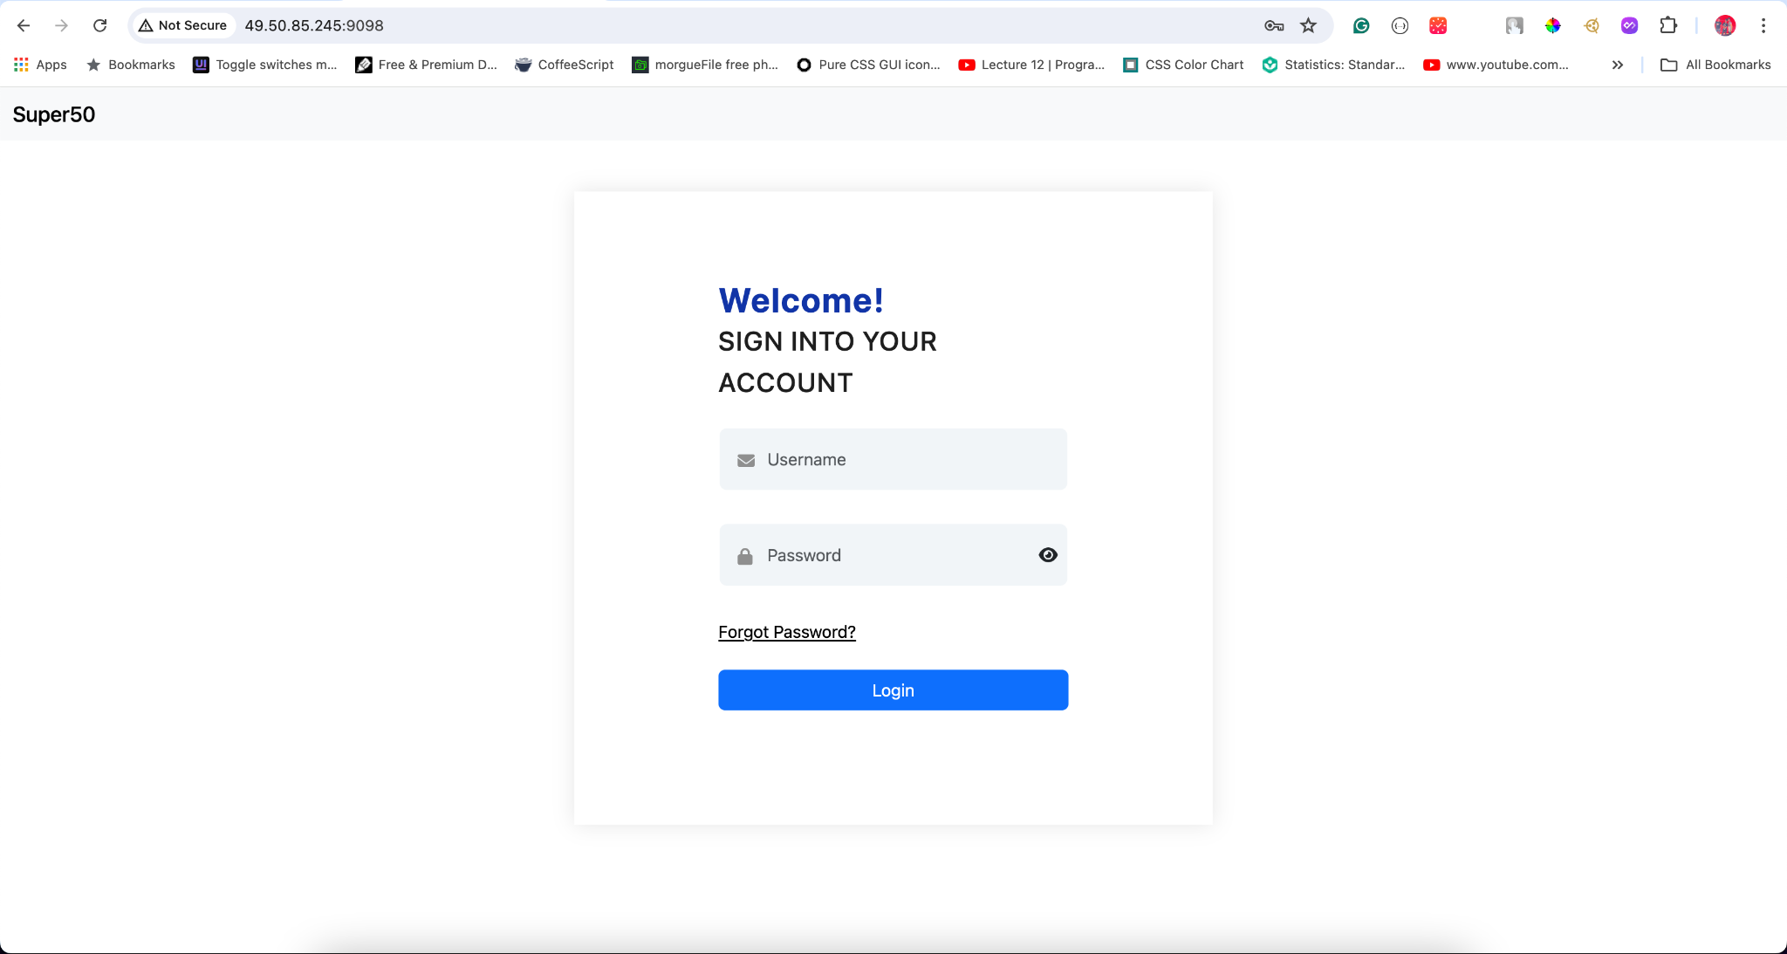

To start your administrative tasks, follow these steps:

1. Open a web browser (Chrome, Firefox, or Safari recommended).
2. Enter the URL:<http://49.50.85.245:9098/>.
3. You will be directed to the Mehanti Admin Panel login page.

### **Admin Login and Authentication**

To ensure security and access control:

1. Enter your assigned **Username** and **Password**.
2. Click **Login**.
3. If successful, you will be directed to the Dashboard. Otherwise, an error message will appear, and repeated failed attempts may lock your account temporarily.

**Security Tips:**

* Do not share your login credentials.
* Use a strong, unique password.
* Change your password regularly.
* Report any suspected account compromise immediately.

### **Dashboard Overview**

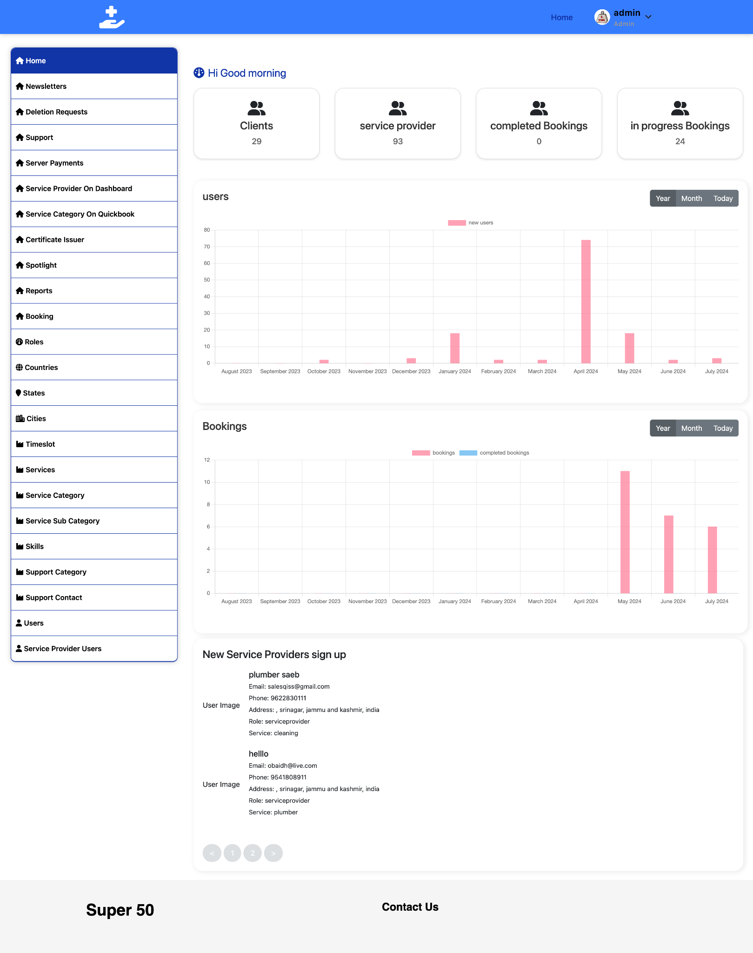

The Dashboard serves as your control center, providing a snapshot of the platform’s performance:

* **User Statistics:** Total registered users, new sign-ups, and active users.
* **Service Provider Metrics:** Registered providers, active providers, and top categories.
* **Booking Information:** Recent bookings, completed services, and upcoming appointments.
* **Revenue Dashboard:** Daily, weekly, and monthly revenue, including pending payouts.
* **System Alerts:** Critical notifications requiring immediate attention.
* **Quick Access Links:** Shortcuts to frequently used sections.

Familiarize yourself with the Dashboard to monitor the platform’s status and identify areas needing attention.

## **3. Newsletter Management**

Effective communication through newsletters helps in user engagement and retention.

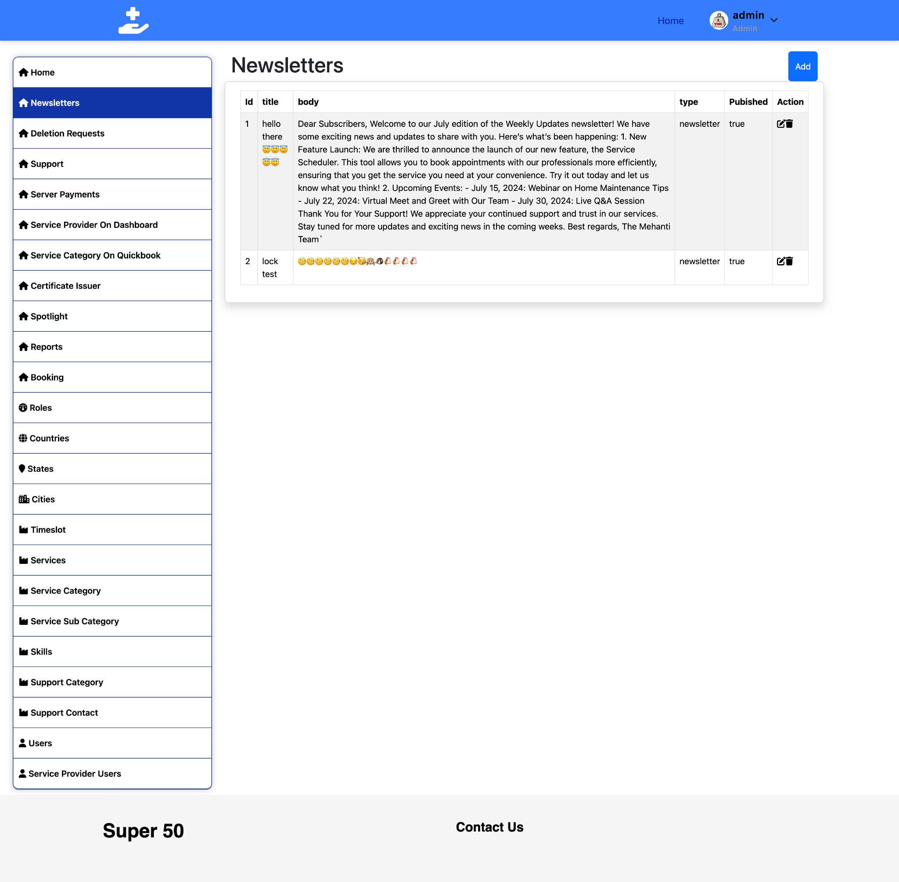

### **View All Newsletters**

To manage newsletters:

1. Click **Newsletters** in the left sidebar.
2. View the list of newsletters with details such as:
   * Title
   * Creation Date
   * Status (Draft/Sent)
   * Open Rate
   * Click-through Rate
3. Use the search bar to find specific newsletters and sort by column headers.

### **Create Newsletter**

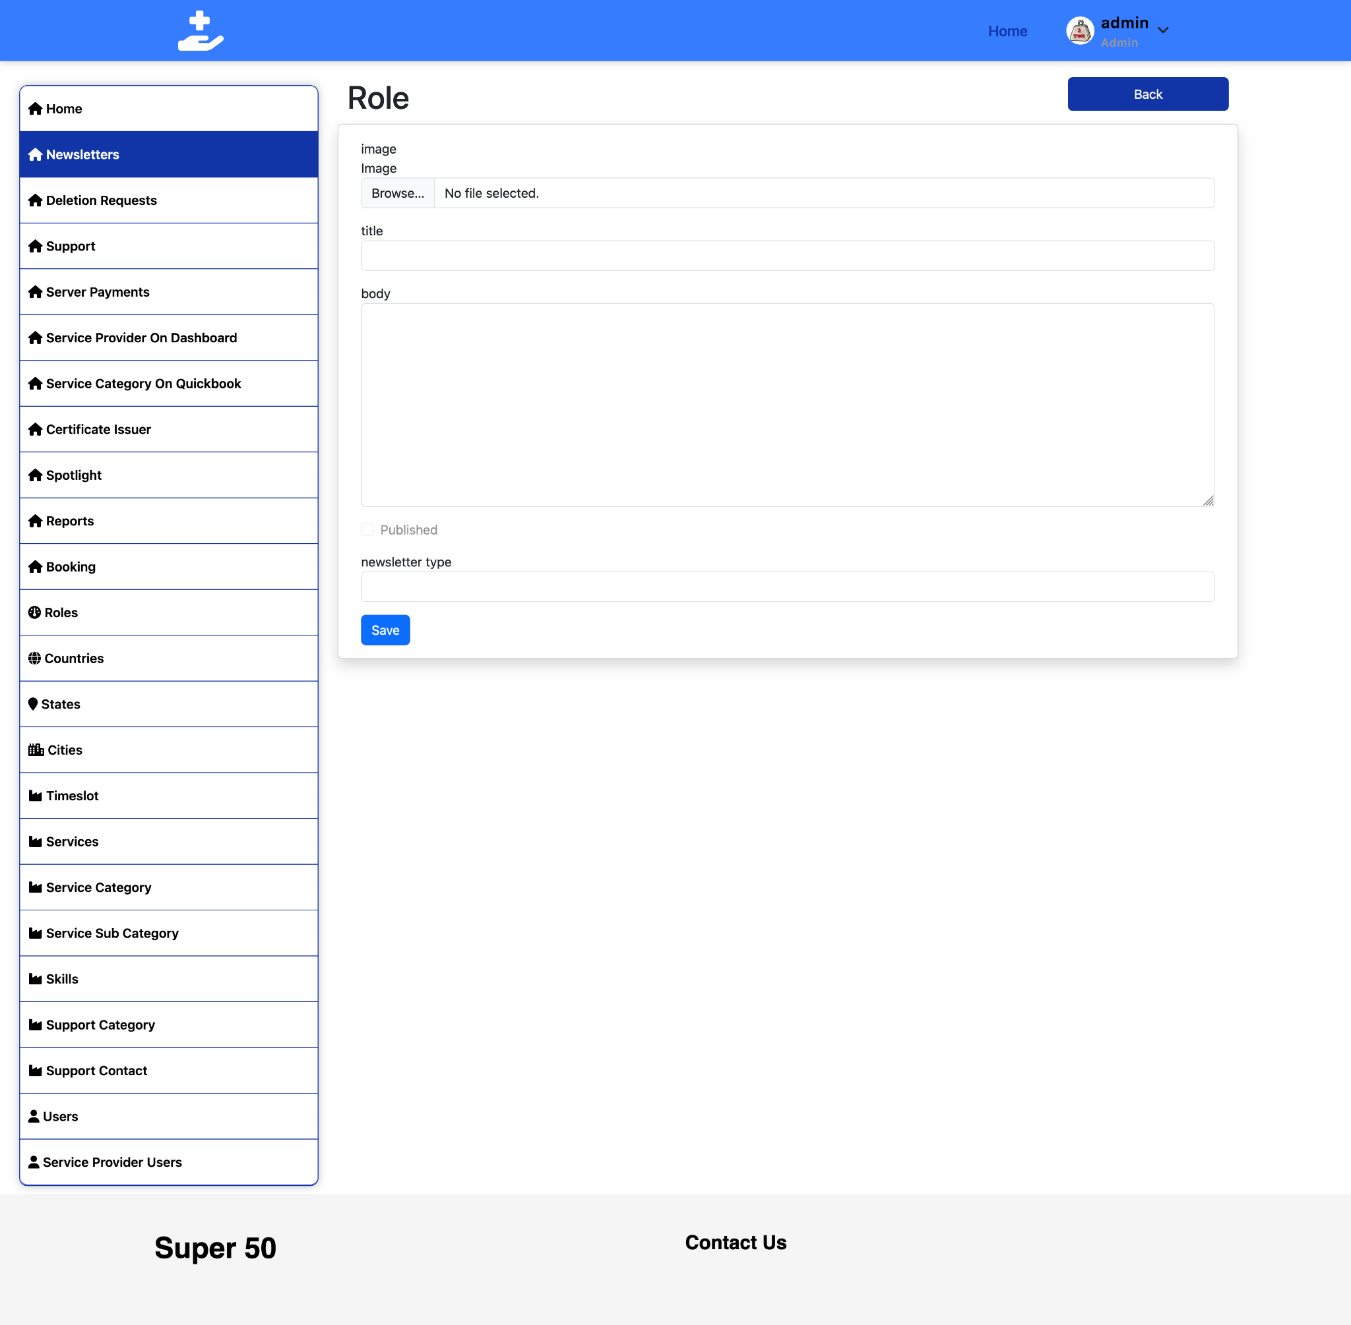

To create a new newsletter:

1. Click **Create New Newsletter**.
2. Fill in:
   * **Basic Information:** Title and recipient list.
   * **Content Editor:** Format text, add images, include links.
   * **Preview Pane:** Review the newsletter on different devices.
   * **Scheduling:** Choose to send immediately or schedule.
3. Click **Save as Draft** or **Send/Schedule**.

**Best Practices:**

* Craft engaging subject lines.
* Use clear and appealing layouts.
* Include a strong call-to-action (CTA).
* Personalize content with merge tags.

### **Edit Newsletter**

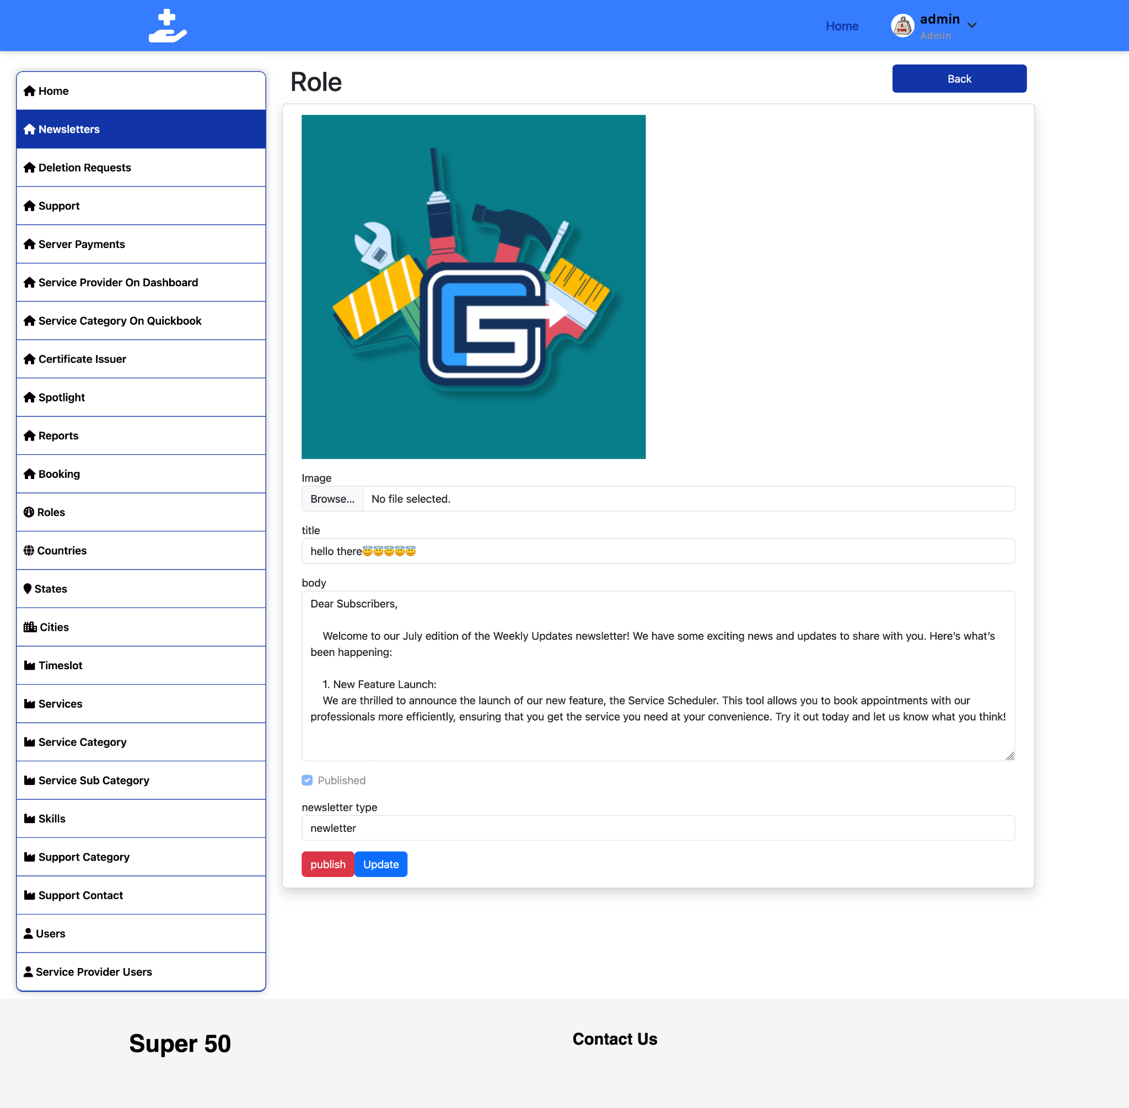

To modify an existing newsletter:

1. Find the newsletter and click the **Edit** icon.
2. Make changes to the content and preview.
3. Click **Save Changes**.

Note: Sent newsletters cannot be edited but can be duplicated.

### **Delete Newsletter**



To remove a newsletter:

1. Click the **Delete** icon next to the newsletter.
2. Confirm the deletion in the popup.

**Important:** Deletion is permanent; consider archiving instead if historical records are needed.

### **Update Newsletter**

To update newsletters:

1. Find and click the **Update** icon.
2. Modify content, subject line, or scheduling.
3. Click **Save Updates**.

For sent newsletters, this will create a new draft based on the original.

## **4. Deletion Requests**

Handling deletion requests is crucial for privacy and data protection compliance. In the digital age, users are increasingly aware of their rights regarding personal data. Ensuring that deletion requests are processed promptly and accurately not only aligns with legal requirements such as GDPR and CCPA but also builds trust with your users. Mishandling these requests can lead to severe penalties and damage the reputation of the platform.

### **View All Deletion Requests**

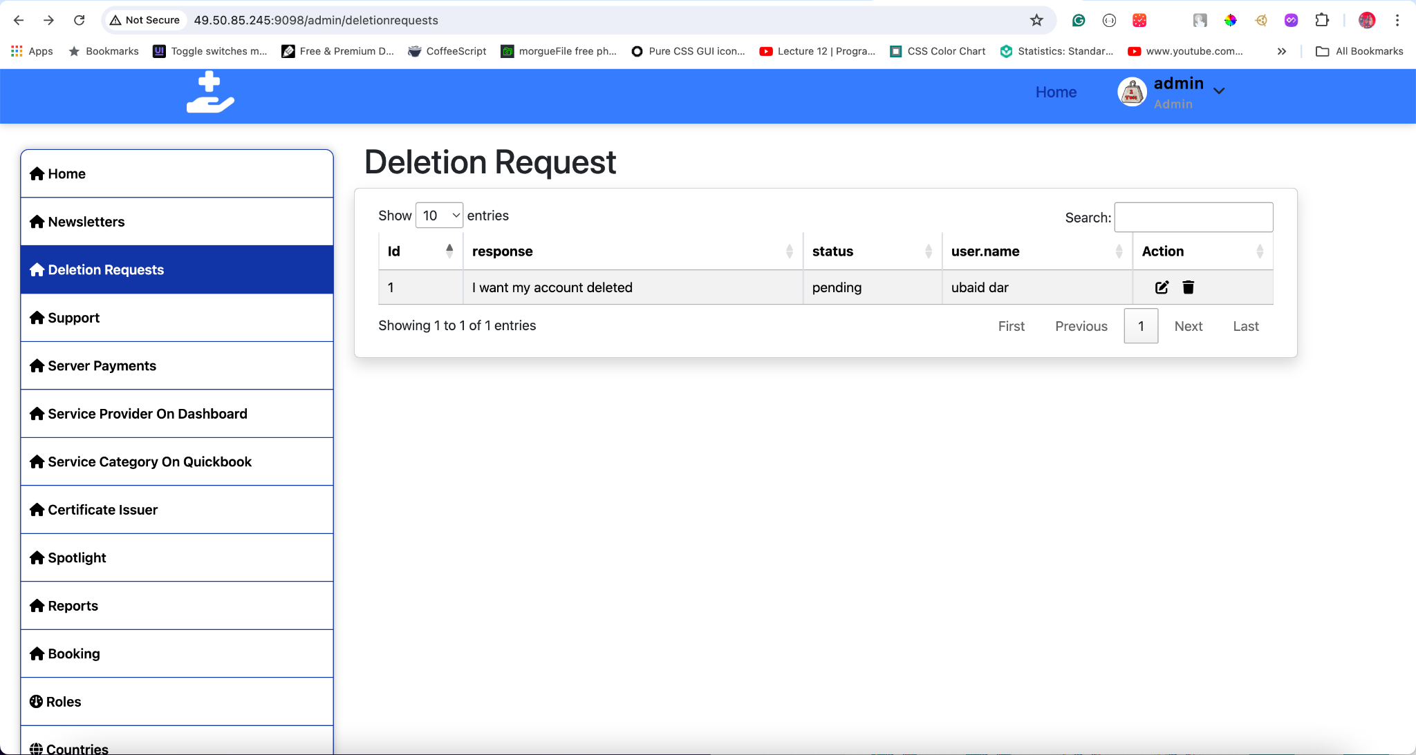

To access and manage deletion requests:

1. Click **Deletion Requests** in the left sidebar.
2. View requests with comprehensive details such as:
   * **User ID:** The unique identifier of the user making the request.
   * **Username:** The name associated with the user account.
   * **Date of Request:** When the deletion request was submitted.
   * **Reason for Deletion:** Users may provide a reason for their request, which can offer insights into potential areas for platform improvement.
   * **Status:** Indicates the current status of the request (Pending, Approved, Rejected).

You can utilize the search bar to find specific requests and sort columns to prioritize processing.

### **Update Deletion Request**

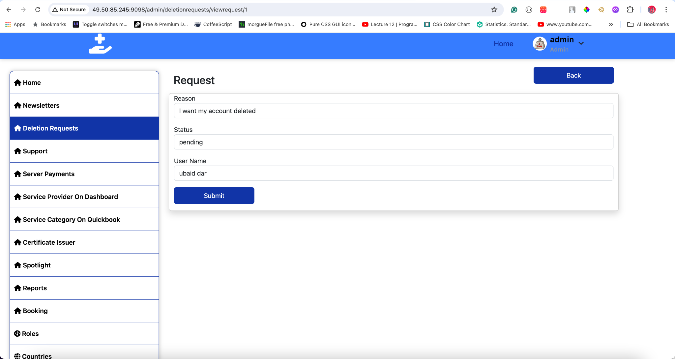

To process a deletion request:

1. Select and review the request details thoroughly.
2. Choose an action:
   * **Approve:** This action will initiate the deletion of the user account and associated data. Ensure all legal and company protocols are followed.
   * **Reject:** Reject the request if it does not meet the criteria for deletion or if further verification is required.
   * **Request More Information:** If the request lacks necessary details, ask the user for additional information to proceed.
3. Select data deletion options to specify which data will be removed and add notes if necessary.
4. Click **Save** to update the request status.

**Important Considerations:**

* **Backup Data:** Ensure that a secure backup is available before proceeding with the deletion. This is crucial in case of accidental data removal or for audit purposes.
* **Notify the User:** Once the request is processed, inform the user about the status of their request. Transparency is key in maintaining user trust.
* **Log Actions:** Maintain detailed logs of all actions taken for each request to ensure accountability and for future reference.

By following these guidelines, you can manage deletion requests efficiently, ensuring compliance with privacy regulations and maintaining user trust in the Mehanti platform.

## **5. Support Management**

Efficient management of support requests ensures user satisfaction.

### **View All Support Requests**

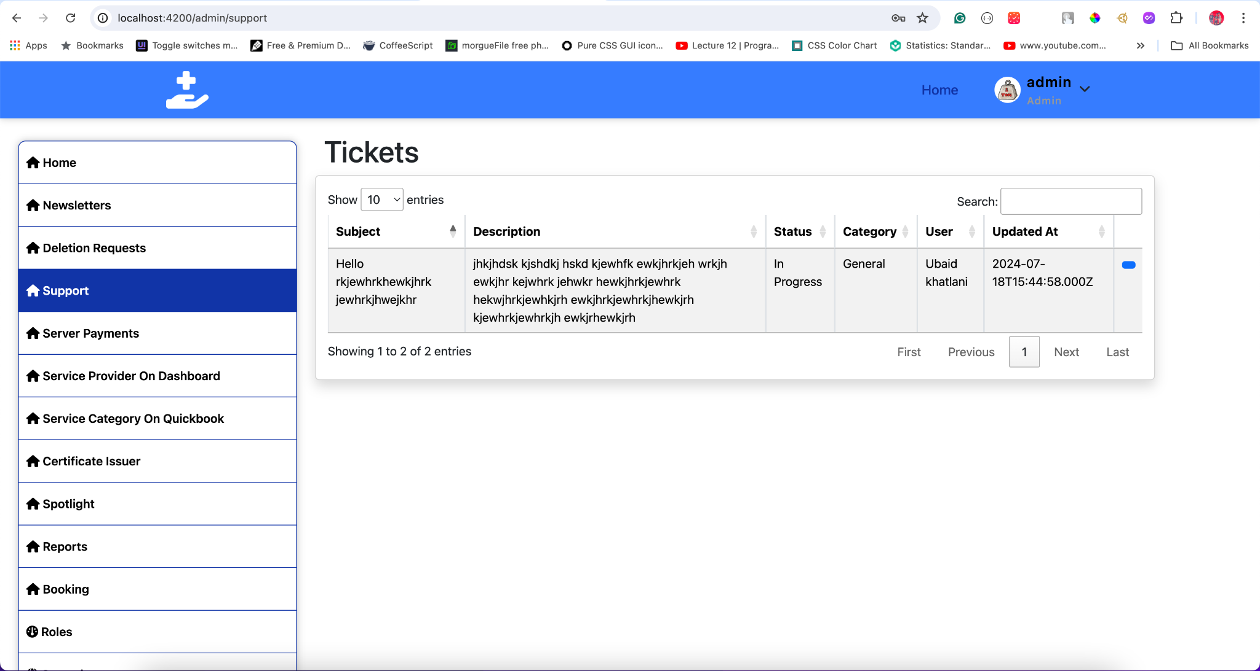

To manage support requests:

1. Click **Support Management**.
2. Review requests with details such as:
   * Request ID
   * User ID
   * Username
   * Date of Request
   * Issue Summary
   * Status (Pending, In Progress, Resolved, Closed)
3. Use the search bar and sorting options for better management.

### **Update Support Request**

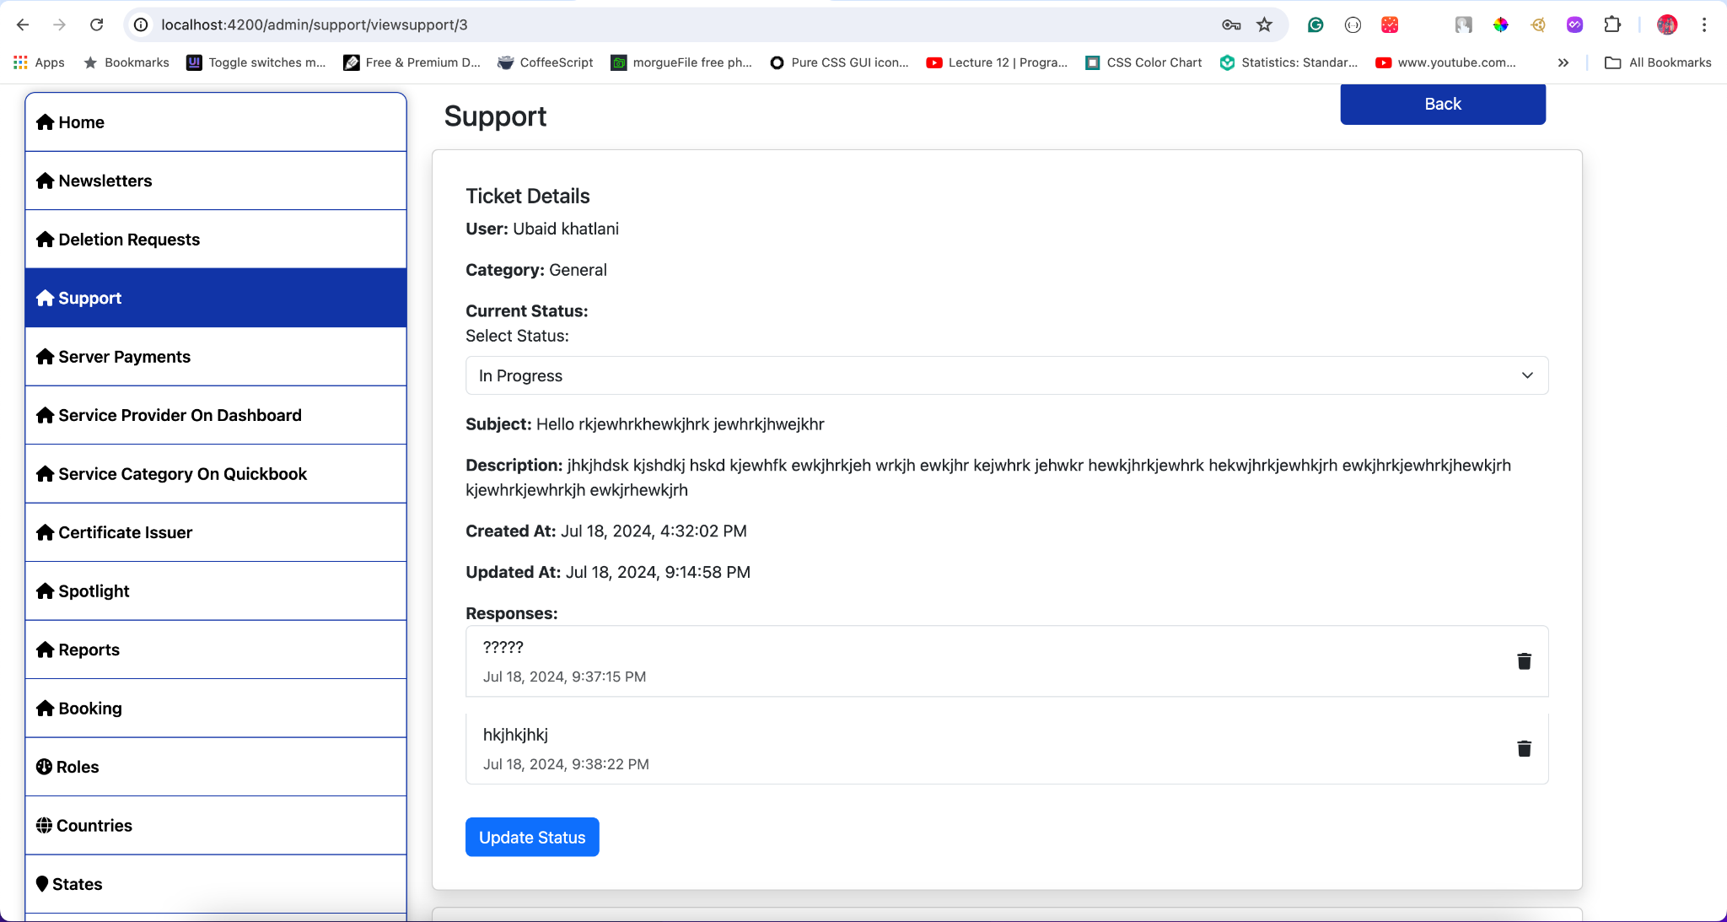

To handle a support request:

1. Select a request to view details.
2. Update status or add notes.
3. Click **Save Changes**.

**Tips:**

* Prioritize urgent issues.
* Maintain clear communication with users.
* Track resolution times to improve response efficiency.

### **Manage Support Tickets**

To oversee tickets:

1. Navigate to **Support Tickets**.
2. View all tickets with their status and details.
3. Assign or reassign tickets as needed.

### **Track Response Times**

To monitor response efficiency:

1. Click **Response Times** in the support section.
2. Review metrics such as average response time and resolution time.
3. Use this data to improve support processes.

## **6. Payments**

Proper payment management ensures smooth financial operations and enhances the trust and satisfaction of both service providers and clients. Efficient handling of payments is crucial to maintain the financial integrity of the platform and to provide a seamless experience for all users involved.

### **View All Payments**

To access and review payment details:

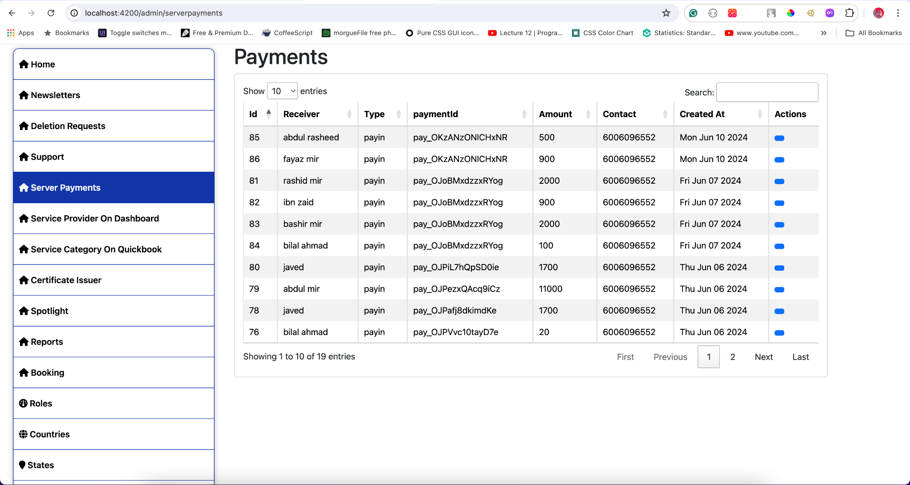

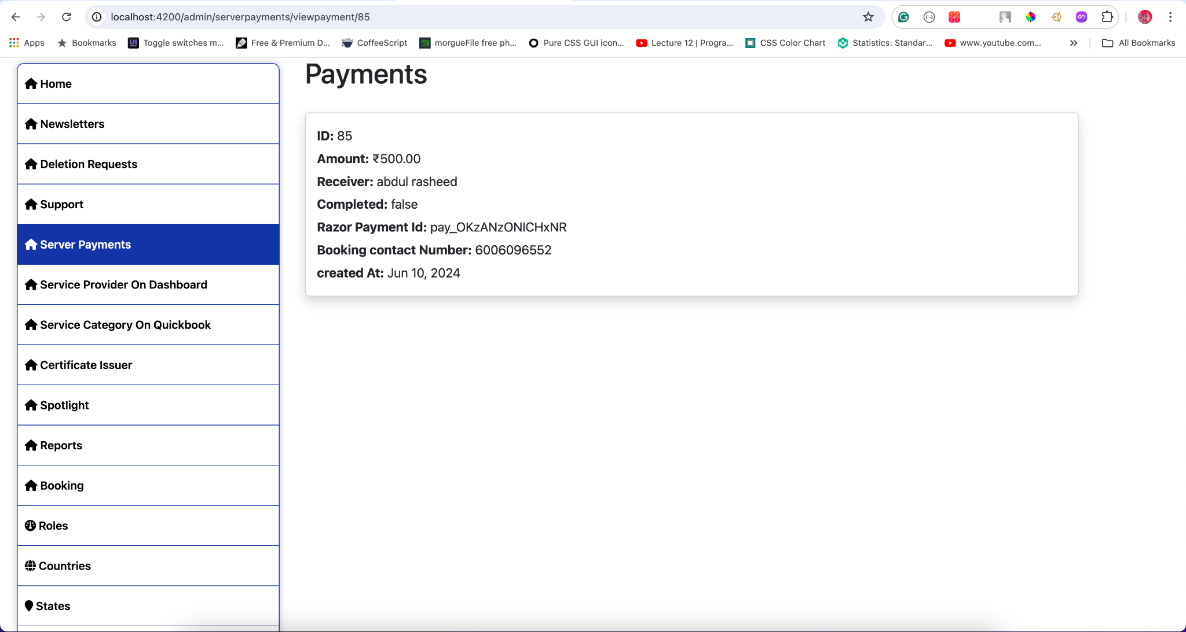

1. **Click Payments** in the left sidebar.
2. **Review Payment Transactions:** You'll see a comprehensive list of payment transactions with detailed information, including:
   * **Transaction ID:** A unique identifier for each transaction, which helps in tracking and auditing.
   * **Amount:** The total amount involved in the transaction.
   * **Date:** The date and time when the transaction was processed.
   * **Status:** The current status of the transaction (e.g., Pending, Completed, Failed).
   * **Payment Method:** The method used for the transaction, such as credit card, bank transfer, or digital wallet.
3. **Search and Sort:** Utilize the search bar to find specific transactions quickly. Sort transactions by date, amount, status, or other criteria for efficient management.

**Best Practices:**

* **Regular Reconciliation:** Regularly reconcile transactions to ensure all payments are accounted for and any discrepancies are promptly addressed.
* **Audit Trails:** Maintain detailed audit trails of all transactions for compliance and future reference.

### **Process Payments**

To manage and process payments effectively:

1. **Select a Payment:** Click on a specific payment from the list to view its detailed information.
2. **Verify Transaction Details:** Ensure all transaction details are correct, including the amount, payment method, and recipient details.
3. **Click Process Payment:** To complete the transaction, click the **Process Payment** button. This will move the transaction from a pending state to a completed state, ensuring funds are transferred appropriately.

**Tips for Efficient Payment Processing:**

* **Double-Check Details:** Always verify payment details before processing to prevent errors.
* **Monitor Payment Gateways:** Regularly check the status of payment gateways to ensure they are functioning correctly and securely.
* **Automate Where Possible:** Utilize automation for recurring payments and bulk transactions to save time and reduce the risk of manual errors.

## **7. Service Provider on Dashboard**

Efficiently manage the visibility of service providers on the mobile dashboard to ensure users have access to the right information.

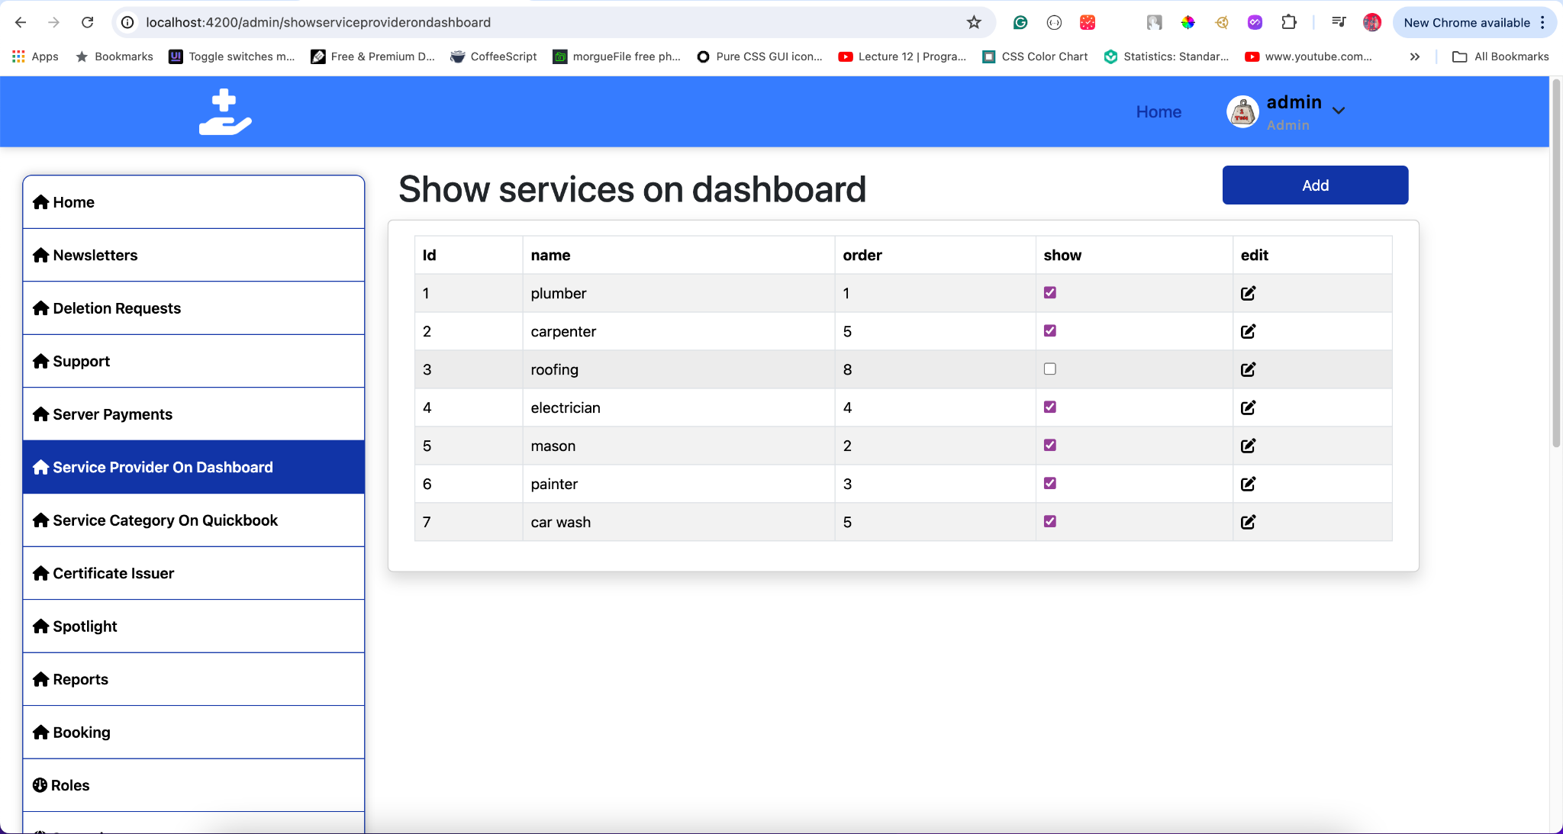

##### **View Service Providers**

To manage service provider details on the Dashboard:

1. Click **Service Provider on Dashboard**.
2. Review the list of service providers with details such as:
   * Service ID
   * Service Name
   * Order
   * Visibility (Show/Unshow)
3. Use the **Show** checkbox to control the visibility of each service provider on the mobile dashboard.

##### **Edit Service Provider Details**

To update service provider details:

1. Select a provider from the list.
2. Click **Edit**.
3. Modify details like service name, order, or visibility.
4. Click **Save Changes**.

##### **Add New Service Provider Category**

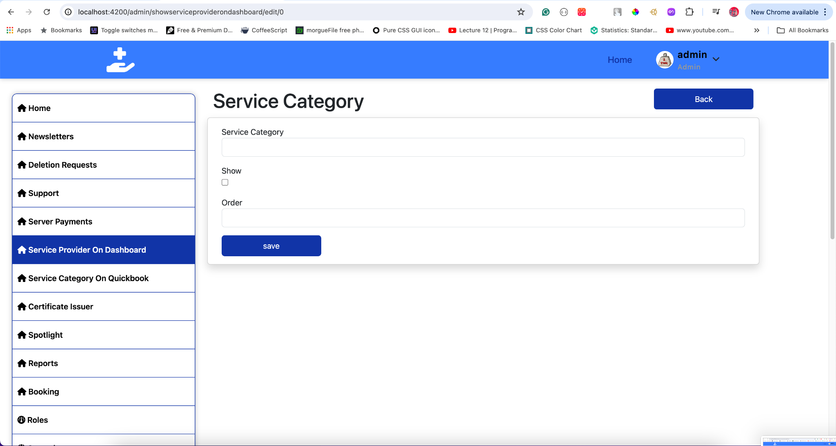

To add a new category:

1. Click **Add**.
2. Enter the new category details.
3. Set the order and visibility preferences.
4. Click **Save**.

**Tips:**

* Regularly review and update the list to keep it relevant.
* Ensure the most popular or critical services are easily accessible.

### **Visual Guide**

#### **Service Provider on Dashboard Interface**

**Service Provider Dashboard View**

* Displays a list of service providers with options to show/hide them on the mobile dashboard.

**Mobile Dashboard View**

* Shows how service providers are displayed to users on the mobile app.

**Edit Service Provider Category**

* Interface for editing service provider categories, including options to show or hide them.

## **8. Service Category on QuickBooks**

#### **Manage Service Categories**

Efficiently manage service categories to ensure proper organization and synchronization with QuickBooks.

##### **View and Edit Service Categories**

To manage service categories:

1. Click **Service Categories**.
2. Review the list of categories with details such as:
   * Category ID
   * Category Name
   * Description
   * Status (Active, Inactive)
3. Use the search bar and filters to find specific categories.

##### **Edit Service Categories**

To update a category:

1. Select a category from the list.
2. Click **Edit**.
3. Modify the necessary information.
4. Click **Save Changes**.

#### **Sync with QuickBooks**

Integration with QuickBooks ensures seamless accurate data synchronization.

##### **Navigate to QuickBooks Integration**

To access QuickBooks integration:

1. Click **QuickBooks Integration** in the sidebar.
2. Review the integration status and settings.

To synchronize data with QuickBooks:

1. Click **Sync Now**.
2. Confirm the synchronization of service categories and financial data.
3. Review the sync status and any error messages.

**Tips:**

* Regularly sync with QuickBooks to maintain data consistency.
* Monitor synchronization logs for any issues.

### **Visual Guide**

#### **Manage Service Categories Interface**

**Service Categories View**

* Displays a list of service categories with options to edit.  
  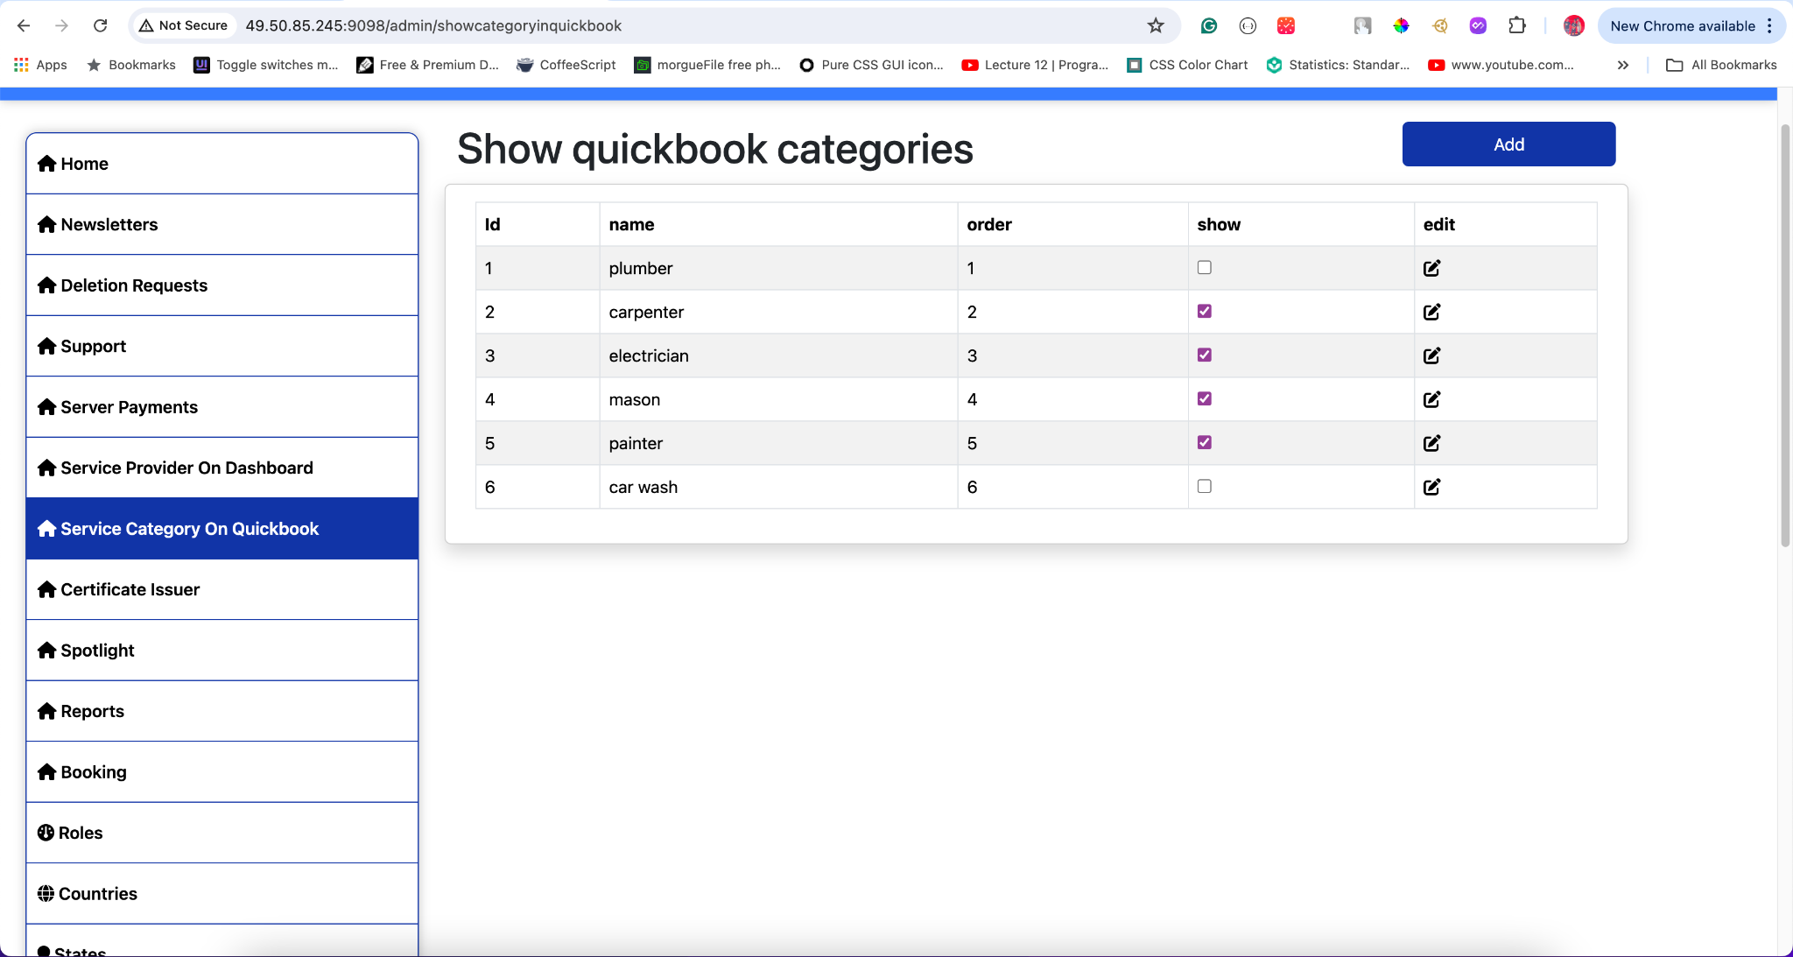

**Edit Service Categories**

* Interface for editing service category details.
* 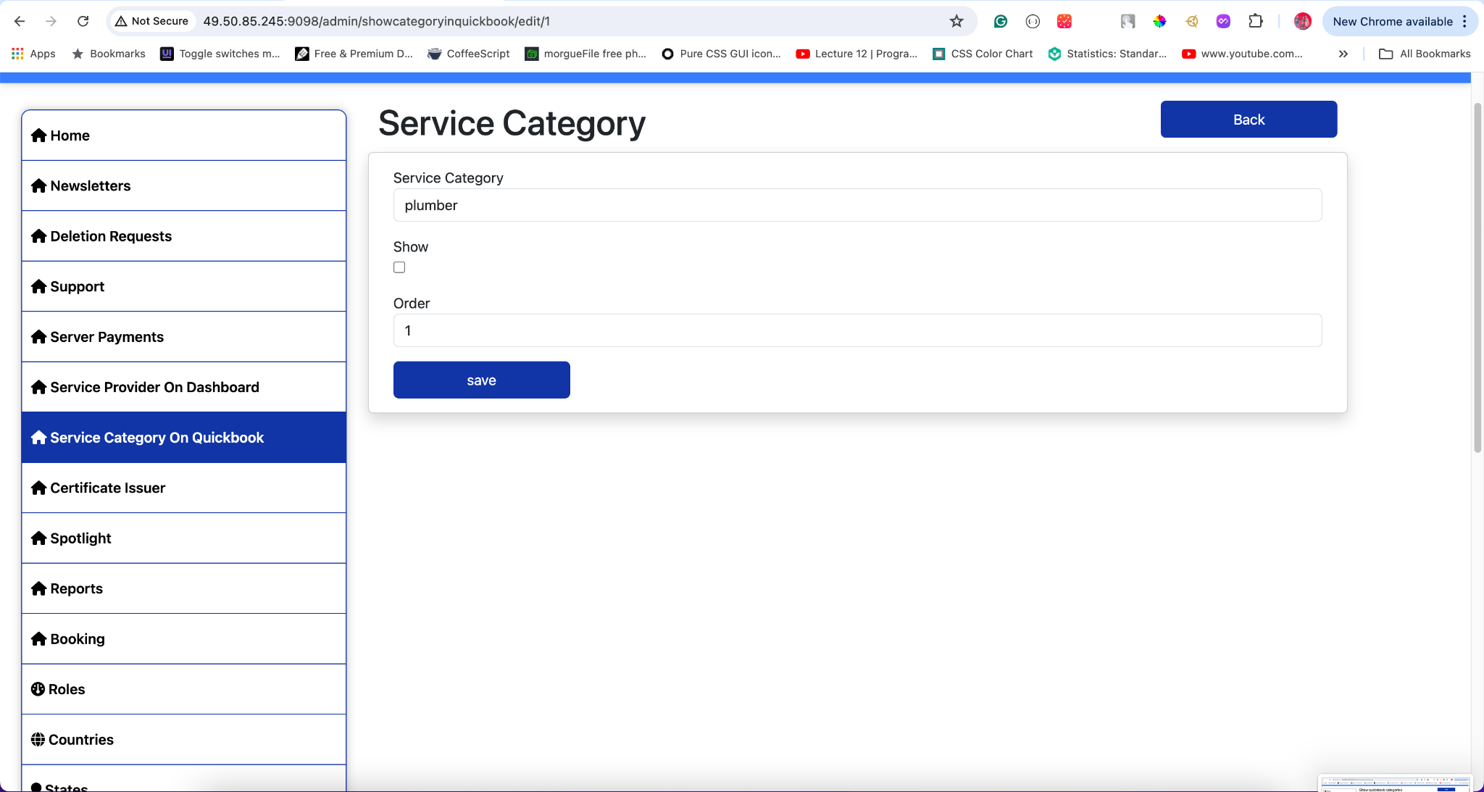

**QuickBooks Integration View**

* Interface for syncing service categories and financial data with QuickBooks.
* 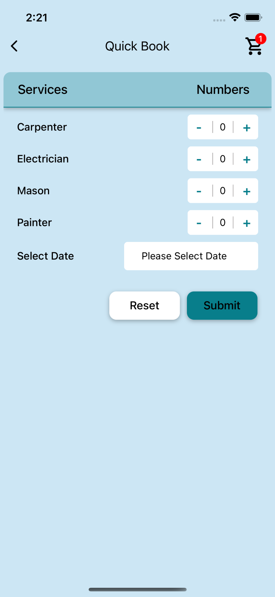

## **9. Certificate Issuers**

Efficient management of certificate issuers ensures that service providers can add relevant certifications to their profiles, enhancing their credibility and service quality.

#### **View Certificate Issuers**

To view and manage certificate issuer details:

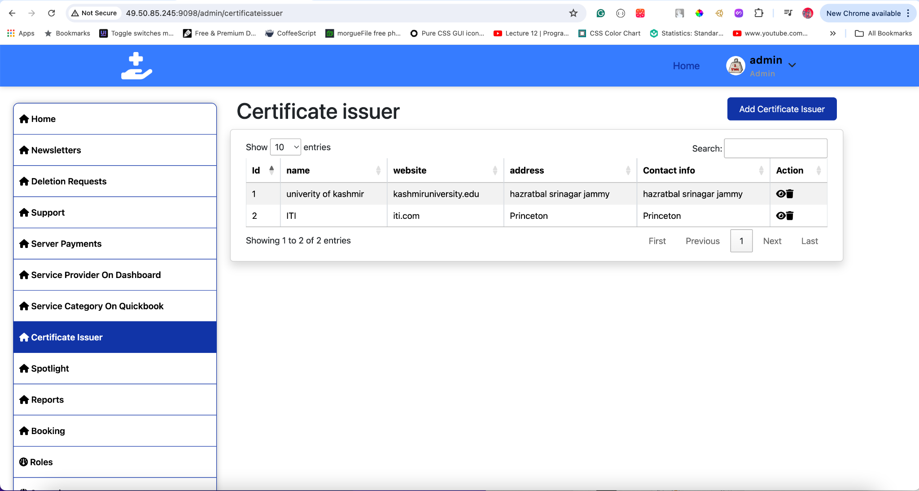

1. **Click Certificate Issuers** in the sidebar.
2. Review issuer information including:
   * **Issuer Name:** The name of the certification issuing authority.
   * **Contact Details:** Phone number, email, and address of the issuer.
   * **Certificates Issued:** List of certificates the issuer provides.

**Tips:**

* Use the search bar and filters to quickly find specific issuers.
* Ensure contact details are accurate for future correspondence.

#### **Add New Issuer**

To add a new certification issuer:

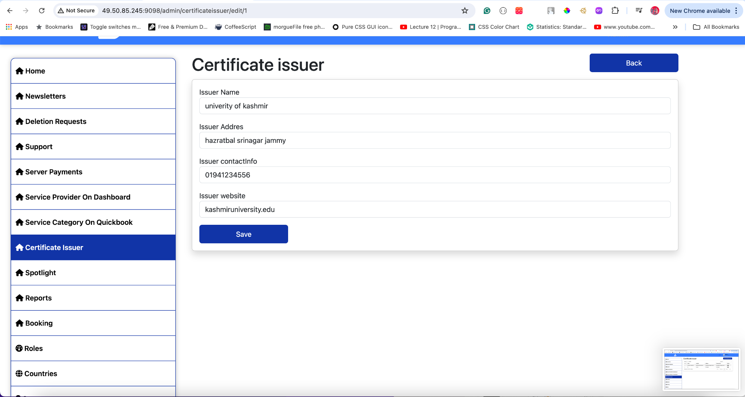

1. **Click Add New Issuer**.
2. Enter the following details:
   * **Issuer Name**
   * **Contact Details** (Phone number, email, address)
   * **Certificates Issued**
3. **Save** the new issuer information.

**Tips:**

* Double-check the entered details before saving to avoid errors.
* Ensure the issuer is recognized and reputable.

#### **Update Issuer Information**

To update existing issuer details:



1. **Select the issuer** from the list.
2. **Click Edit**.
3. Make necessary changes such as:
   * Updating contact details
   * Adding or removing certificates issued
4. **Save Changes**.

**Tips:**

* Regularly review issuer details to ensure they are up-to-date.
* Notify the issuer of any changes made to their information.

### **Visual Guide**

#### **Certificate Issuers Interface**

**Certificate Issuers View**

* Displays a list of certificate issuers with options to edit or add new issuers.
* 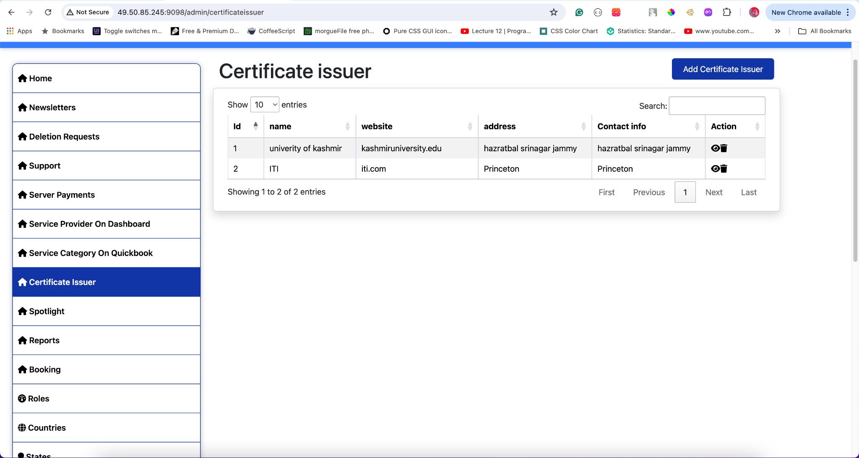

**Add New Issuer**

* Interface for adding new certificate issuers.
* 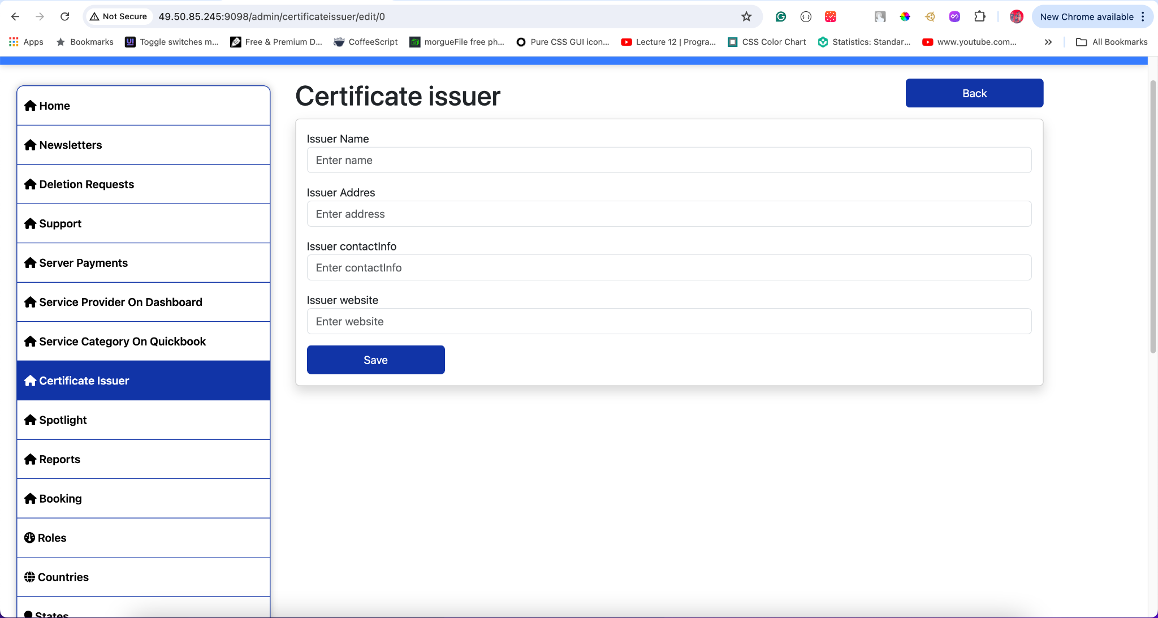

**Edit Issuer Information**

* Interface for updating existing certificate issuer details.
* 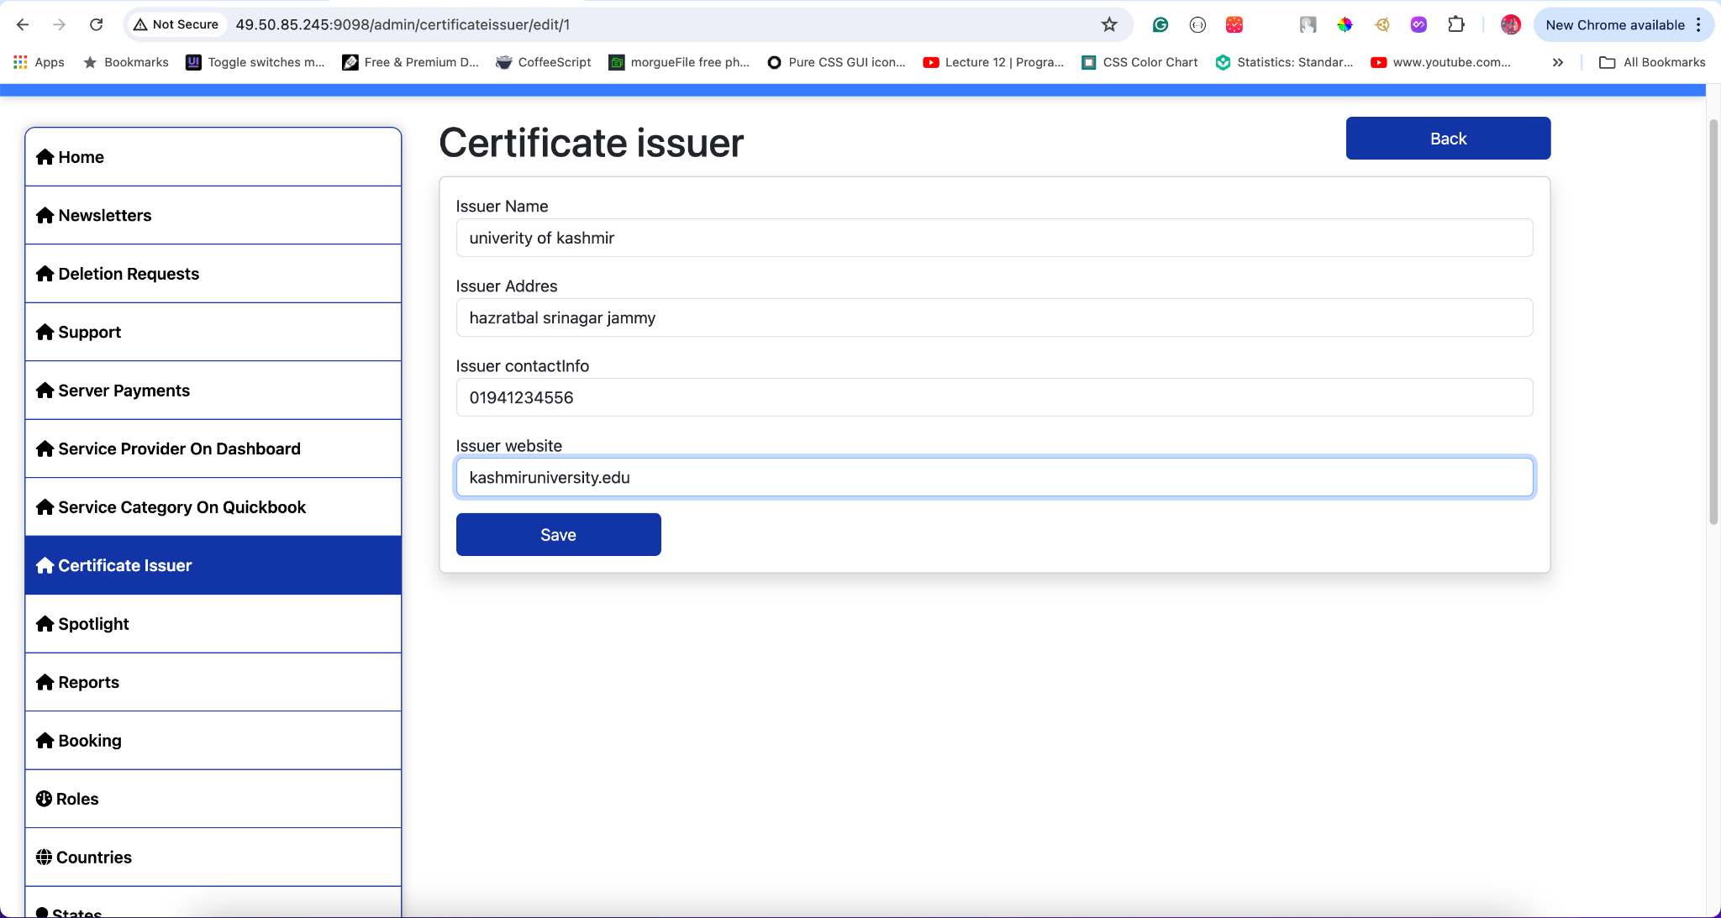

## **10. Spotlights**

The Spotlight section allows you to manage promotional content, ensuring that relevant and engaging spotlight items are displayed on the app. Here's how you can view, edit, delete, and add spotlight items:

#### **View All Spotlight Items**

To view all spotlight items:

1. **Click Spotlight** in the sidebar.
2. You will see a list of all spotlight items including:
   * **Title**
   * **Subtitle**
   * **Button Text**
   * **Description**
   * **URL**
   * **Start Date**
   * **End Date**
   * **Background Image**
   * **Clicks**
   * **Impressions**
   * **Priority**

**Tips:**

* Use the search bar and filters to quickly find specific spotlight items.
* Monitor the clicks and impressions to assess the performance of each spotlight item.

#### **Edit Spotlight Item**

To edit an existing spotlight item:

1. **Select the spotlight item** you want to edit from the list.
2. **Click Edit**.
3. Update the necessary fields such as:
   * **Title**
   * **Subtitle**
   * **Button Text**
   * **Description**
   * **URL**
   * **Start Date**
   * **End Date**
   * **Background Image**
   * **Clicks**
   * **Impressions**
   * **Priority**
4. **Save Changes**.

**Tips:**

* Ensure the updated information is accurate and relevant.
* Regularly update spotlight items to keep the content fresh and engaging.

#### **Delete Spotlight Item**

To delete a spotlight item:

1. **Select the spotlight item** you want to delete from the list.
2. **Click Delete**.
3. Confirm the deletion.

**Tips:**

* Only delete spotlight items that are no longer relevant or needed.
* Consider archiving items before deletion if you might need them later.

#### **Add New Spotlight Item**

To add a new spotlight item:

1. **Click Add**.
2. Fill in the following details:
   * **Title**: The main title of the spotlight item.
   * **Subtitle**: A brief subtitle providing additional context.
   * **Button Text**: The text that will appear on the call-to-action button.
   * **Description**: A detailed description of the spotlight item.
   * **URL**: A link to more information or the relevant page.
   * **Start Date**: The date when the spotlight item should start appearing.
   * **End Date**: The date when the spotlight item should stop appearing.
   * **Background Image**: An image that will serve as the background for the spotlight item.
   * **Clicks**: The number of times the spotlight item has been clicked.
   * **Impressions**: The number of times the spotlight item has been viewed.
   * **Priority**: The importance level of the spotlight item, affecting its display order.
3. **Save** the new spotlight item.

**Tips:**

* Use high-quality images for the background to make the spotlight item visually appealing.
* Set realistic start and end dates to ensure the spotlight item is relevant.
* Regularly review and update the content to keep it engaging for users.

### **Visual Guide**

#### **Spotlight Items Interface**

**View All Spotlight Items**

* Displays a list of all spotlight items with options to edit or delete each item.\
* \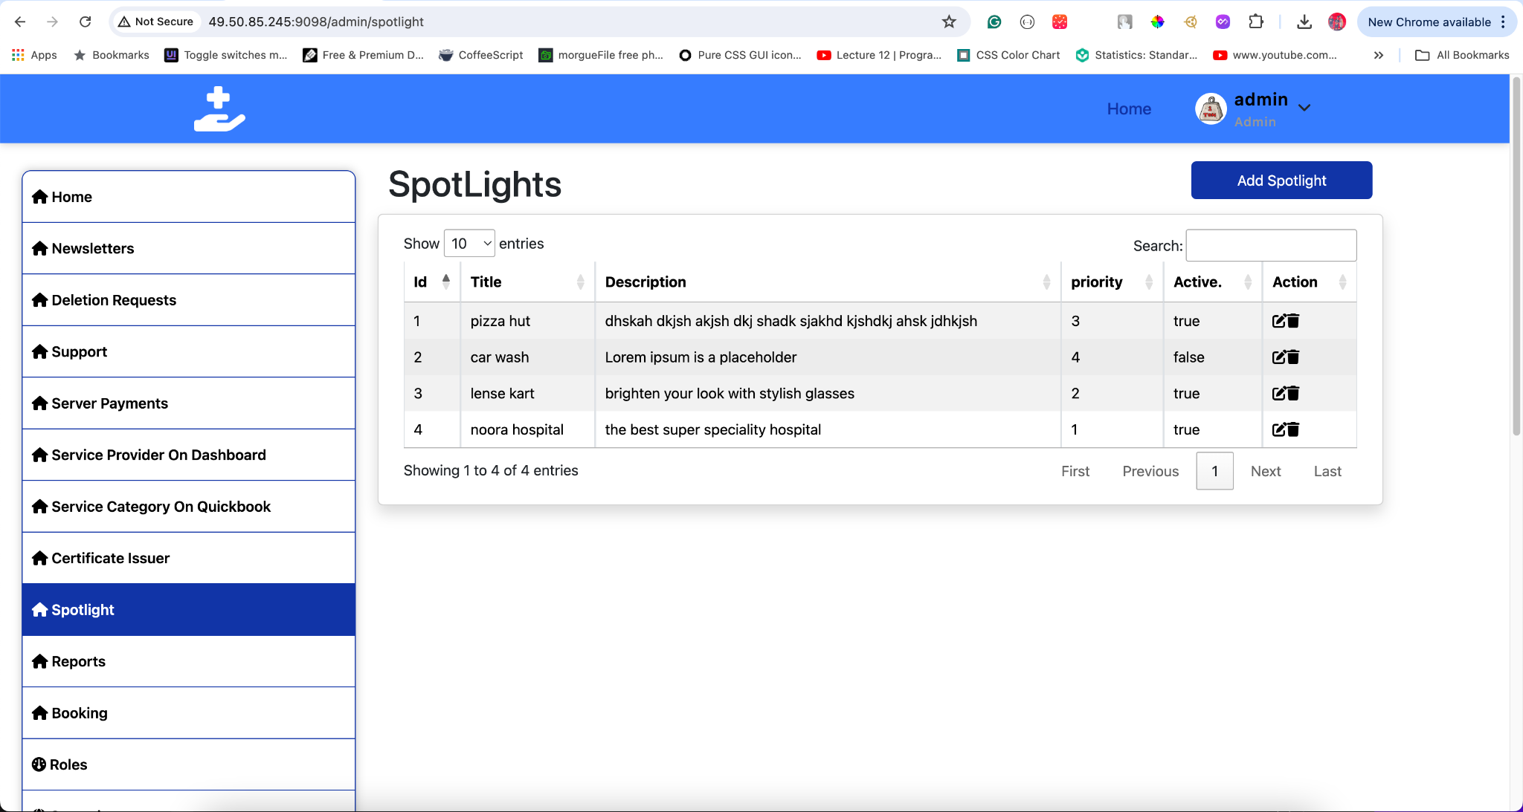

**Add New Spotlight Item**

* Interface for adding a new spotlight item with fields for title, subtitle, button text, description, URL, start and end dates, background image, clicks, impressions, and priority.
* 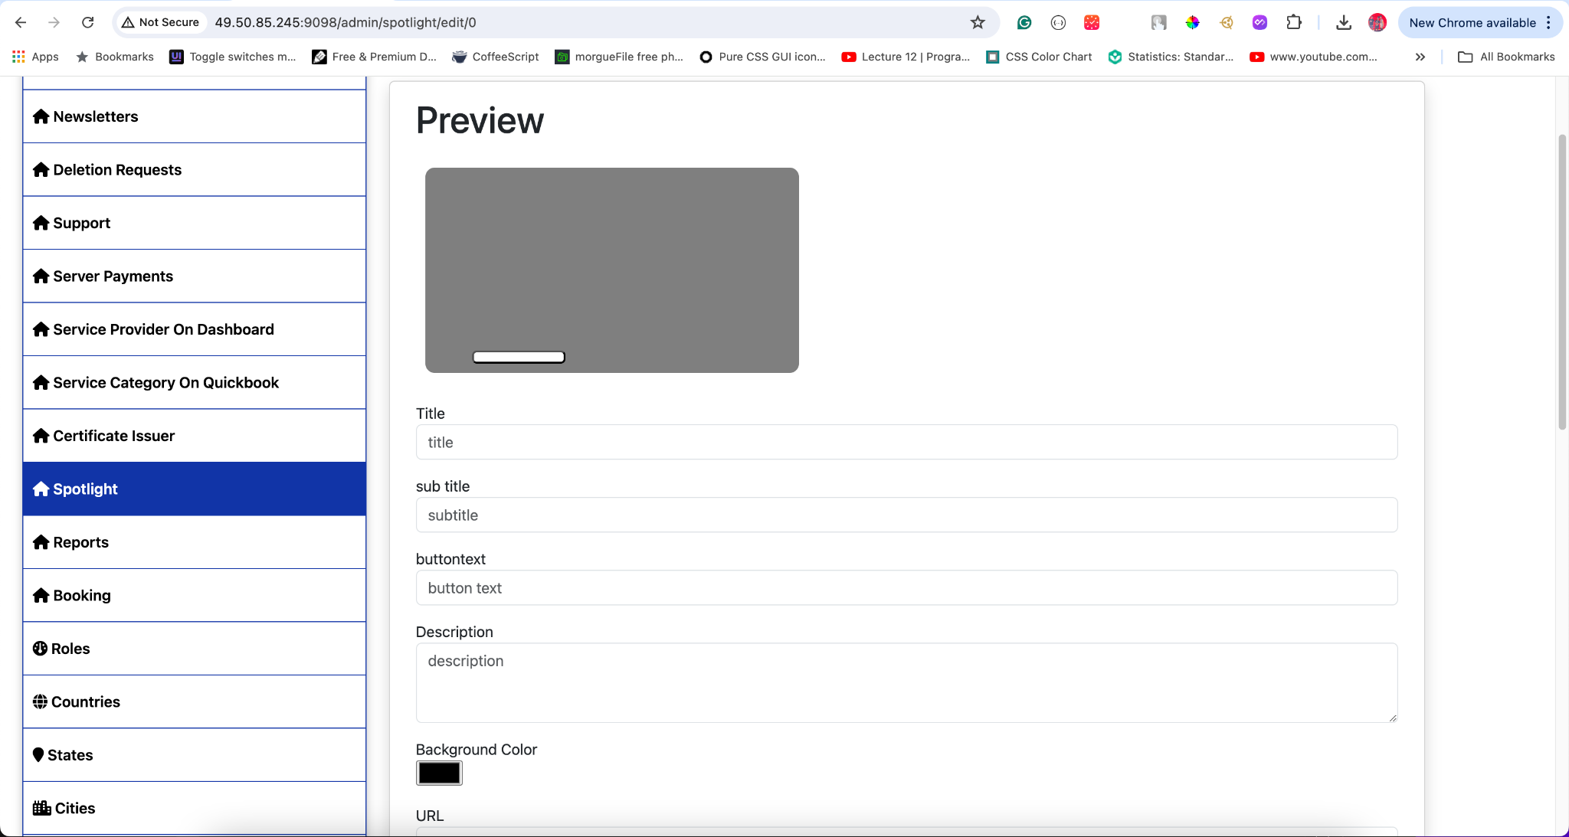

**Edit Spotlight Item**

* Interface for updating existing spotlight items.
* 

This section ensures that you can effectively manage spotlight items, keeping the app's promotional content updated and engaging. Regular updates and monitoring of clicks and impressions help in assessing the performance and relevance of each spotlight item.

## **11. Reports**

The Reports section allows administrators to manage and review reports received against service providers. It provides functionalities for viewing, and managing the status and responses of these reports.

#### **View Reports**

To access and review various reports:

1. **Click Reports** in the sidebar.
2. You will see a list of all available reports, which can be filtered by:
   * **Type**: Different categories of reports.
   * **Date**: Specific time periods for which the reports were filed.

**Tips:**

* Use the search bar and filters to quickly find specific reports.
* Regularly review reports to ensure timely action and resolution.

#### **Manage Report Status**

Reports can have their statuses changed to reflect the current state of the issue reported against the service provider.

To change the status of a report:

1. **Select the report** you want to update from the list.
2. **Click Change Status**.
3. Choose the appropriate status from the available options (e.g., Pending, In Progress, Resolved).
4. **Save Changes**.

**Tips:**

* Update the status regularly to keep track of the progress and resolution of each report.
* Ensure that status changes are communicated to relevant parties.

#### **Respond to Reports**

Responses can be added to reports to show the user the progress and actions taken against the service provider.

To add a response to a report:

1. **Select the report** you want to respond to.
2. **Click Add Response**.
3. Enter the response details, outlining the actions taken and the current status.
4. **Save Response**.

**Tips:**

* Provide clear and detailed responses to keep users informed about the progress.
* Use the response history to track all communications and actions taken.

### **Visual Guide**

#### **Reports Interface**

**View Reports**

* Displays a list of all reports with options to filter by type and date.
* 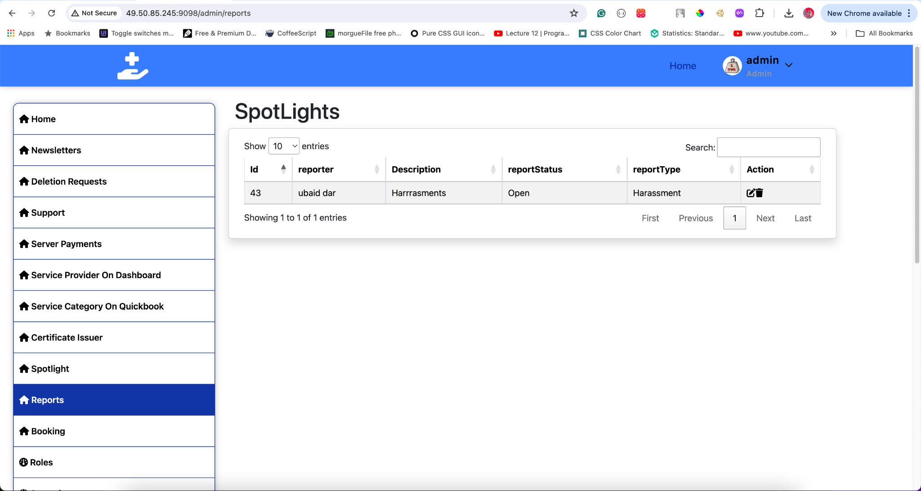

**Change Report Status**

* Interface for updating the status of a report.
* 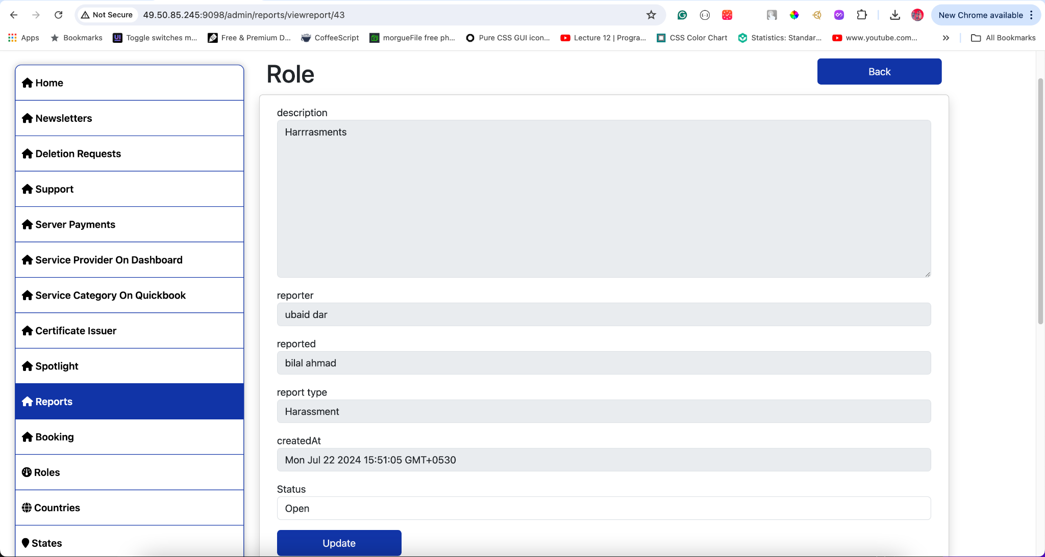

**Respond to Report**

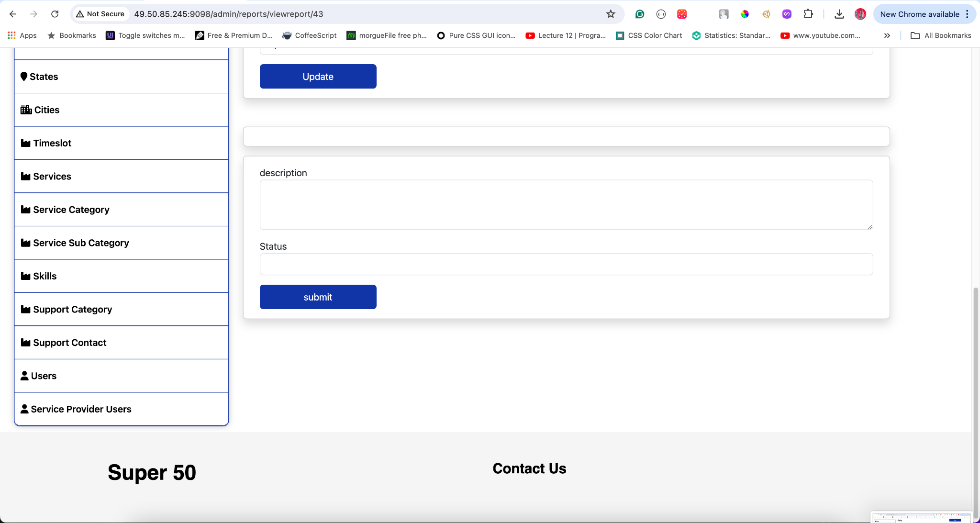

This section ensures that administrators can effectively manage reports against service providers, keeping track of progress and resolutions. Regular updates and clear responses help maintain transparency and trust with users.

## **12. Bookings**

**View Bookings** To manage and review all bookings:

* **Access Bookings**
  + Navigate to the Bookings section in the sidebar.
  + A list of all bookings will be displayed, showing:
    - Booking ID
    - Name
    - Date
    - Address
    - Phone
    - Duration
    - Payment Status
    - User
    - Provider
    - Action (View Details)

**Booking Details** Each booking entry includes detailed information:

* **Booking ID**: The unique identifier for the booking.
* **Name**: The name of the person who made the booking.
* **Date**: The date and time of the booking.
* **Address**: The location where the service is to be provided.
* **Phone**: The contact number of the person who made the booking.
* **Duration**: The length of time for the booked service (e.g., 2 hours, full day).
* **Payment Status**: The status of the payment (e.g., full, partial).
* **User**: The user who booked the service.
* **Provider**: The service provider assigned to the booking.
* **Action**: An icon to view more details about the booking.

**View Booking Details** To view more details about a booking:

* Click the eye icon under the Action column.
* This will open a detailed view of the booking, showing all relevant information and allowing for further actions if needed.
* 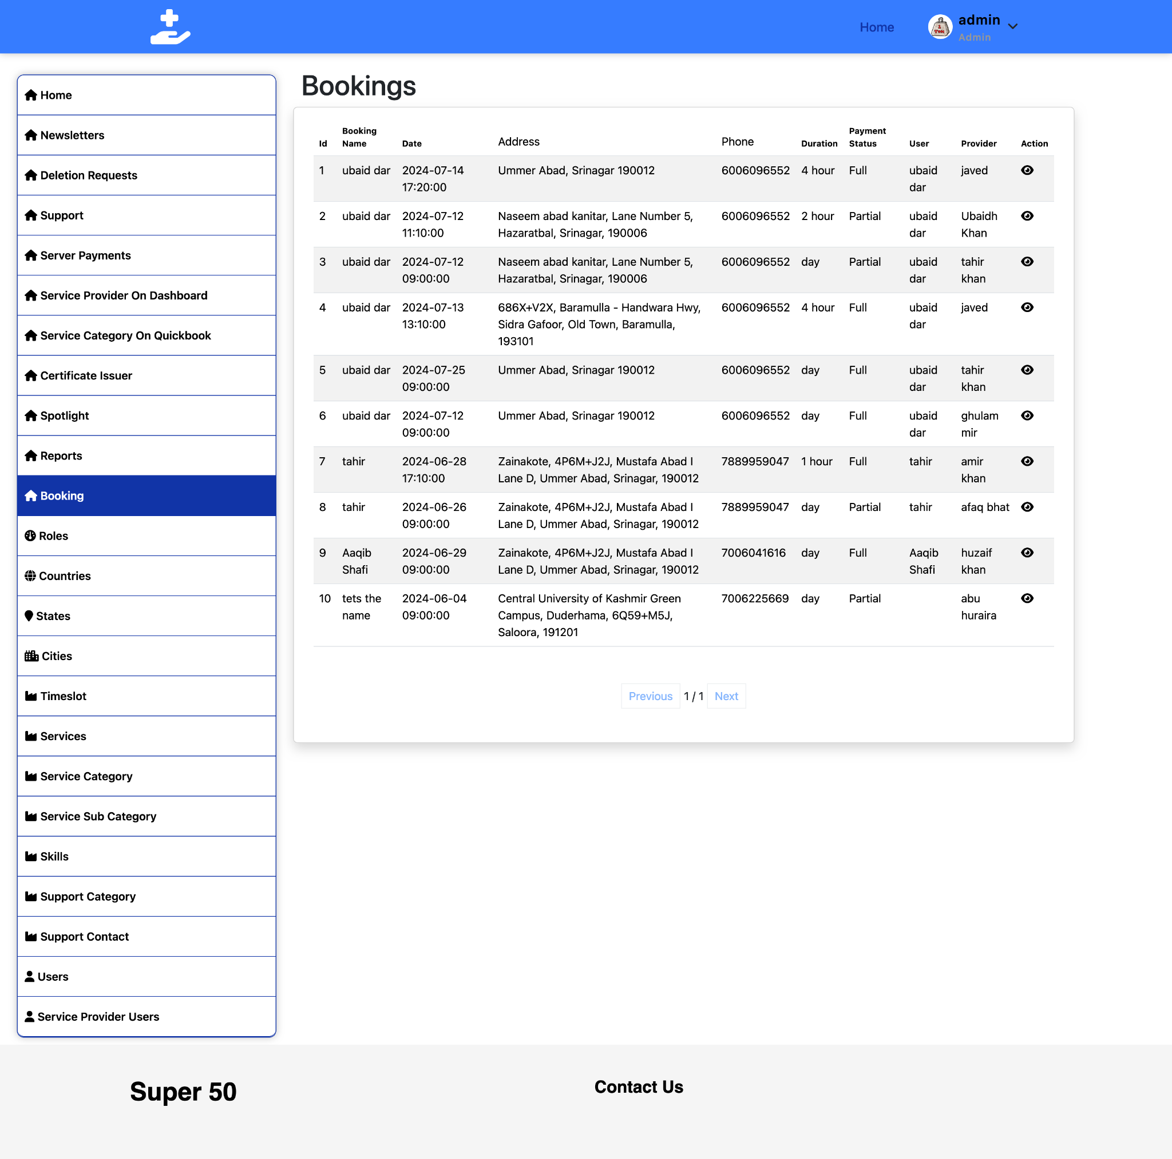

**Manage Bookings** Admins can manage bookings by:

* Reviewing all bookings in the list.
* Searching for specific bookings using the search bar.
* Filtering bookings based on different criteria.
* 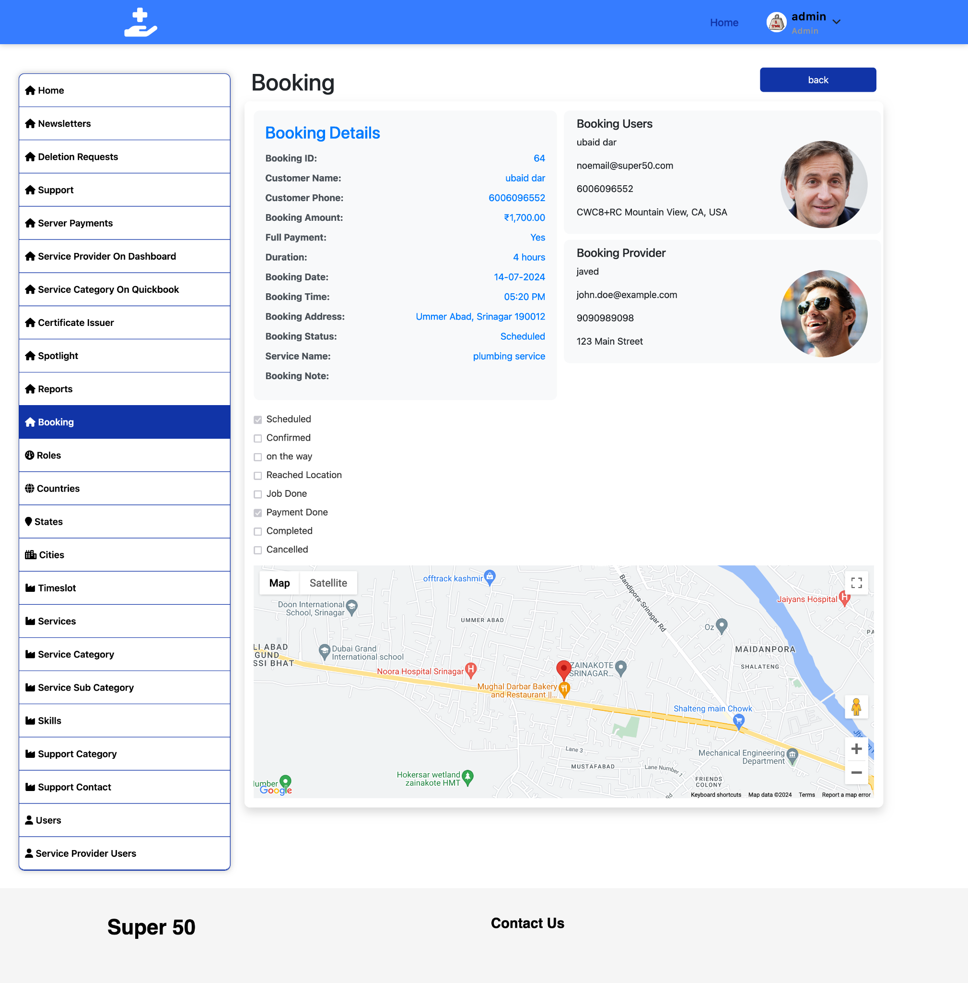

## **13. Roles**

The Roles section allows administrators to manage user roles within the application and website. This includes adding, updating, editing, and deleting roles to ensure proper access control and user management.

#### **View Roles**

To view existing roles:

1. **Click Roles** in the sidebar.
2. A list of all roles will be displayed, showing:
   * Role Name

#### **Add New Role**

To add a new role:

1. **Click Add New Role**.
2. Enter the following details:
   * **Role Name**: The name of the role (e.g., Admin, Editor, Viewer).
3. **Save** the new role.

**Tips:**

* Clearly define the role name and description for easy identification.
* Assign appropriate permissions to ensure users have the necessary access without over-privileging.

#### **Edit Role**

To edit an existing role:

1. **Select the role** you want to edit from the list.
2. **Click Edit Role**.
3. **Save Changes**.

**Tips:**

* Ensure that any changes to roles are communicated to affected users.
* Regularly review roles to ensure they still meet organizational needs.

#### **Delete Role**

To delete an existing role:

1. **Select the role** you want to delete from the list.
2. **Click Delete Role**.
3. Confirm the deletion.

**Tips:**

* Be cautious when deleting roles to avoid disrupting user access.
* Ensure there are no users currently assigned to the role being deleted.

### **Visual Guide**

#### **Roles Interface**

**View Roles**

* Displays a list of all roles with options to search and filter.
* 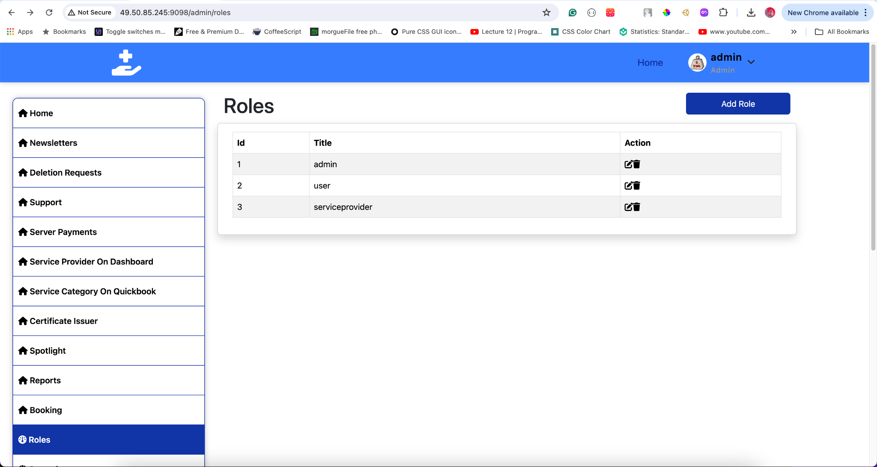

**Add New Role**

* Interface for adding a new role with fields for name, description, and permissions.
* 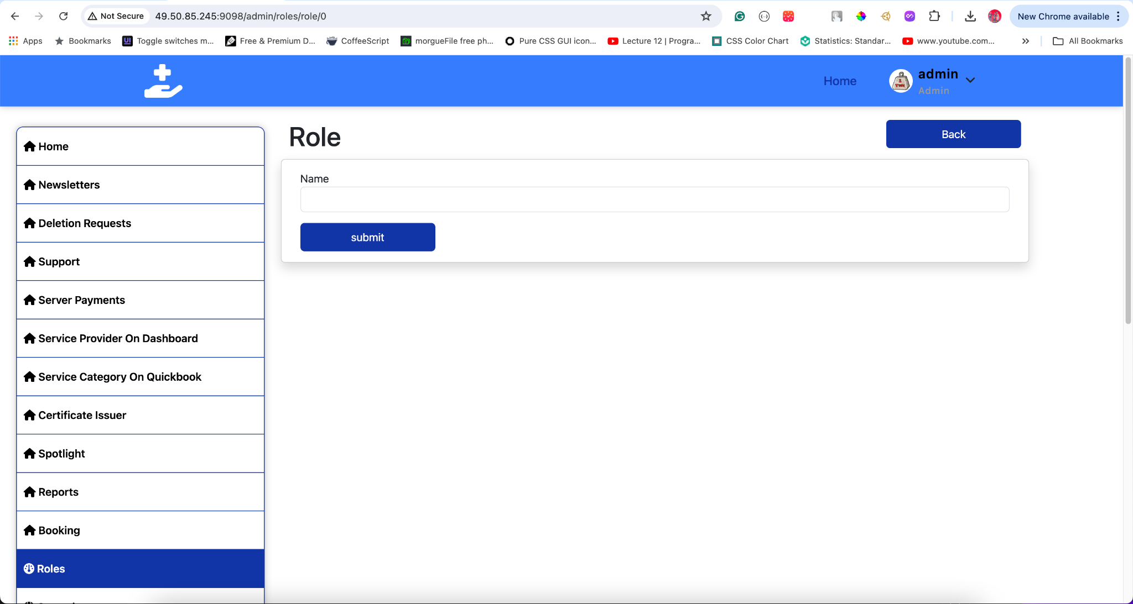

**Edit Role**

* Interface for editing an existing role's details and permissions.
* 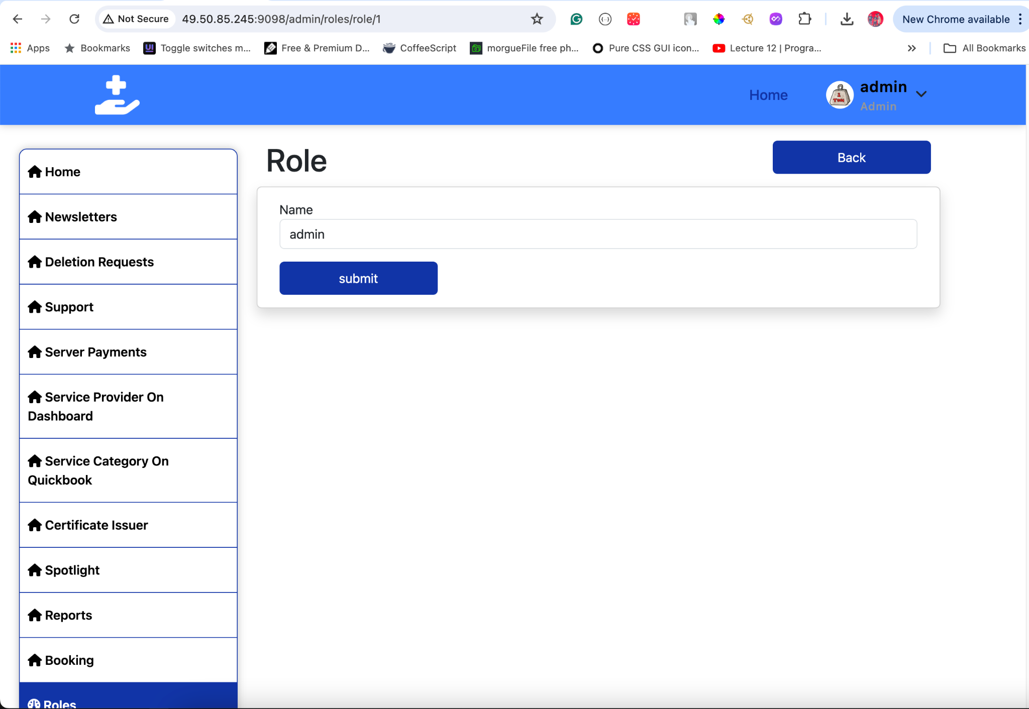

**Delete Role**

* Confirmation dialog for deleting a role.
* 

## **14. Countries**

#### **Overview**

The Country section allows administrators to manage country data within the application. This includes adding new countries, updating existing ones, viewing all countries, and deleting countries as needed.

#### **View Countries**

To view existing countries:

1. **Click** Countries in the sidebar.
2. **A list of all countries** will be displayed, showing:
   * **Country Name**: The name of the country.
   * **Country Code**: The official code or abbreviation for the country (if applicable).

**Tips:**

* Use the search and filter options to quickly locate a specific country.

#### **Add New Country**

To add a new country:

1. **Click** Add New Country.
2. **Enter the following details**:
   * **Country Name**: The name of the country (e.g., United States, Canada).
   * **Country Code**: The official code or abbreviation for the country (if applicable).
3. **Click** Save to create the new country entry.

**Tips:**

* Ensure the country name is spelled correctly and follows standard naming conventions.
* Include the country code if applicable to maintain consistency.

#### **Edit Country**

To edit an existing country:

1. **Select** the country you want to edit from the list.
2. **Click** Edit Country.
3. **Update** the details as needed:
   * **Country Name**
   * **Country Code**
4. **Click** Save Changes.

**Tips:**

* Confirm the accuracy of updated details to prevent errors.
* Communicate any significant changes to relevant users.

#### **Delete Country**

To delete an existing country:

1. **Select** the country you want to delete from the list.
2. **Click** Delete Country.
3. **Confirm** the deletion in the confirmation dialog.

**Tips:**

* Be cautious when deleting countries to avoid data inconsistencies.
* Ensure there are no dependencies or references to the country being deleted.

#### **Visual Guide**

* **Countries Interface**:
  + Displays a list of all countries with options to search and filter.
  + 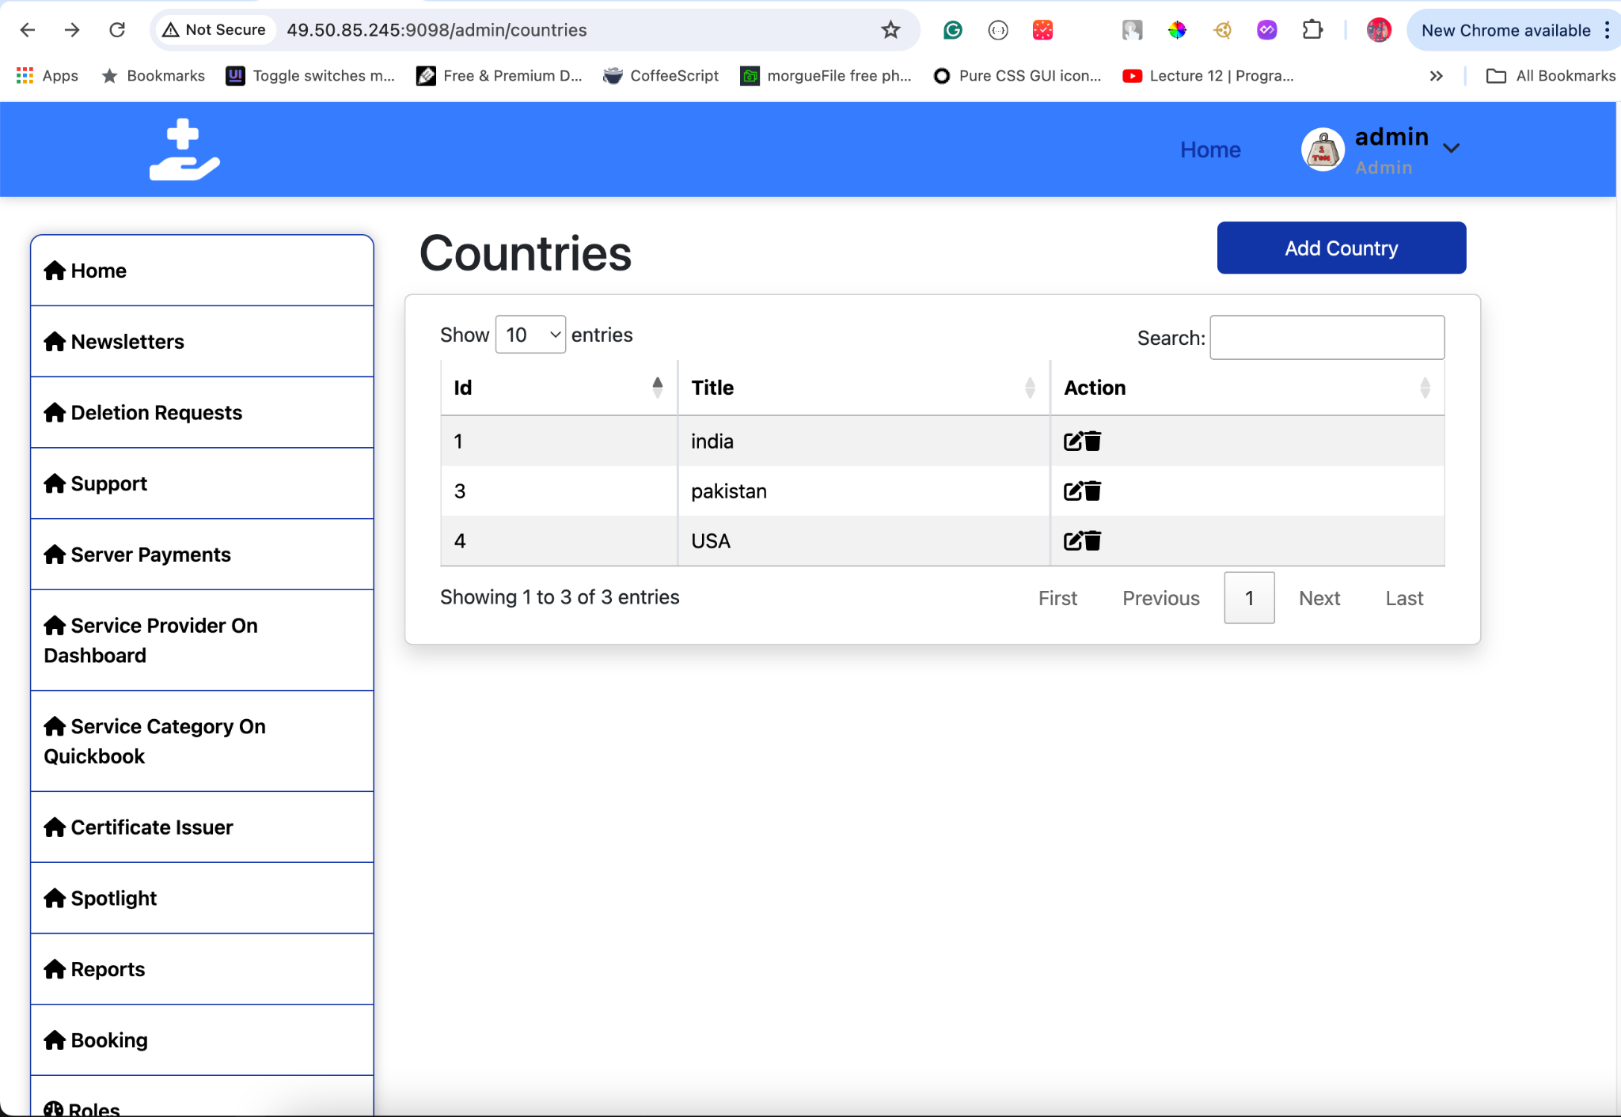
* **Add New Country**:
  + Interface for adding a new country with fields for name and code.
  + 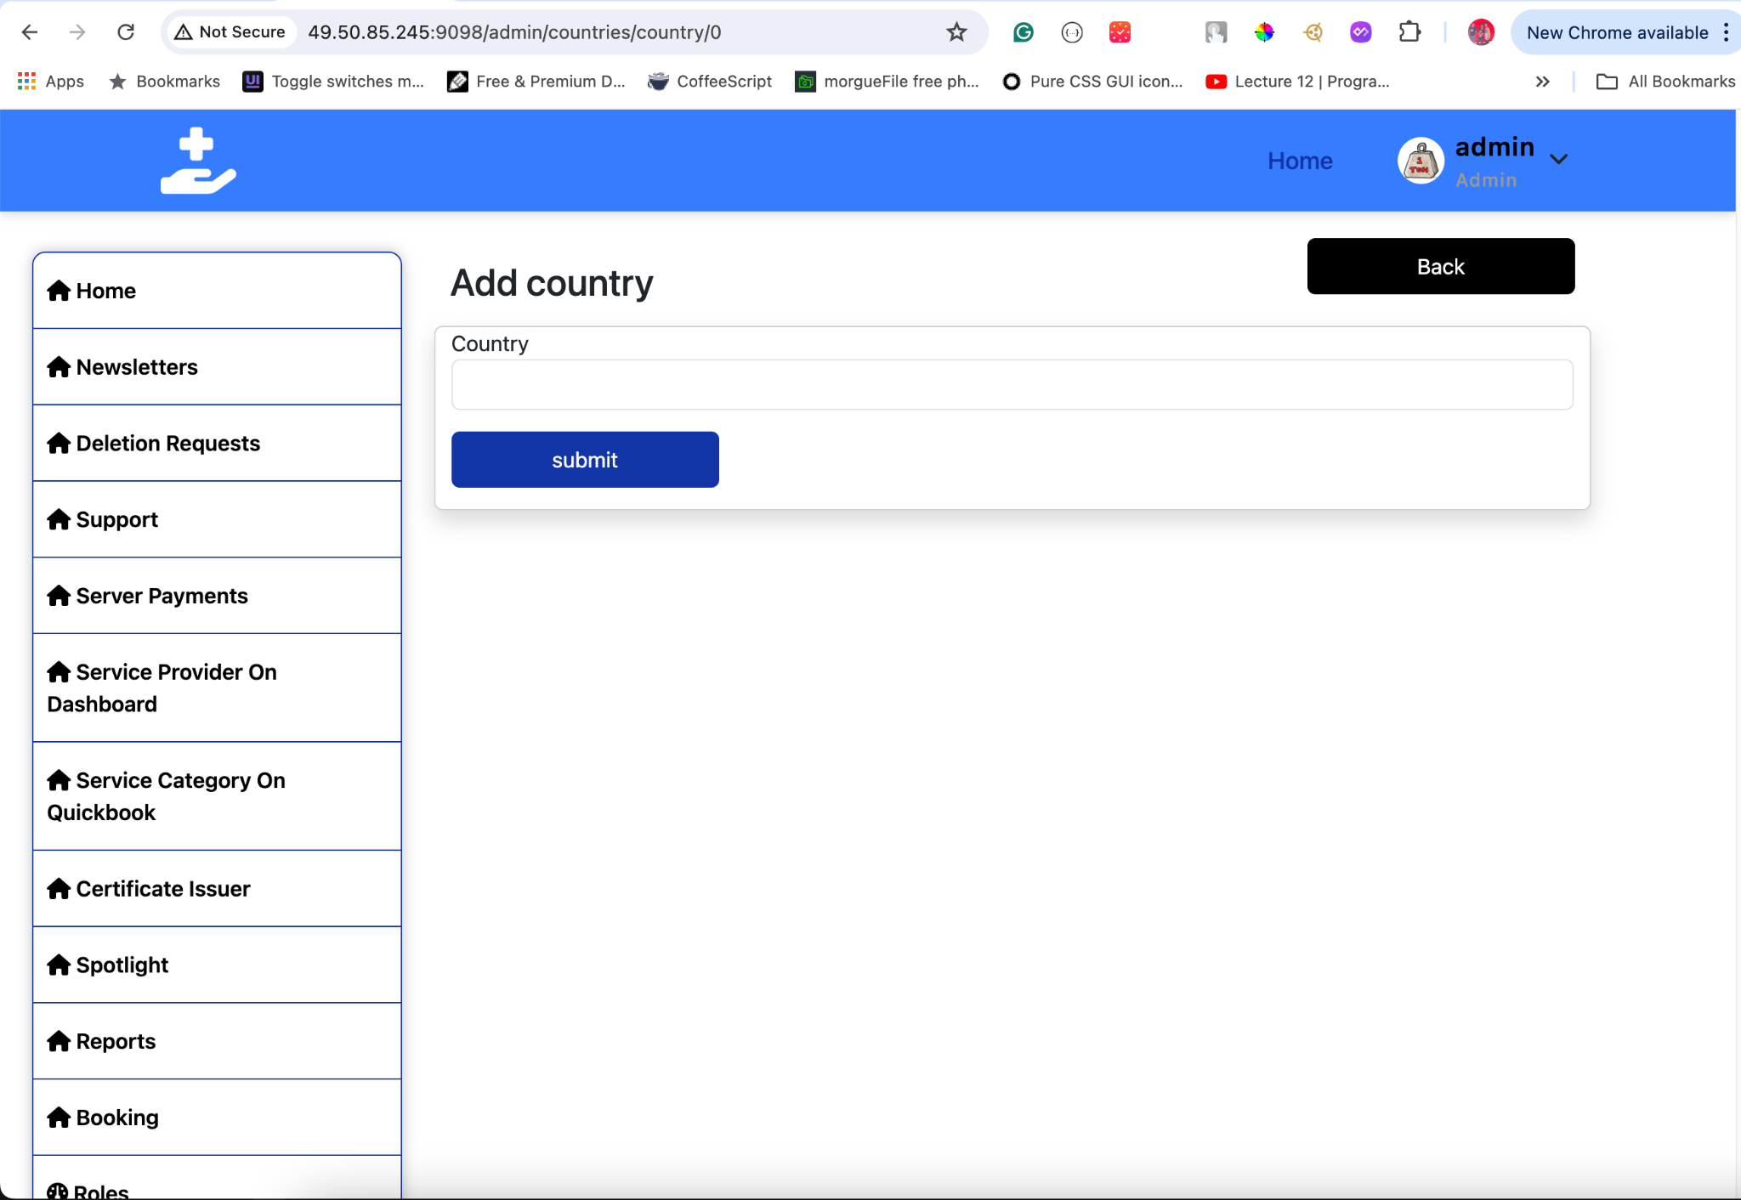
* **Edit Country**:
  + Interface for editing an existing country's details.
  + 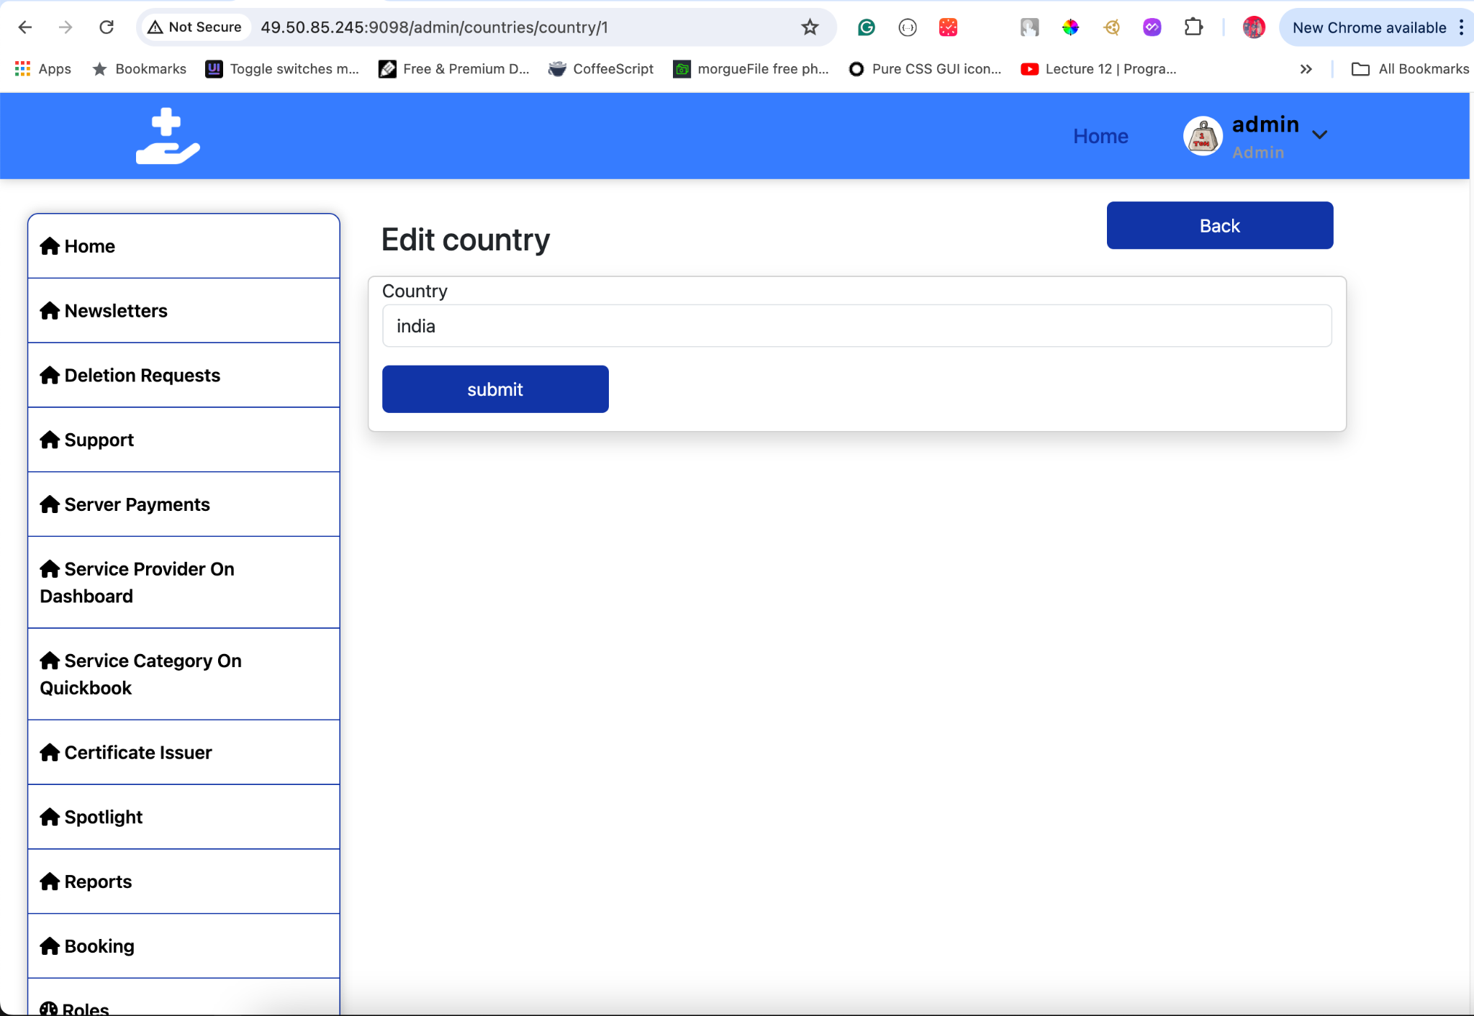
* **Delete Country**:
  + Confirmation dialog for deleting a country.
  + 

This format should provide a clear and user-friendly guide for managing country data in your application. If you need any additional details or sections, just let me know!

## **15. States**

#### **Overview**

The States section allows administrators to manage state data within the application. This includes viewing all states, adding new states, updating existing ones, and deleting states. States are linked to countries via a foreign key.

#### **View States**

To view existing states:

1. **Click** States in the sidebar.
2. **A list of all states** will be displayed, showing:
   * **State Name**: The name of the state.
   * **Country**: The country to which the state belongs.
   * **State Code**: The official code or abbreviation for the state (if applicable).

**Tips:**

* Use the search and filter options to quickly locate a specific state.

#### **Add New State**

To add a new state:

1. **Click** Add New State.
2. **Enter the following details**:
   * **State Name**: The name of the state (e.g., California, Ontario).
   * **Country**: Select the country to which the state belongs. This is a foreign key relationship, so ensure the correct country is chosen from a dropdown or selection list.
   * **State Code**: The official code or abbreviation for the state (if applicable).
3. **Click** Save to create the new state entry.

**Tips:**

* Ensure the state name is spelled correctly and follows standard naming conventions.
* Select the correct country from the dropdown to maintain data integrity.

#### **Edit State**

To edit an existing state:

1. **Select** the state you want to edit from the list.
2. **Click** Edit State.
3. **Update** the details as needed:
   * **State Name**
   * **Country**: If changing the country, select the new country from the dropdown.
   * **State Code**
4. **Click** Save Changes.

**Tips:**

* Confirm the accuracy of updated details and the correct country selection.
* Communicate any significant changes to relevant users.

#### **Delete State**

To delete an existing state:

1. **Select** the state you want to delete from the list.
2. **Click** Delete State.
3. **Confirm** the deletion in the confirmation dialog.

**Tips:**

* Be cautious when deleting states to avoid data inconsistencies.
* Ensure there are no dependencies or references to the state being deleted.

#### **Visual Guide**

* **States Interface**:
  + Displays a list of all states with options to search and filter.
  + 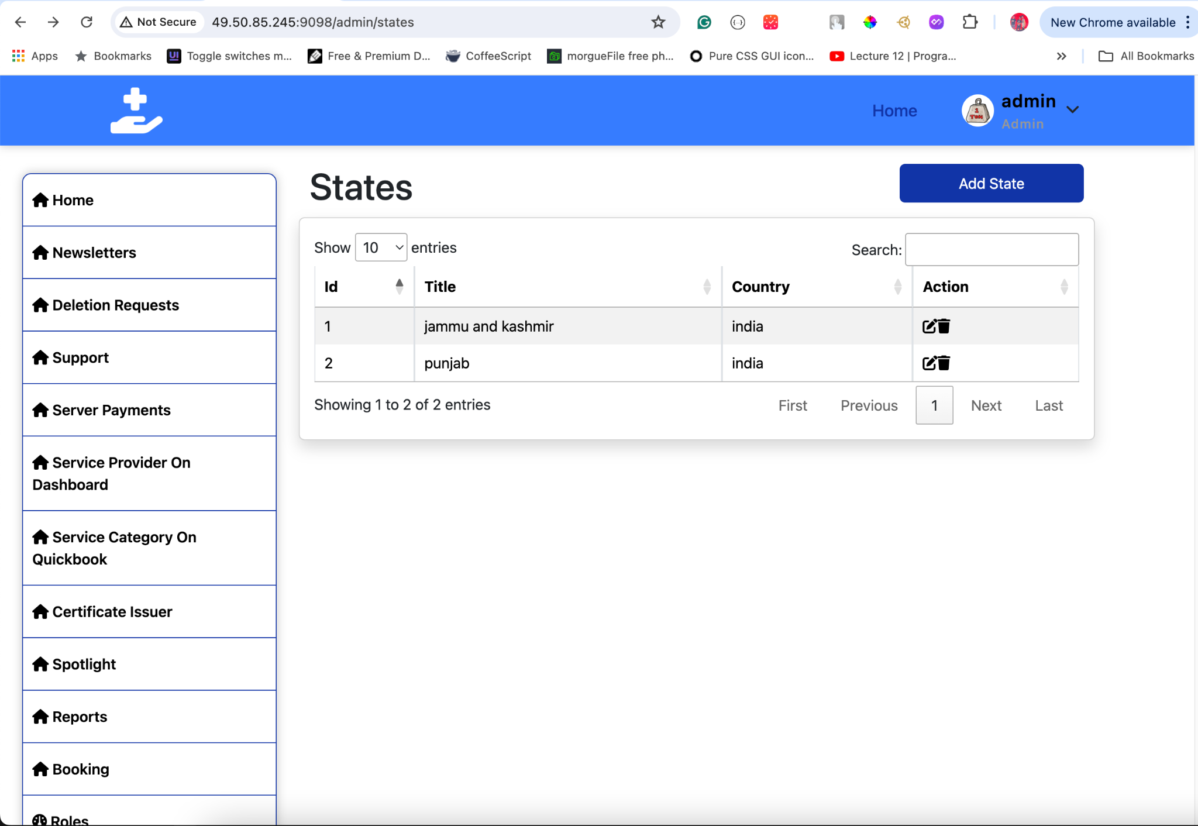
* **Add New State**:
  + Interface for adding a new state with fields for name, country (foreign key), and code.
  + 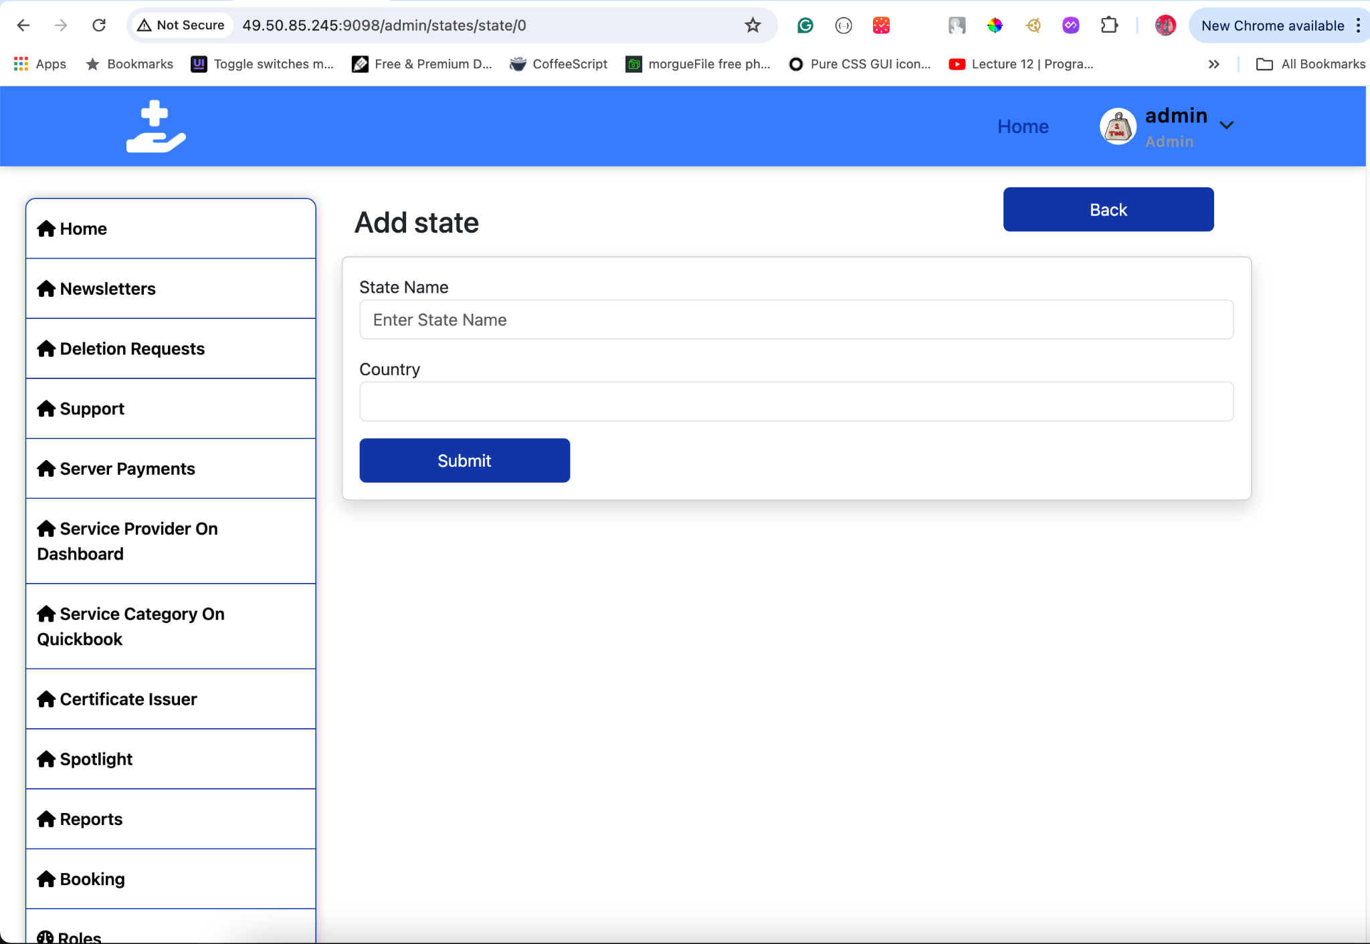
* **Edit State**:
  + Interface for editing an existing state's details and country association.
  + 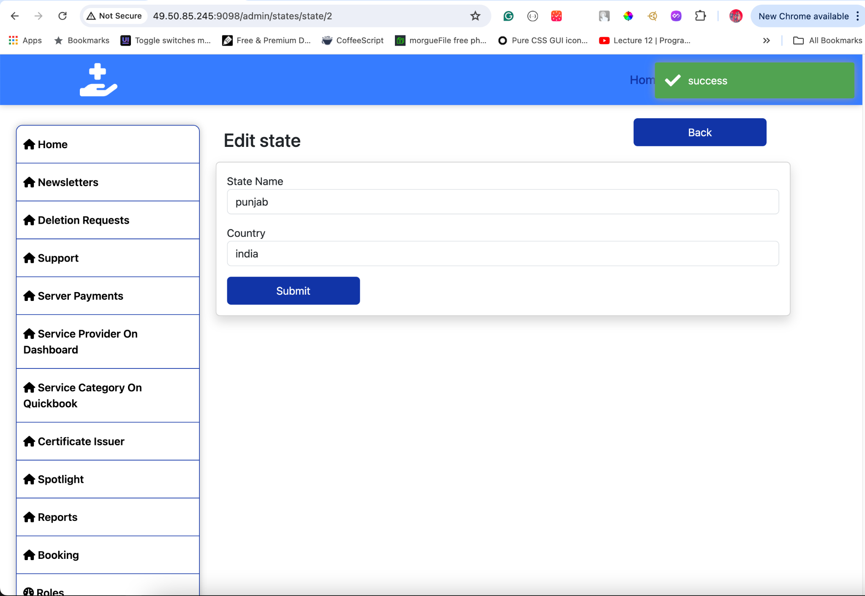
* **Delete State**:
  + Confirmation dialog for deleting a state.
  + 

This documentation should clearly explain how to manage state data, including the relationship with countries. If you need any more details or adjustments, let me know!

## **16. Cities**

#### **Overview**

The Cities section allows administrators to manage city data within the application. This includes viewing all cities, adding new cities, updating existing ones, and deleting cities. Cities are associated with both countries and states via foreign key relationships.

#### **View Cities**

To view existing cities:

1. **Click** Cities in the sidebar.
2. **A list of all cities** will be displayed, showing:
   * **City Name**: The name of the city.
   * **State**: The state to which the city belongs.
   * **Country**: The country to which the state (and thereby the city) belongs.
   * **City Code**: The official code or abbreviation for the city (if applicable).

**Tips:**

* Use the search and filter options to quickly locate a specific city.

#### **Add New City**

To add a new city:

1. **Click** Add New City.
2. **Enter the following details**:
   * **City Name**: The name of the city (e.g., New York, Toronto).
   * **State**: Select the state to which the city belongs from a dropdown or selection list. This state is associated with a specific country.
   * **Country**: Select the country to which the state belongs. This field might be auto-populated based on the selected state.
   * **City Code**: The official code or abbreviation for the city (if applicable).
3. **Click** Save to create the new city entry.

**Tips:**

* Ensure the city name is spelled correctly and follows standard naming conventions.
* Select the correct state and country to maintain data integrity.

#### **Edit City**

To edit an existing city:

1. **Select** the city you want to edit from the list.
2. **Click** Edit City.
3. **Update** the details as needed:
   * **City Name**
   * **State**: If changing the state, select the new state from the dropdown. The country should update automatically based on the selected state.
   * **Country**: This field might be auto-populated based on the selected state. Ensure the country is correct if editable.
   * **City Code**
4. **Click** Save Changes.

**Tips:**

* Confirm the accuracy of updated details and ensure the correct state and country are selected.
* Communicate any significant changes to relevant users.

#### **Delete City**

To delete an existing city:

1. **Select** the city you want to delete from the list.
2. **Click** Delete City.
3. **Confirm** the deletion in the confirmation dialog.

**Tips:**

* Be cautious when deleting cities to avoid data inconsistencies.
* Ensure there are no dependencies or references to the city being deleted.

#### **Visual Guide**

* **Cities Interface**:
  + Displays a list of all cities with options to search and filter.
  + 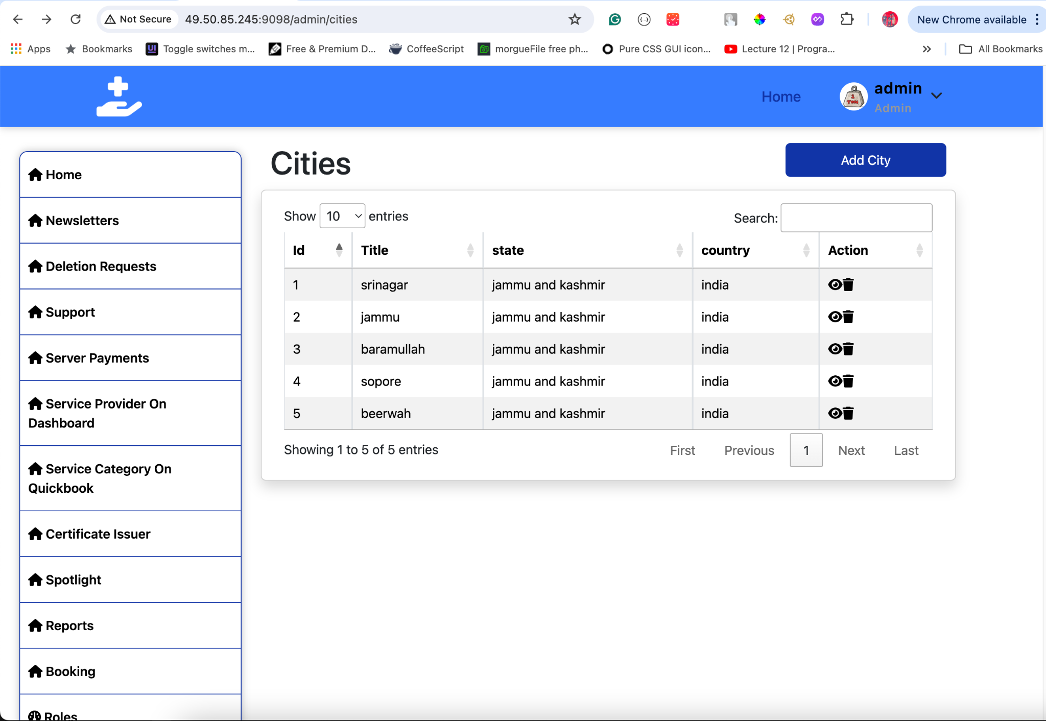
* **Add New City**:
  + Interface for adding a new city with fields for name, state (foreign key), country (foreign key), and code.
  + 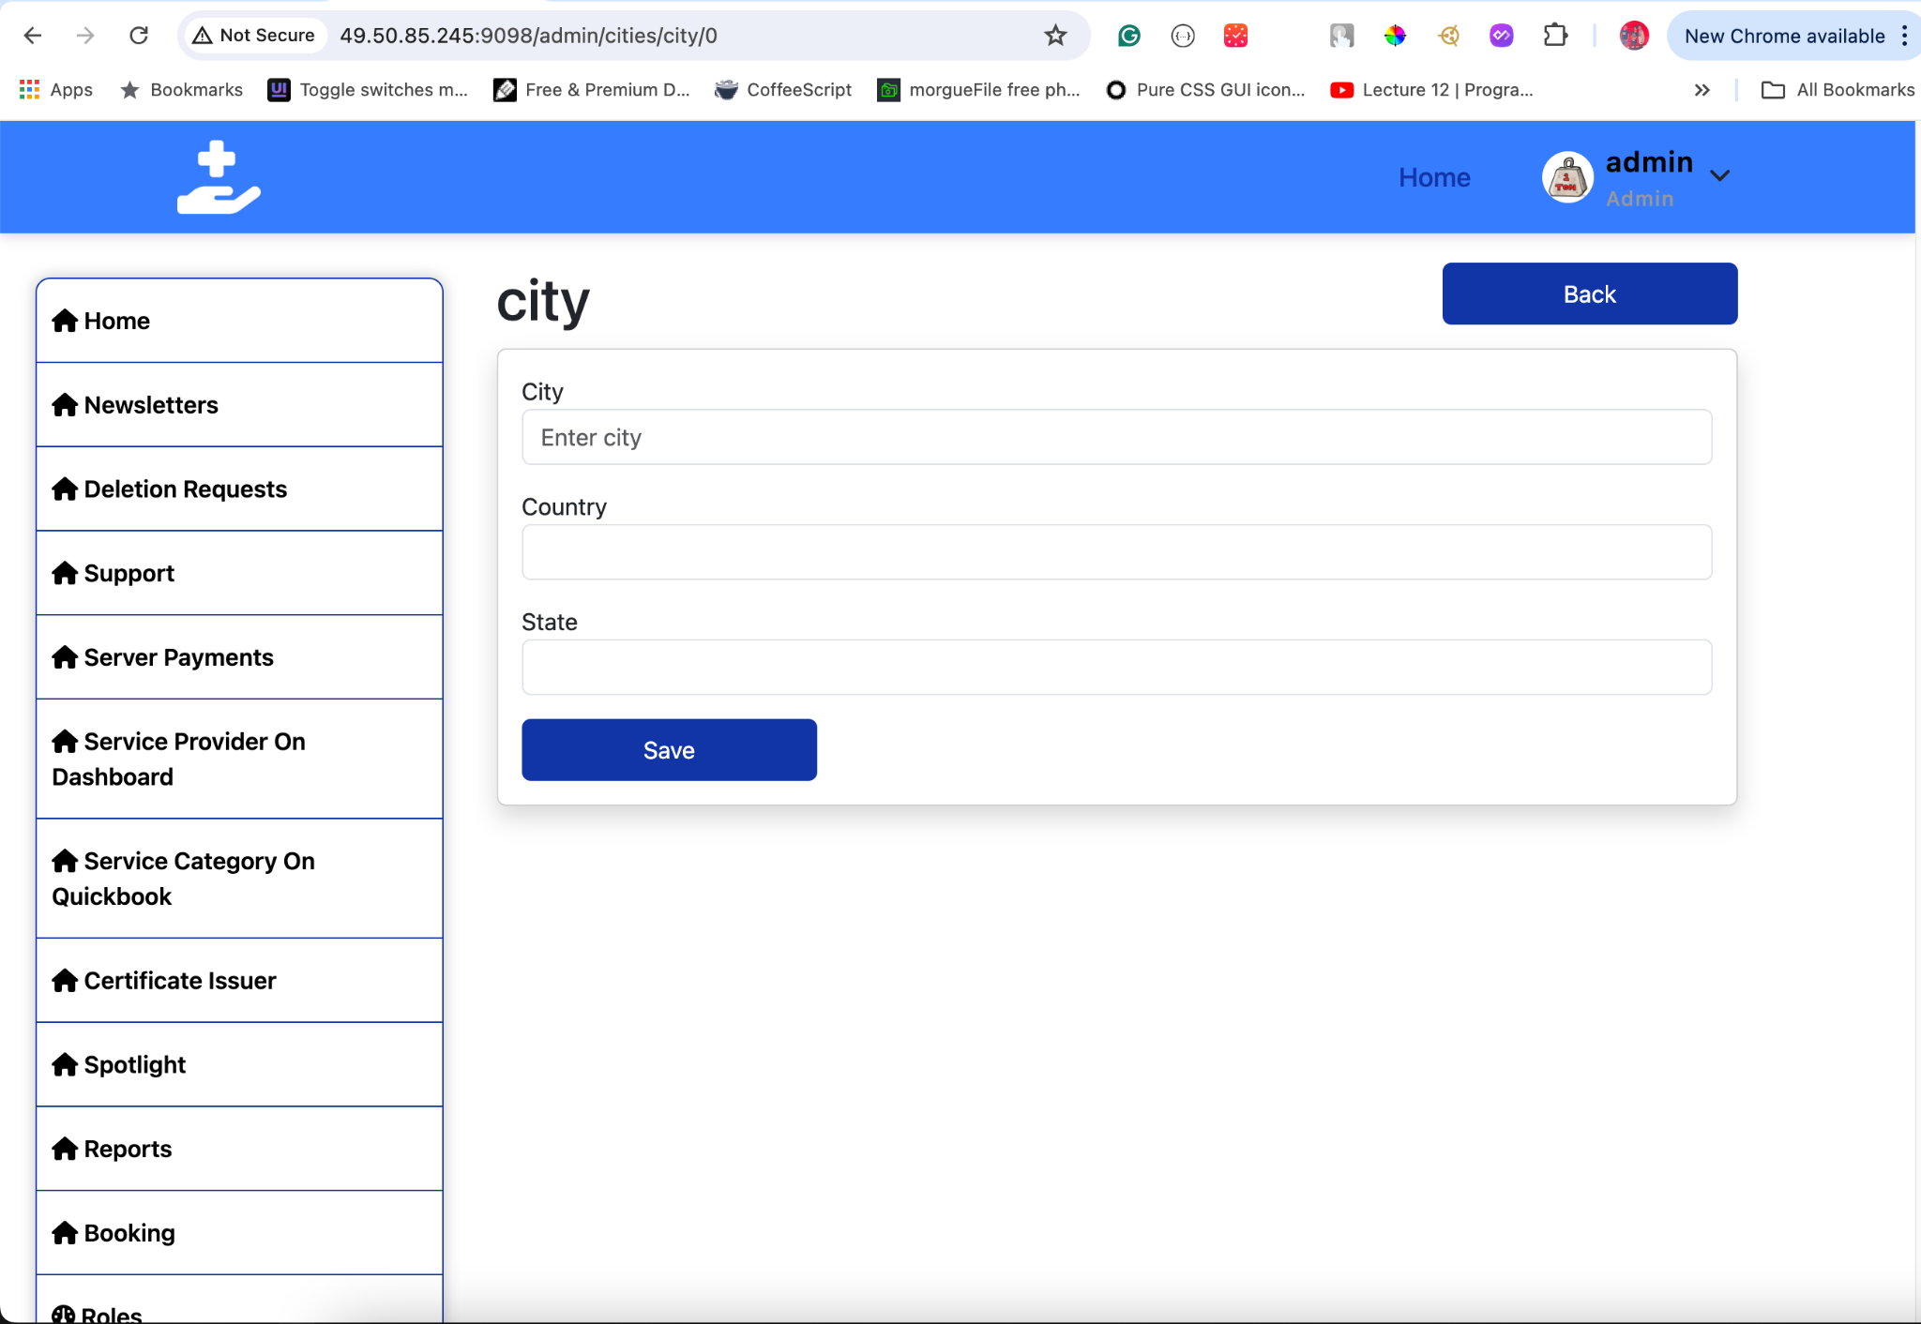
* **Edit City**:
  + Interface for editing an existing city’s details, including selecting or updating the state and country.
  + 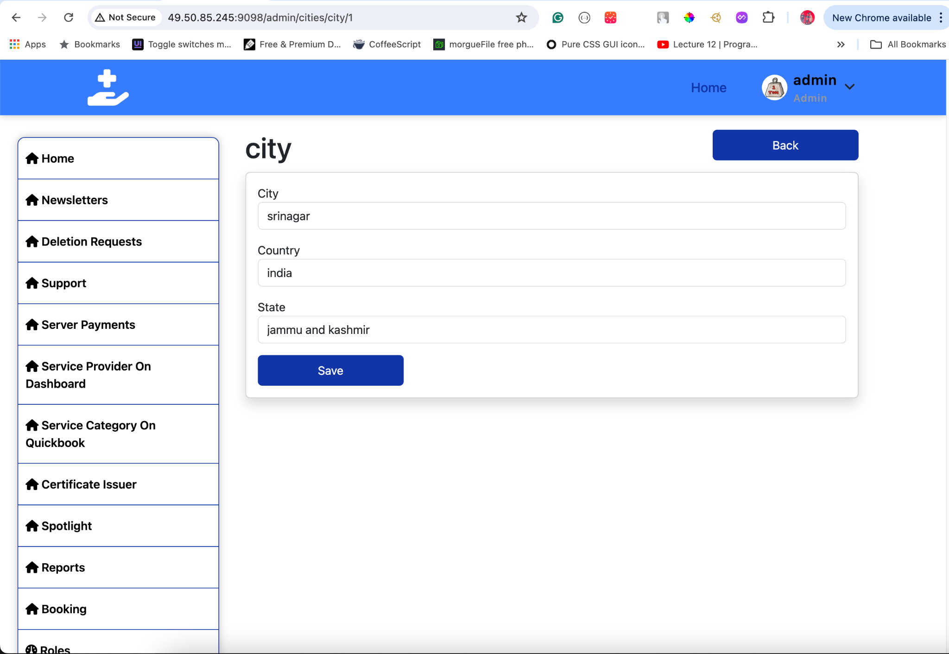
* **Delete City**:
  + Confirmation dialog for deleting a city.
  + 

This documentation should provide clear instructions for managing city data, including handling the foreign key relationships with states and countries. If you need further details or adjustments, feel free to ask!

## **17. Timeslots**

#### **Overview**

The Time Slots section allows administrators to manage time slots within the application. Each time slot is defined by a title and its duration in seconds. This section includes functionality for viewing all time slots, adding new time slots, updating existing ones, and deleting time slots.

#### **View Time Slots**

To view existing time slots:

1. **Click** Time Slots in the sidebar.
2. **A list of all time slots** will be displayed, showing:
   * **ID**: Unique identifier for the time slot.
   * **Title**: The title or name of the time slot (e.g., 1 hour, 2 hours).
   * **Time in Seconds**: Duration of the time slot in seconds.

**Tips:**

* Use the search and filter options to quickly locate a specific time slot.

#### **Add New Time Slot**

To add a new time slot:

1. **Click** Add New Time Slot.
2. **Enter the following details**:
   * **Title**: The title or name of the time slot (e.g., 1 hour, 2 hours).
   * **Time in Seconds**: Duration of the time slot in seconds (e.g., 3600 for 1 hour).
3. **Click** Save to create the new time slot.

**Tips:**

* Ensure the title is clear and descriptive.
* Enter the duration in seconds accurately to avoid calculation errors.

#### **Edit Time Slot**

To edit an existing time slot:

1. **Select** the time slot you want to edit from the list.
2. **Click** Edit Time Slot.
3. **Update** the details as needed:
   * **Title**: Modify the title if necessary.
   * **Time in Seconds**: Update the duration if needed.
4. **Click** Save Changes.

**Tips:**

* Verify the updated duration to ensure it reflects the correct time.
* Communicate any significant changes to relevant users.

#### **Delete Time Slot**

To delete an existing time slot:

1. **Select** the time slot you want to delete from the list.
2. **Click** Delete Time Slot.
3. **Confirm** the deletion in the confirmation dialog.

**Tips:**

* Be cautious when deleting time slots to avoid removing essential time intervals.
* Ensure that the time slot is not in use or referenced elsewhere in the application before deletion.

#### **Visual Guide**

* **Time Slots Interface**:
  + Displays a list of all time slots with options to search and filter.
  + 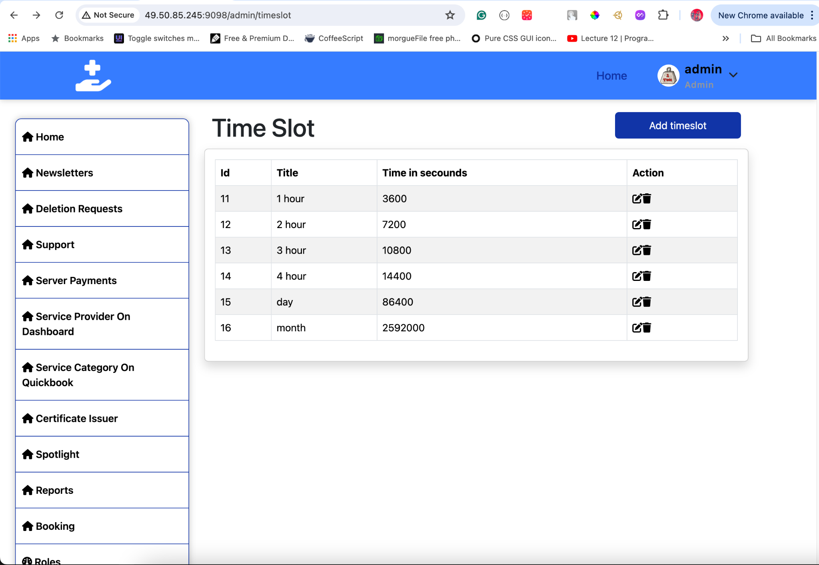
* **Add New Time Slot**:
  + Interface for adding a new time slot with fields for title and duration in seconds.
  + 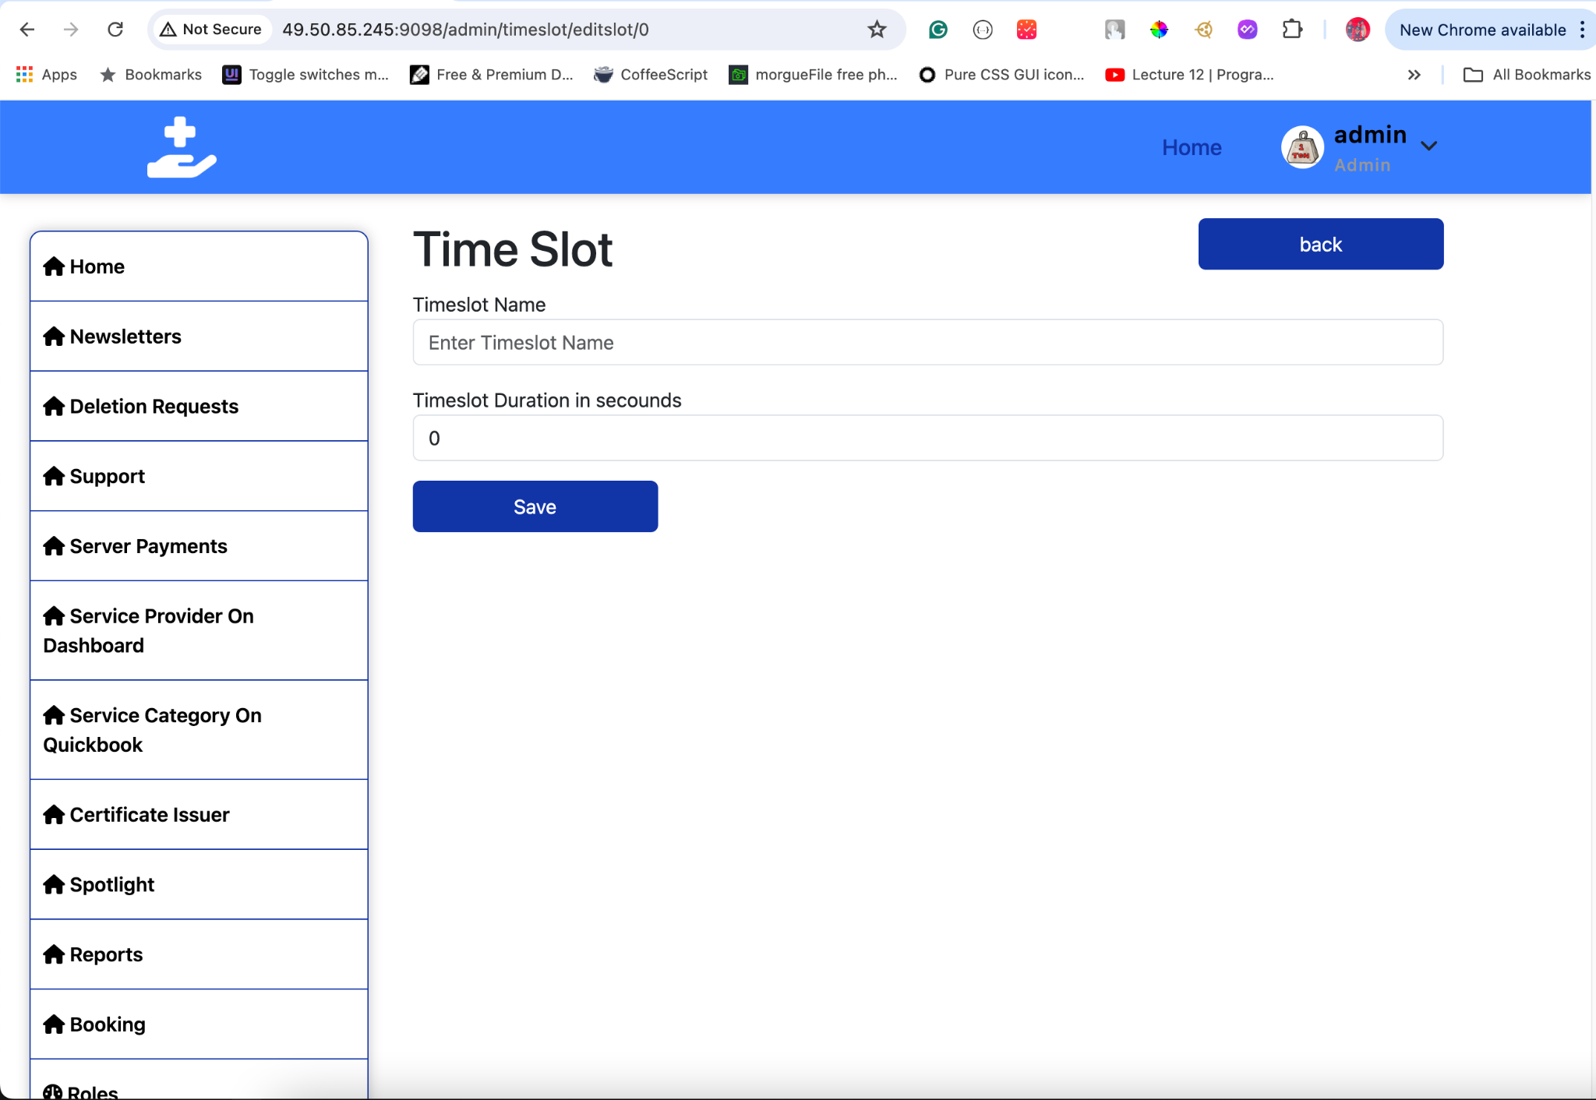
* **Edit Time Slot**:
  + Interface for ed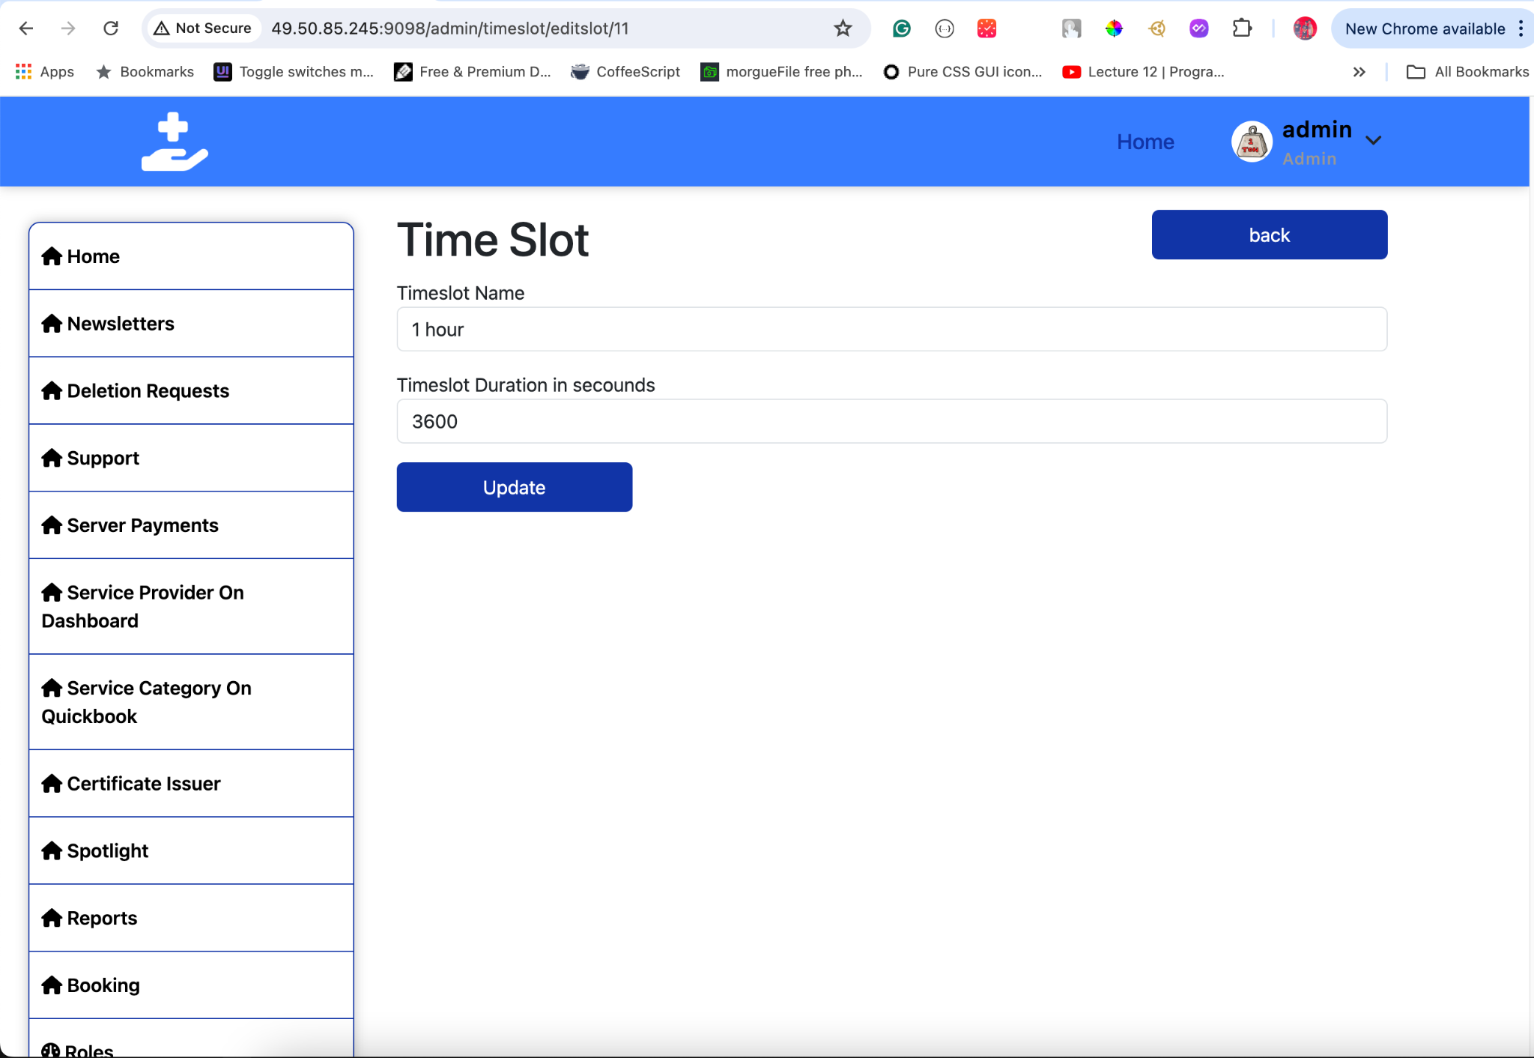iting an existing time slot’s title and duration.

This documentation should help users manage time slots effectively within your application. If you need any further details or adjustments, feel free to ask!

## **18. Service Categories**

#### **Overview**

The Service Categories section allows administrators to manage service categories within the application. This includes viewing all categories, adding new ones, updating existing categories, and deleting categories. Each category includes a name, an image, and a checkbox to determine whether it should be shown in the master search options.

#### **View Service Categories**

To view existing service categories:

1. **Click** Service Categories in the sidebar.
2. **A list of all service categories** will be displayed, showing:
   * **ID**: Unique identifier for the category.
   * **Name**: The name of the category (e.g., Carpentry, Plumbing).
   * **Image**: The image associated with the category (if available).
   * **Show in Master Search**: Indicates whether the category should be shown in the master search options (True/False).

**Tips:**

* Use the search and filter options to quickly locate a specific category.

#### **Add New Service Category**

To add a new service category:

1. **Click** Add New Category.
2. **Enter the following details**:
   * **Name**: The name of the category (e.g., Electrical).
   * **Image**: Upload an image for the category. Click on the upload button to select and upload an image file from your device.
   * **Show in Master Search**: Check this box if you want the category to be included in the master search options; leave it unchecked otherwise.
3. **Click** Save to create the new category.

**Tips:**

* Ensure the category name is descriptive and relevant.
* Choose a clear and representative image for better visual identification.
* Use the checkbox to control whether the category appears in search results.

#### **Edit Service Category**

To edit an existing service category:

1. **Select** the category you want to edit from the list.
2. **Click** Edit Category.
3. **Update** the details as needed:
   * **Name**: Modify the name if necessary.
   * **Image**: Upload a new image if you want to change the existing one. Click on the upload button to select and upload a new image file.
   * **Show in Master Search**: Check or uncheck the box based on whether you want the category to be included in the master search options.
4. **Click** Save Changes.

**Tips:**

* Confirm that the updated details accurately reflect the category’s purpose.
* Ensure that any new image uploaded is clear and relevant to the category.
* Adjust the checkbox as needed to manage search visibility.

#### **Delete Service Category**

To delete an existing service category:

1. **Select** the category you want to delete from the list.
2. **Click** Delete Category.
3. **Confirm** the deletion in the confirmation dialog.

**Tips:**

* Be cautious when deleting categories to avoid disrupting the categorization of services.
* Ensure there are no active services associated with the category before deletion.

#### **Visual Guide**

* **Service Categories Interface**:
  + Displays a list of all categories with options to search and filter.
  + Shows images and the checkbox st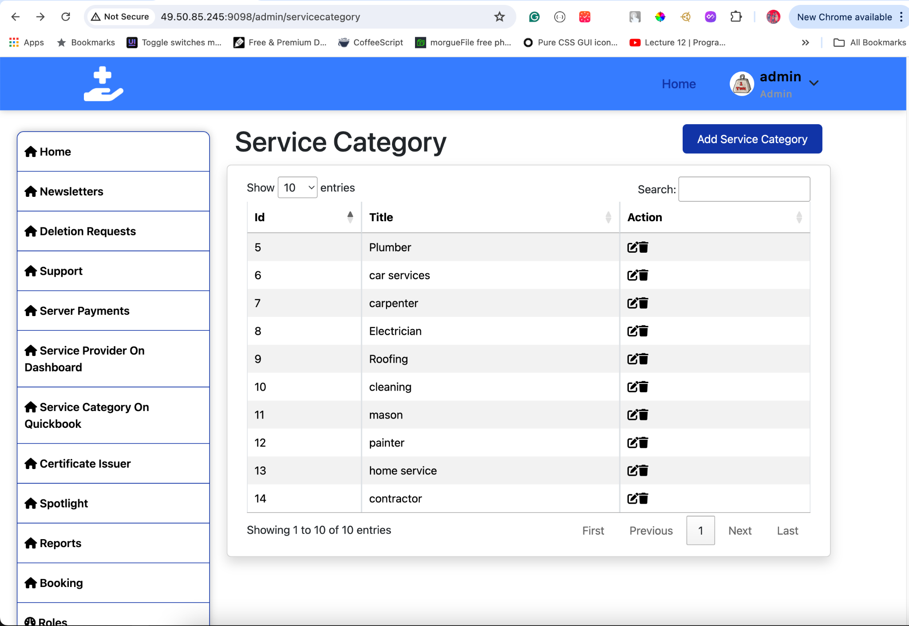atus for each category.
* **Add New Category**:
  + Interface for adding a new category with fields for name, image upload, and a checkbox for search visibility.
  + 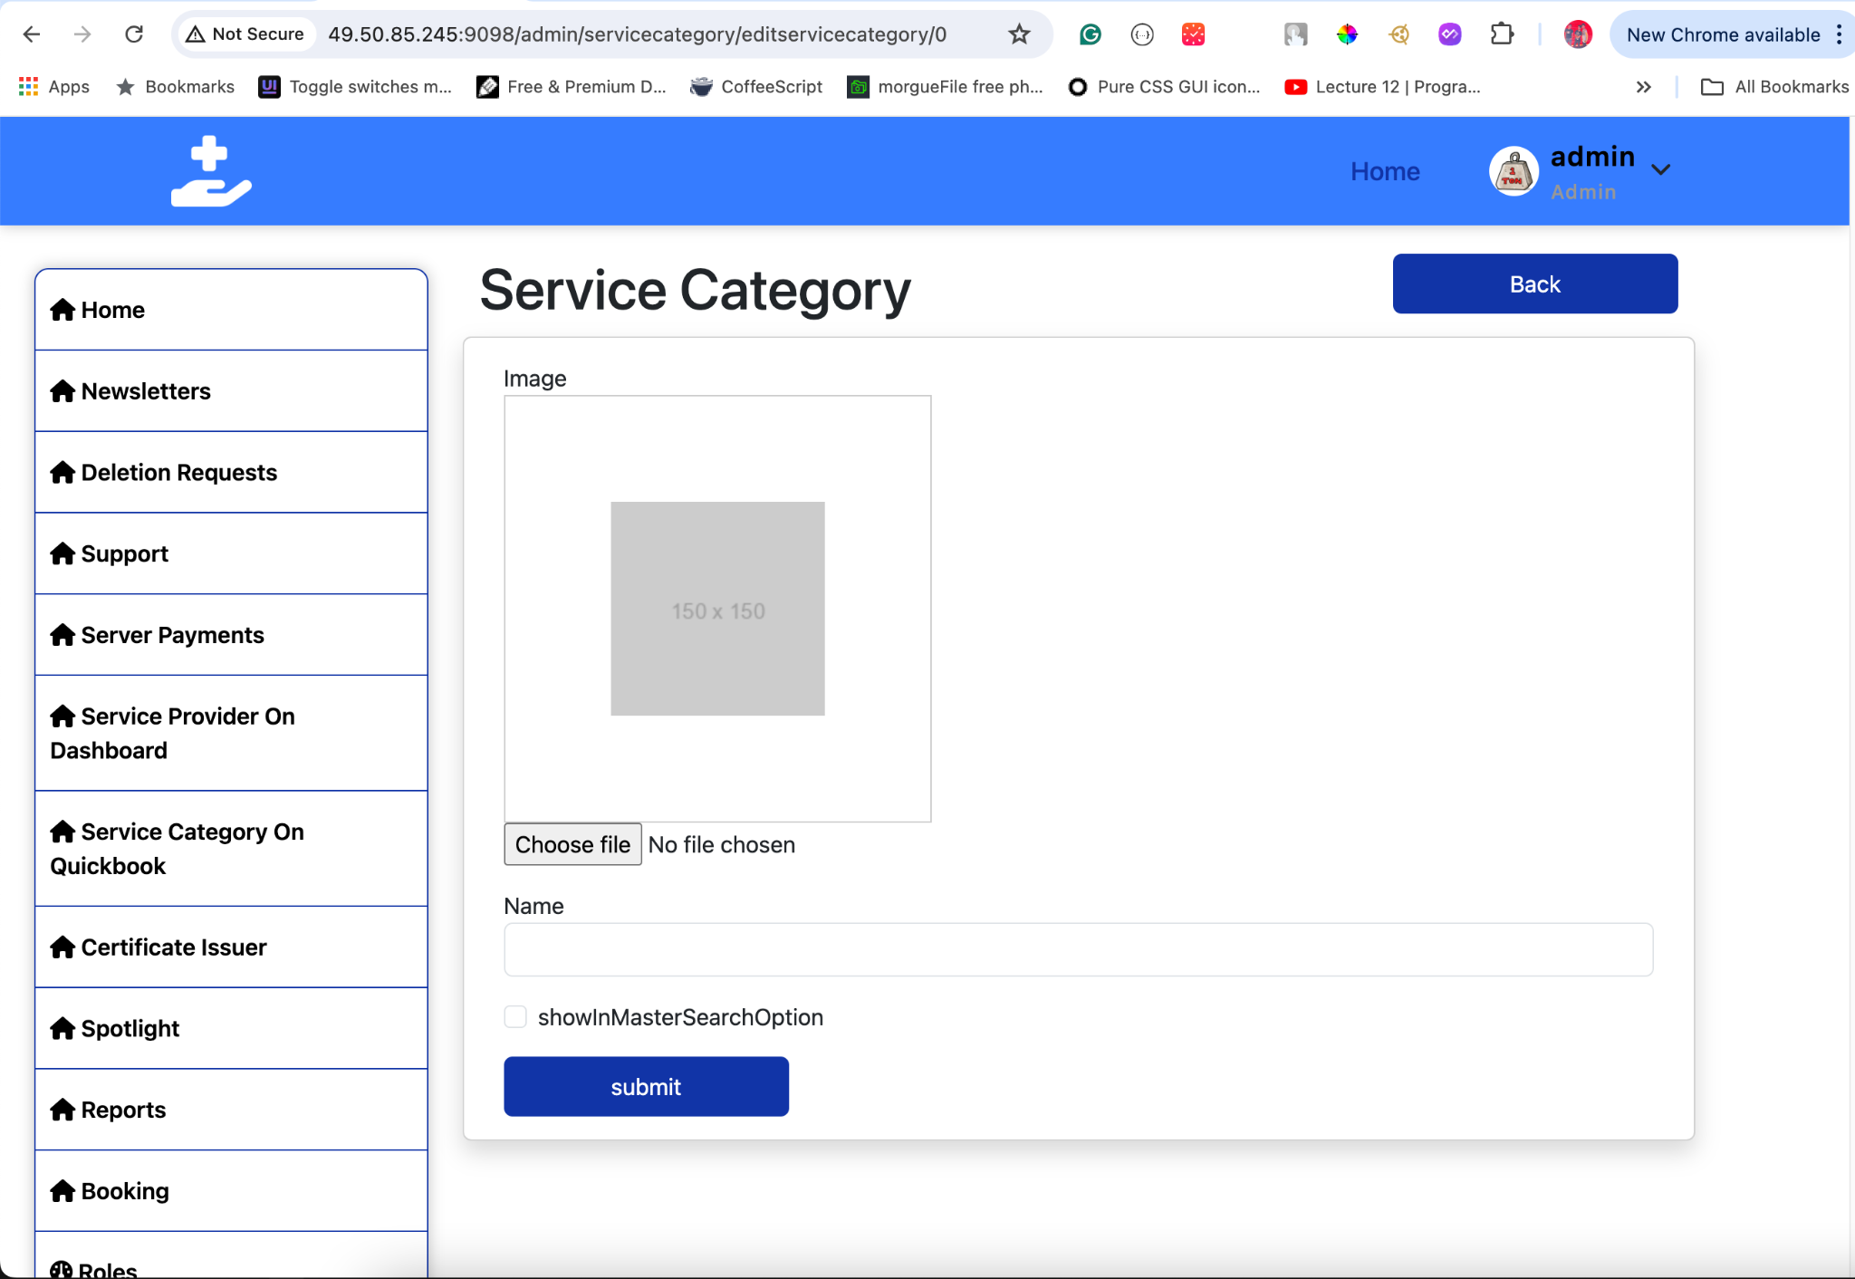
* **Edit Category**:
  + Interface for editing an existing category’s name, image, and search visibility.
  + 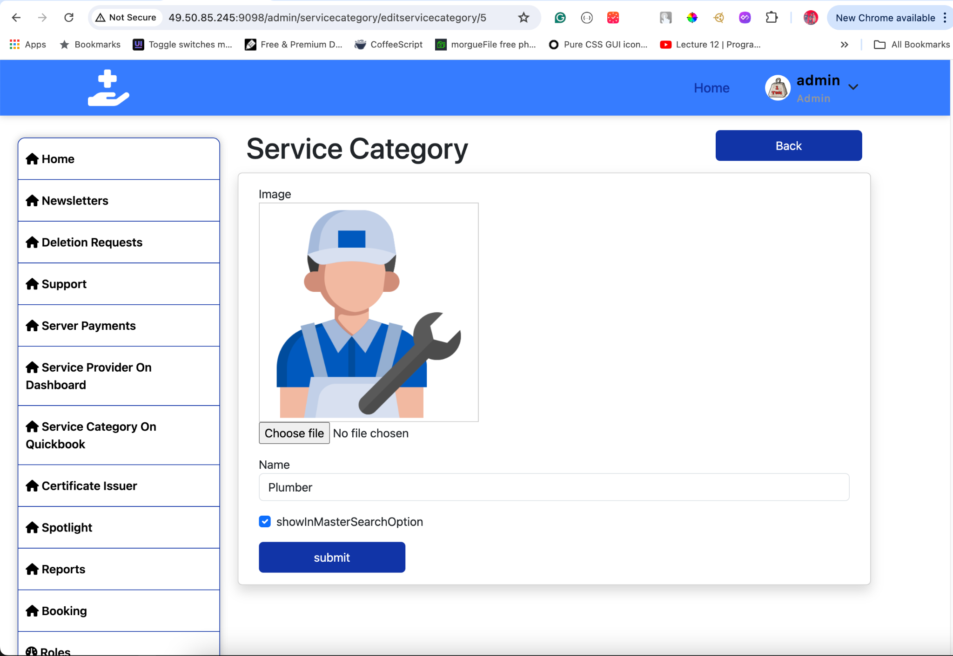
* **Delete Category**:
  + Confirmation dialog for deleting a category.
  + 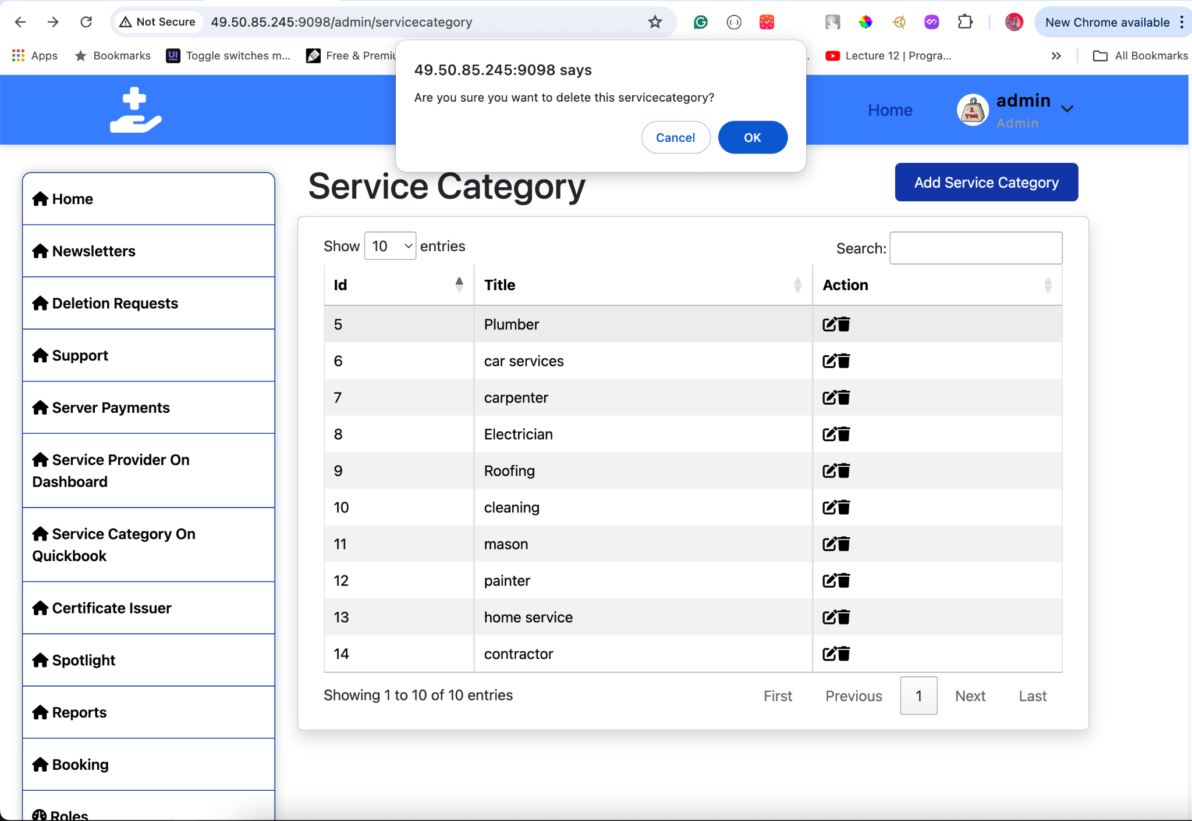

This documentation should help users effectively manage service categories with the provided functionality. If you need any more adjustments or additional details, just let me know!

## **19. Service Sub Categories**

#### **Overview**

The Service Sub Categories section allows administrators to manage sub-categories under service categories within the application. This includes viewing all sub-categories, adding new ones, updating existing sub-categories, and deleting sub-categories. Each sub-category is associated with a parent service category.

#### **View Service Sub Categories**

To view existing service sub-categories:

1. **Click** Service Sub Categories in the sidebar.
2. **A list of all service sub-categories** will be displayed, showing:
   * **ID**: Unique identifier for the sub-category.
   * **Name**: The name of the sub-category (e.g., Electrical Wiring, Plumbing Fixtures).
   * **Service Category**: The parent service category to which the sub-category belongs.
   * **Image**: The image associated with the sub-category (if available).
   * **Show in Master Search**: Indicates whether the sub-category should be shown in the master search options (True/False).

**Tips:**

* Use the search and filter options to quickly locate a specific sub-category.
* Review the associated service category to understand the context of the sub-category.

#### **Add New Service Sub Category**

To add a new service sub-category:

1. **Click** Add New Sub Category.
2. **Enter the following details**:
   * **Name**: The name of the sub-category (e.g., Electrical Wiring).
   * **Service Category**: Select the parent service category from a dropdown list or similar selector.
   * **Image**: Upload an image for the sub-category. Click on the upload button to select and upload an image file from your device.
   * **Show in Master Search**: Check this box if you want the sub-category to be included in the master search options; leave it unchecked otherwise.
3. **Click** Save to create the new sub-category.

**Tips:**

* Ensure the sub-category name is descriptive and relevant to the parent service category.
* Choose a clear and representative image for better visual identification.
* Use the checkbox to control whether the sub-category appears in search results.

#### **Edit Service Sub Category**

To edit an existing service sub-category:

1. **Select** the sub-category you want to edit from the list.
2. **Click** Edit Sub Category.
3. **Update** the details as needed:
   * **Name**: Modify the name if necessary.
   * **Service Category**: Update the parent service category if needed by selecting a new one from the dropdown list.
   * **Image**: Upload a new image if you want to change the existing one. Click on the upload button to select and upload a new image file.
   * **Show in Master Search**: Check or uncheck the box based on whether you want the sub-category to be included in the master search options.
4. **Click** Save Changes.

**Tips:**

* Confirm that the updated details accurately reflect the sub-category’s purpose.
* Ensure that any new image uploaded is clear and relevant to the sub-category.
* Adjust the checkbox as needed to manage search visibility.

#### **Delete Service Sub Category**

To delete an existing service sub-category:

1. **Select** the sub-category you want to delete from the list.
2. **Click** Delete Sub Category.
3. **Confirm** the deletion in the confirmation dialog.

**Tips:**

* Be cautious when deleting sub-categories to avoid disrupting the categorization of services.
* Ensure there are no active services associated with the sub-category before deletion.

#### **Visual Guide**

* **Service Sub Categories Interface**:
  + Displays a list of all sub-categories with options to search and filter.
  + Shows images, associated service categories, and the checkbox status for each sub-category.
  + 
* **Add New Sub Category**:
  + Interface for adding a new sub-category with fields for name, selecting a service category, image upload, and a checkbox for search visibility.
  + 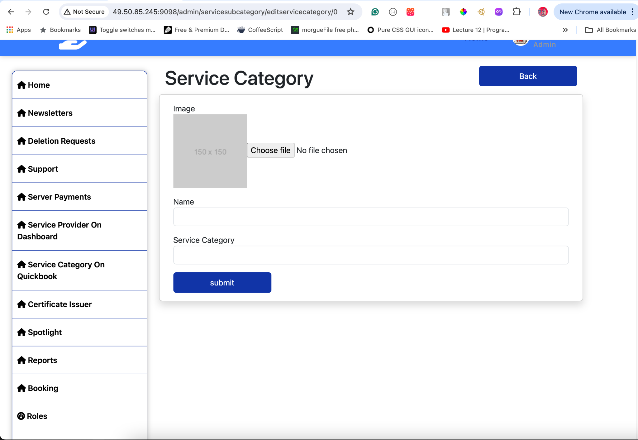
* **Edit Sub Category**:
  + Interface for editing an existing sub-category’s name, associated service category, image, and search visibility.
  + 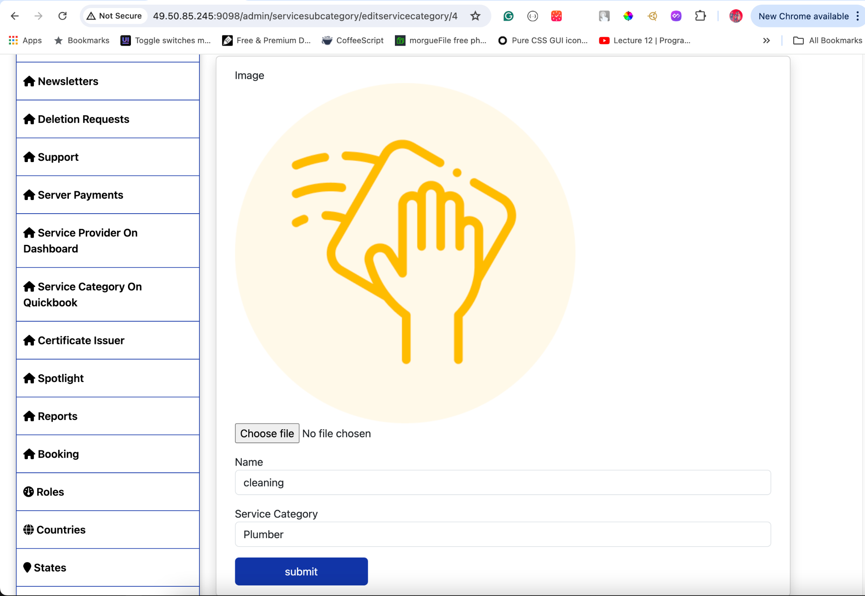

## 

## **20. Support Category**

#### **Overview**

The Support Categories section allows administrators to manage the different categories used for handling support requests within the application. Each category represents a specific type of support request and helps in organizing and directing inquiries to the appropriate channels.

#### **Support Categories List**

The available support categories are:

1. **General**:
   * **Description**: This category typically encompasses broad or unspecified issues or inquiries that do not fall under more specific technical, billing, or other categories.
2. **Technical**:
   * **Description**: This category is intended for issues or inquiries related to technical aspects of a product or service. It may involve troubleshooting, software bugs, hardware issues, or other technical matters.
3. **Billing**:
   * **Description**: This category pertains to issues or inquiries related to billing, invoices, payments, subscriptions, or financial transactions associated with products or services.
4. **Feedback**:
   * **Description**: This category is for users to provide feedback or suggestions about the product or service. It can include comments on user experience, feature requests, and general feedback.
5. **Returns and Refunds**:
   * **Description**: This category is for issues or inquiries regarding the return of products and the process for refunds. It covers return policies, refund status, and related matters.
6. **Security**:
   * **Description**: This category addresses concerns related to the security of user data and the application. It includes reporting security vulnerabilities, data breaches, and security-related queries.
7. **Feature Request**:
   * **Description**: This category is for users to request new features or enhancements to existing features in the product or service.
8. **Others**:
   * **Description**: This category serves as a catch-all for issues or inquiries that do not fit into the predefined General, Technical, or Billing categories. It can include miscellaneous topics or specific issues that are not covered by the other categories.

#### **Manage Support Categories**

To manage support categories:

1. **Click** Support Categories in the sidebar.
2. **Review** the list of all support categories. You can perform the following actions:
   * **View**: See details about each support category.
   * **Add**: Add new support categories if necessary.
   * **Edit**: Modify existing support categories.
   * **Delete**: Remove support categories that are no longer needed.

**Tips:**

* Ensure that support categories are clearly defined to facilitate accurate routing of support requests.
* Regularly review and update categories to accommodate new types of inquiries or issues.

#### **Add New Support Category**

To add a new support category:

1. **Click** Add New Category.
2. **Enter the following details**:
   * **Name**: The name of the category (e.g., Billing).
   * **Description**: A brief description of what the category covers.
3. **Click** Save to create the new category.

**Tips:**

* Clearly define the category name and description to ensure it accurately reflects the type of support request it addresses.

#### **Edit Support Category**

To edit an existing support category:

1. **Select** the category you want to edit from the list.
2. **Click** Edit Category.
3. **Update** the details as needed:
   * **Name**: Modify the category name if necessary.
   * **Description**: Update the description if needed.
4. **Click** Save Changes.

**Tips:**

* Ensure that any changes accurately reflect the intended use of the category.
* Communicate changes to support staff to ensure they are aware of the updated categories.

#### **Delete Support Category**

To delete an existing support category:

1. **Select** the category you want to delete from the list.
2. **Click** Delete Category.
3. **Confirm** the deletion in the confirmation dialog.

**Tips:**

* Be cautious when deleting categories to avoid disrupting the support request process.
* Ensure that there are no active requests associated with the category before deletion.

#### **Visual Guide**

* **Support Categories Interface**:
  + Displays a list of all categories with options to search and filter.
  + 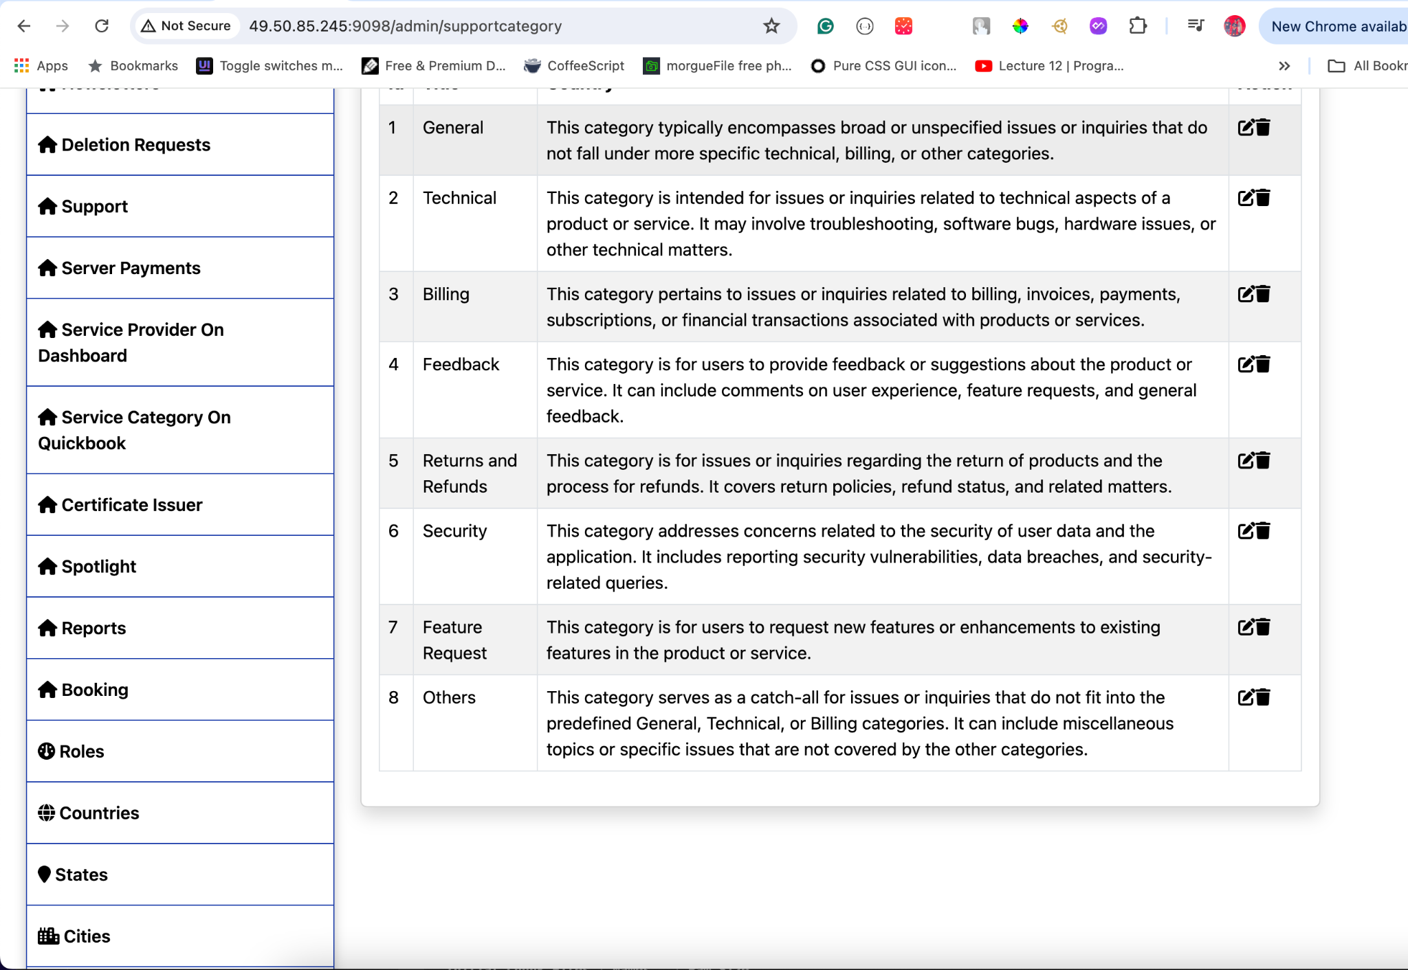
* **Add New Category**:
  + Interface for adding a new category with fields for name and description.
  + 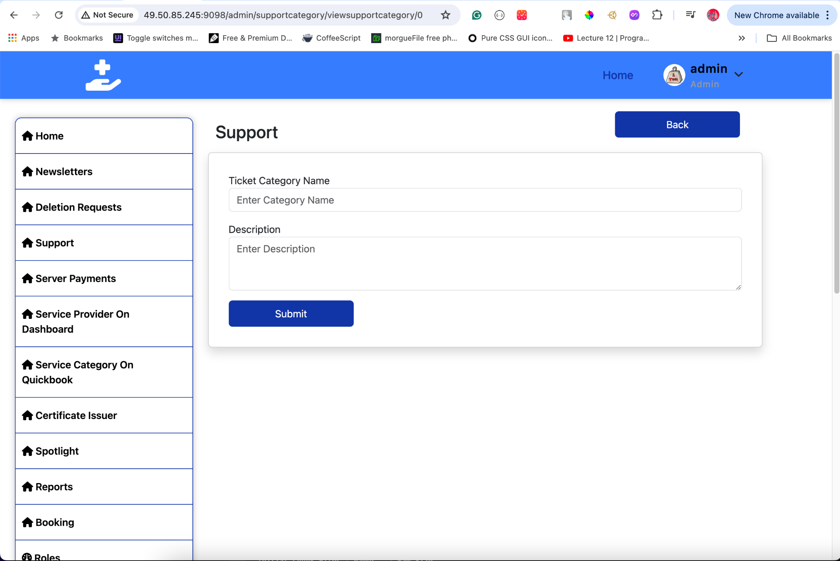
* **Edit Category**:
  + Interface for editing an existing category’s name and description.
  + 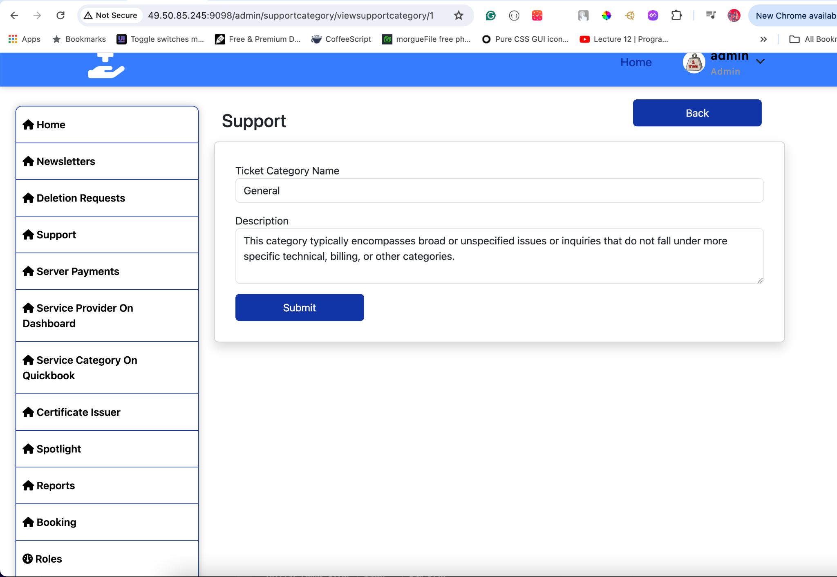
* **Delete Category**:
  + Confirmation dialog for deleting a category.
  + 

## 

## **21. Support Contact**

#### **Overview**

The Support Contact section allows administrators to manage contact information for support. This includes viewing all support contacts, adding new ones, updating existing contact details, and deleting contacts. Each contact entry includes a name, phone number, email, and an active status.

#### **View Support Contacts**

To view existing support contacts:

1. **Click** Support Contact in the sidebar.
2. **A list of all support contacts** will be displayed, showing:
   * **ID**: Unique identifier for the contact.
   * **Name**: The name of the support contact (e.g., Support, Customer Service).
   * **Phone**: The phone number for the support contact.
   * **Email**: The email address for the support contact.
   * **Active**: Indicates whether the contact is currently active (True/False).

**Tips:**

* Use the search and filter options to quickly locate a specific contact.
* Review the active status to ensure the correct contacts are displayed to users.

#### **Add New Support Contact**

To add a new support contact:

1. **Click** Add New Contact.
2. **Enter the following details**:
   * **Name**: The name of the contact (e.g., Technical Support).
   * **Phone**: The phone number for the contact.
   * **Email**: The email address for the contact.
   * **Active**: Check this box if the contact should be active; leave it unchecked if it should be inactive.
3. **Click** Save to create the new contact.

**Tips:**

* Ensure the contact name is clear and representative of the support function.
* Verify the phone number and email address for accuracy.
* Use the active checkbox to control whether the contact information is displayed to users.

#### **Edit Support Contact**

To edit an existing support contact:

1. **Select** the contact you want to edit from the list.
2. **Click** Edit Contact.
3. **Update** the details as needed:
   * **Name**: Modify the name if necessary.
   * **Phone**: Update the phone number if needed.
   * **Email**: Change the email address if necessary.
   * **Active**: Check or uncheck the box to change the contact's active status.
4. **Click** Save Changes.

**Tips:**

* Confirm that the updated details accurately reflect the contact’s purpose.
* Ensure that any new phone number or email address is correct and active.
* Adjust the active checkbox as needed to manage visibility.

#### **Delete Support Contact**

To delete an existing support contact:

1. **Select** the contact you want to delete from the list.
2. **Click** Delete Contact.
3. **Confirm** the deletion in the confirmation dialog.

**Tips:**

* Be cautious when deleting contacts to avoid disrupting the support process.
* Ensure that there are no active support requests associated with the contact before deletion.

#### **Visual Guide**

* **Support Contact Interface**:
  + Displays a list of all contacts with options to search and filter.
  + Shows phone numbers, email addresses, and active status for each contact.
  + 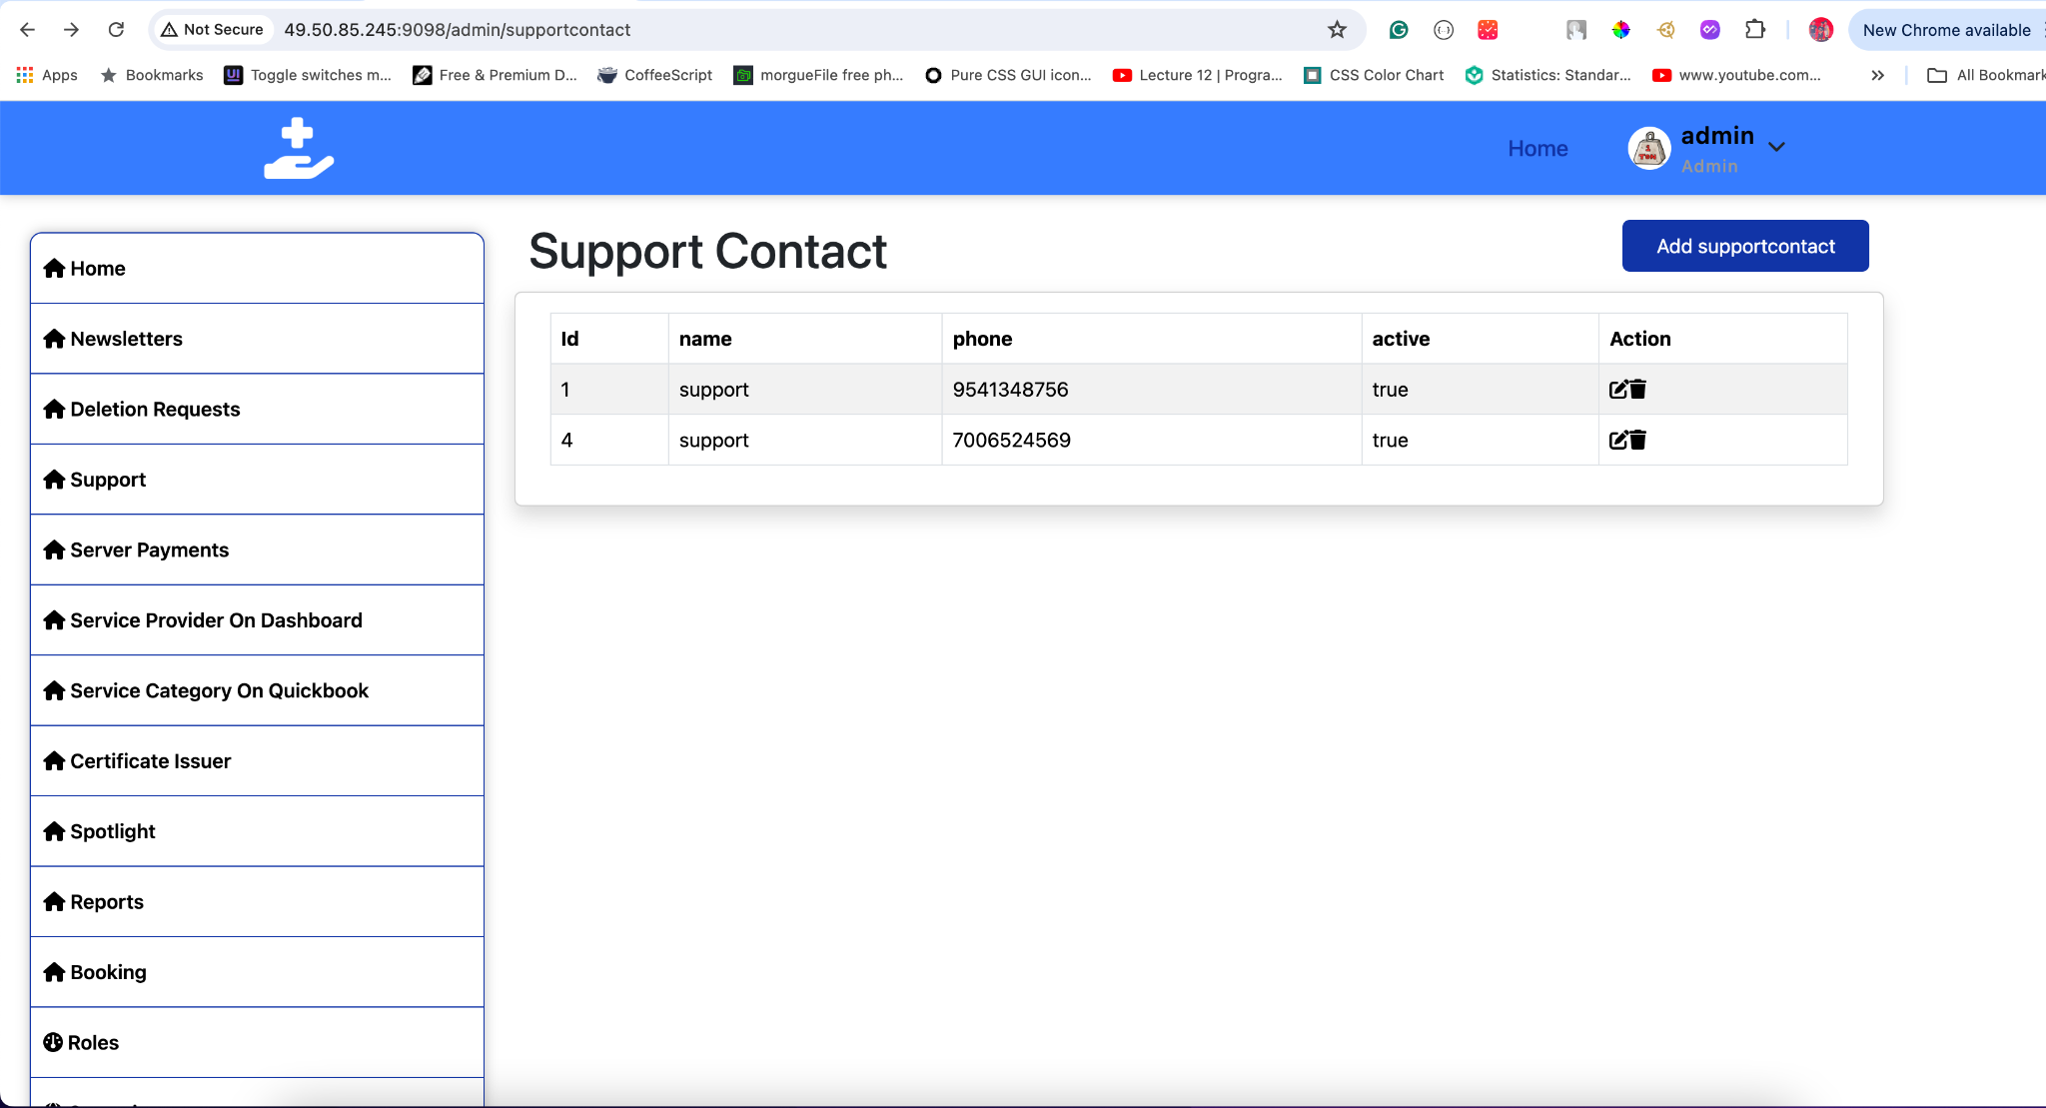
* **Add New Contact**:
  + Interface for adding a new contact with fields for name, phone number, email, and active status.
  + 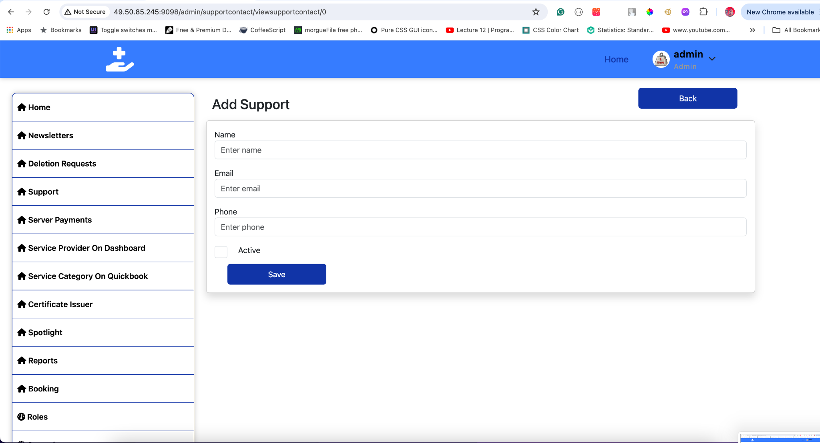
* **Edit Contact**:
  + Interface for editing an existing contact’s name, phone number, email, and active status.
  + 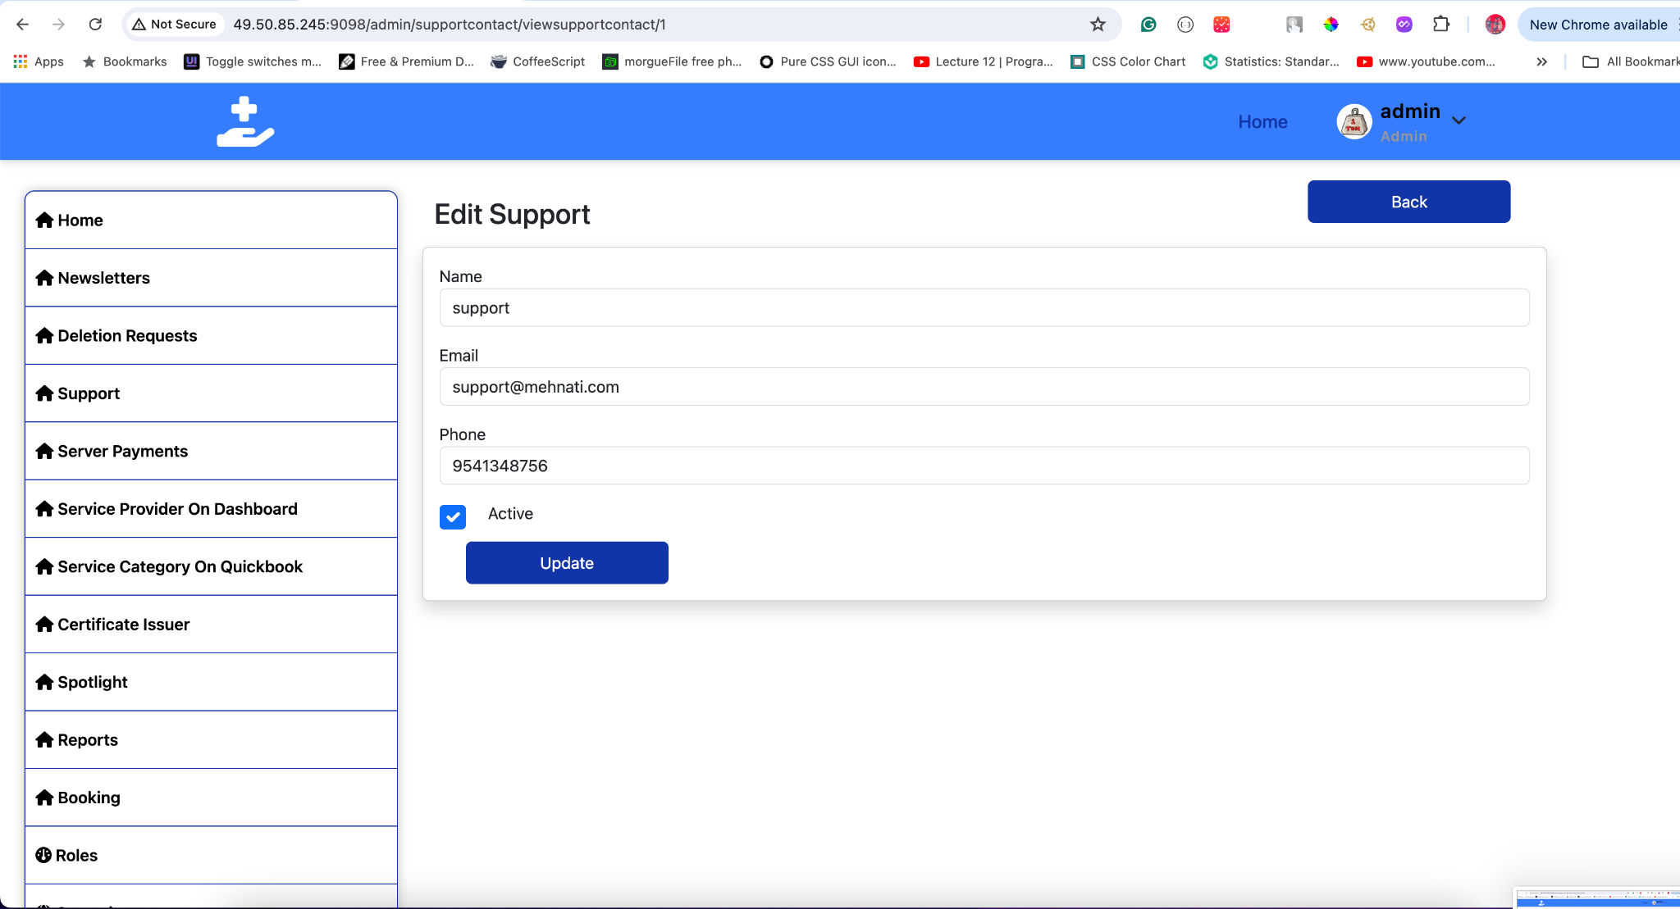
* **Delete Contact**:
  + Confirmation dialog for deleting a contact.
  + 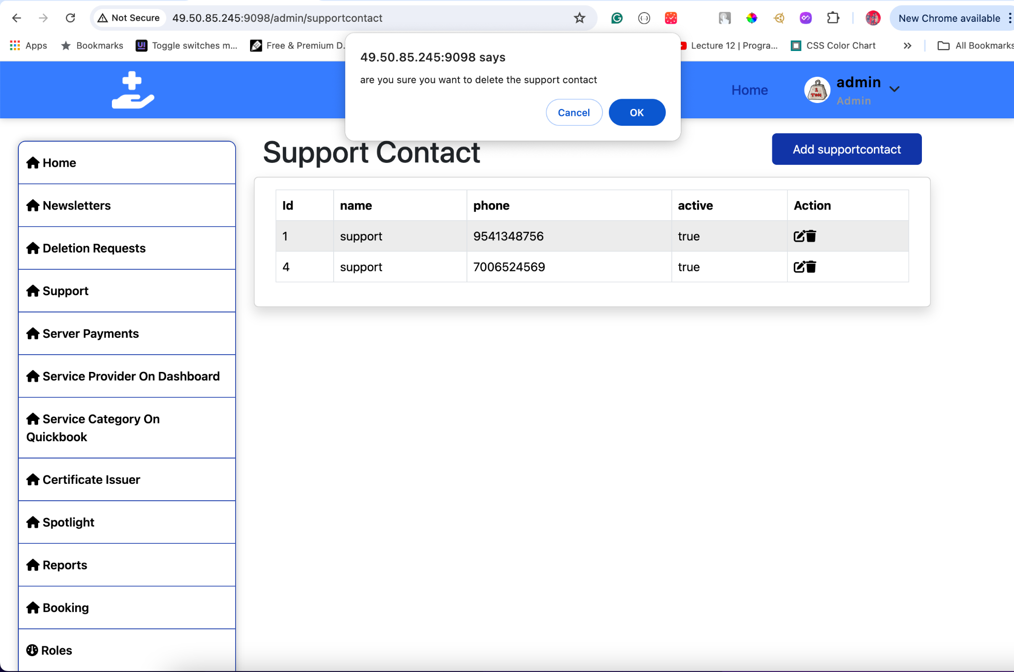

## **22. Users**

The Users section allows administrators to manage all registered users who book services through the application. This includes viewing all user profiles, editing user details, and managing the status of users.

#### **View Users**

To view existing users:

1. **Click** Users in the sidebar.
2. **A list of all users** will be displayed, showing:
   * **User Name**: The name of the user.
   * **User Phone**: The phone number of the user.
   * **User Email**: The email address of the user.
   * **Status**: Indicates if the user is active or banned.
   * **Action**: Options to view, edit, or delete the user.

**Tips:**

* Use the search and filter options to quickly locate a specific user.
* Regularly review user statuses to ensure proper user management.

#### **Edit User**

To edit an existing user:

1. **Select** the user you want to edit from the list.
2. **Click** Edit User.
3. **Update** the details as needed. The user edit form includes the following fields:
   * **Banner**: Upload a profile banner for the user.
   * **Avatar**: Upload a profile picture for the user.
   * **User Name**: Edit the user’s name.
   * **Token**: View the user’s unique token (read-only).
   * **Device ID**: View the user’s device ID (read-only).
   * **Created At**: View the user’s registration date (read-only).
   * **Updated At**: View the last update date (read-only).
   * **Last Seen**: View the last seen timestamp (read-only).
   * **Is Online**: View the user’s online status (read-only).
   * **User Phone**: Edit the user’s phone number.
   * **User Email**: Edit the user’s email address.
   * **PAN Number**: Edit the user’s PAN number.
   * **Aadhaar Number**: Edit the user’s Aadhaar number.
   * **Banned**: Check or uncheck to ban/unban the user.
   * **Active**: Check or uncheck to activate/deactivate the user.
   * **Address**: Edit the user’s address.
   * **Country**: Edit the user’s country.
   * **State**: Edit the user’s state.
   * **City**: Edit the user’s city.
4. **Click** Save Changes to update the user details.

**Tips:**

* Ensure that the user details are accurate and up-to-date.
* Use the ban and active checkboxes to manage user access to the platform.

**Tips:**

* Be cautious when deleting users to avoid disrupting their access to services.

#### **Visual Guide**

* **Users Interface**:
  + Displays a list of all users with options to search and filter.
  + Shows key details such as user name, phone, email, status, and actions.
  + 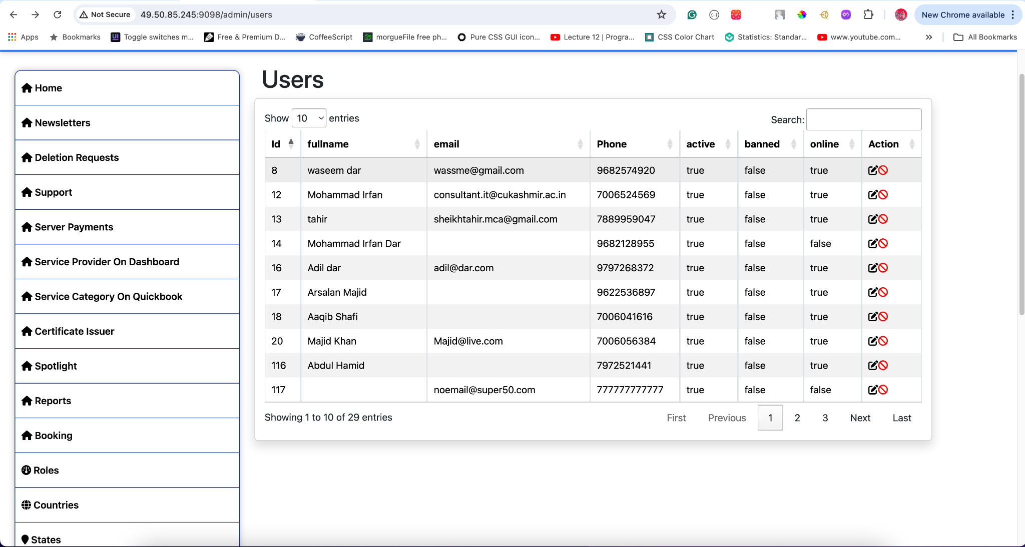
* **Edit User**:
  + Interface for editing user details, including uploading profile banners and avatars, and managing user status and contact information.
  + 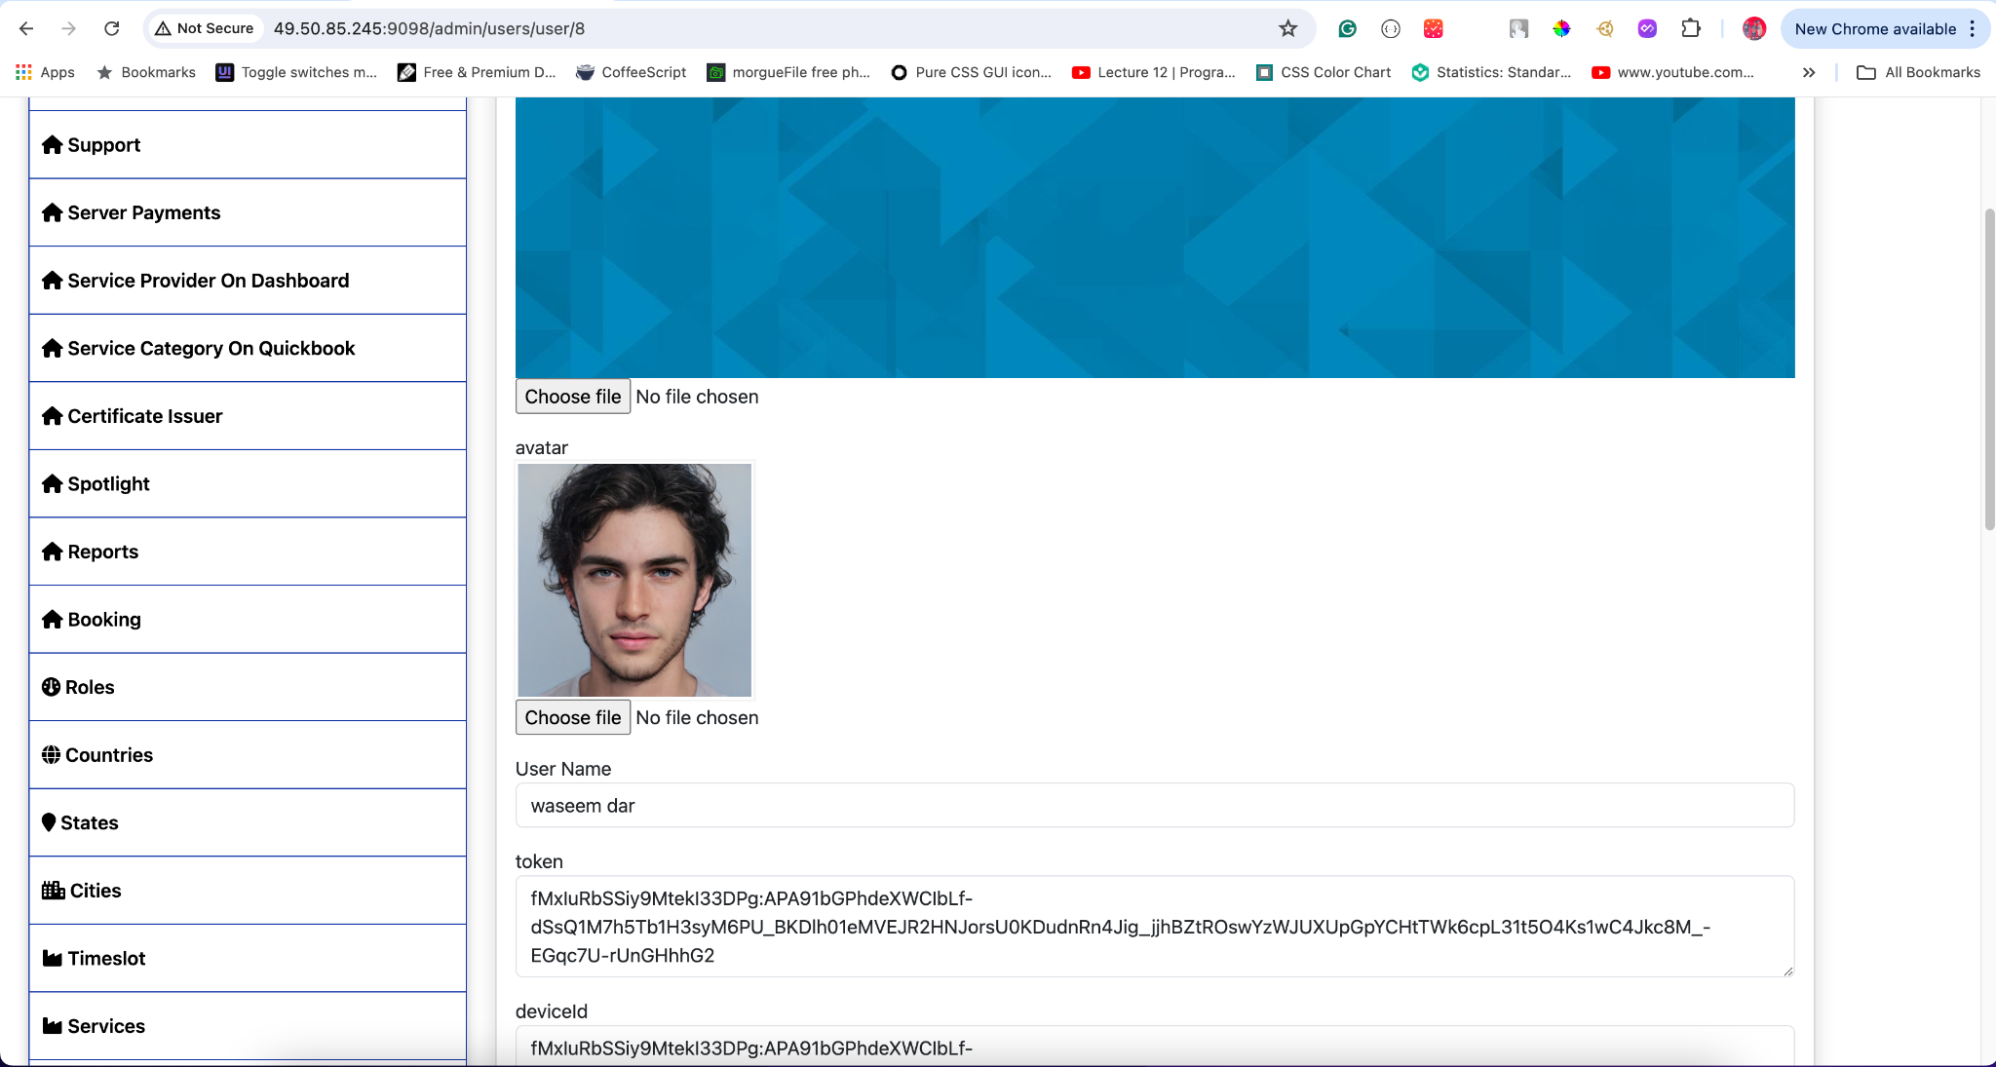

This documentation should help administrators effectively manage user profiles, ensuring that user information is accurate and that access controls are properly enforced. If you need further adjustments or additional details, just let me know!

## **23. Service Providers**

**Manage Service Providers** To manage service provider profiles:

* **View Service Providers**
  + Navigate to the Service Providers section in the sidebar.
  + A list of all service providers will be displayed, showing:
    - Provider ID
    - Email
    - Full Name
    - Type
    - Action (Edit)

**Add New Service Provider** To add a new service provider:

* Click the "Add Service Provider" button.
* Fill in the required details:
  + First Name
  + Last Name
  + Email Address
  + Phone Number
  + Pan Number
  + Aadhar Number
  + Active (checkbox)
  + Is Shadow Banned (checkbox)
  + Is Verified (checkbox)
  + Years of Experience
  + Service Category
  + Service Sub Category
  + Country
  + State
  + City
  + About (description)
* Upload the profile banner and avatar.
* Enter the work start time, work end time, and default daily price.
* Select the service provider type (Individual, Contractor, Dependent).
* Input the bank details:
  + Account Holder Name
  + Account Number
  + IFSC Code
  + Bank Name
* Enter the Razorpay account details if available:
  + Name
  + Email
  + Contact
  + Contact ID
  + Fund Account
* Click "Save" to add the new service provider.

**Edit Service Provider Profile** To edit an existing service provider:

* Select a provider from the list.
* Click the "Edit" icon to update details.
* Modify the necessary information.
* Click "Save" to apply the changes.

**Creating a Payout Account** To create a payout account for a service provider:

* **Access the Service Provider's Profile**
  + Navigate to the Service Providers section.
  + Select a service provider and click the edit icon to view their profile.
* **Add Bank Details**
  + Ensure the following bank details are entered:
    - Account Holder Name
    - Account Number
    - IFSC Code
    - Bank Name
  + Once the bank details are filled, the admin can proceed to create a payout account.
* **Create Payout Account**
  + Click the "Create Payout Account" button at the bottom of the profile page.
  + This will initiate the creation of a payout account on Razorpay.

**Delete Service Provider** To delete an existing service provider:

* Select a provider from the list.
* Click the "Delete" icon.
* Confirm the deletion.

**Visual Guide**

* **Service Providers Interface**
  + Displays a list of all service providers with options to search and filter.
  + 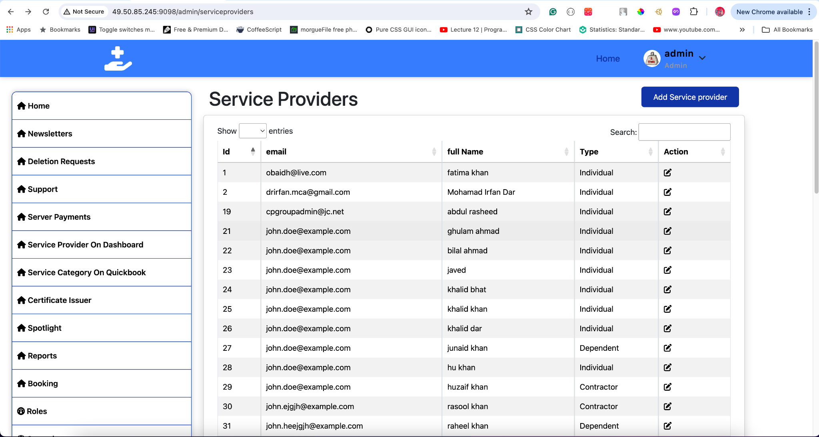
* **Add Service Provider**
  + Interface for adding a new service provider with fields for name, email, phone number, work details, categories, address, about section, and bank details.
  + 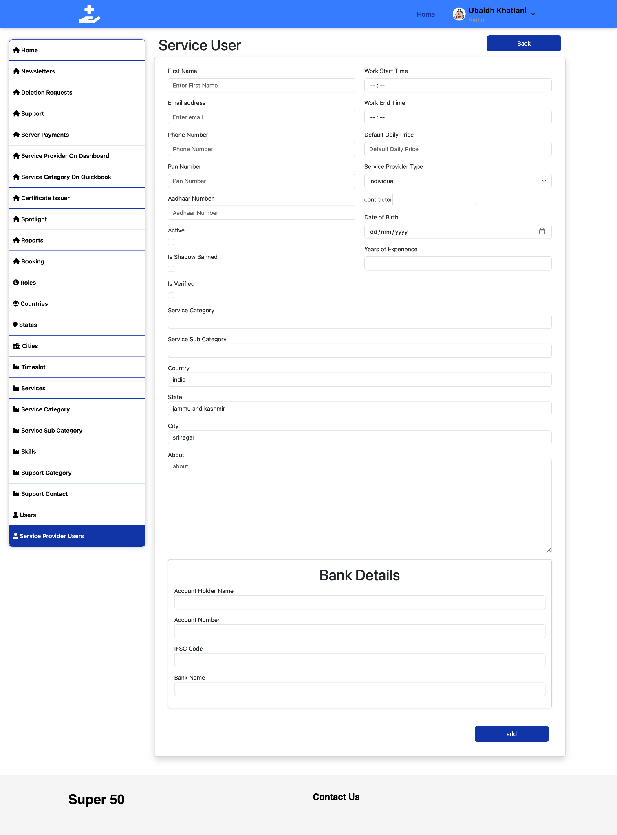
* **Edit Service Provider**
  + Interface for editing an existing service provider's details.
  + 